Solved by
Bc150402773
Difference between the Inverse PCR and conventional PCR?
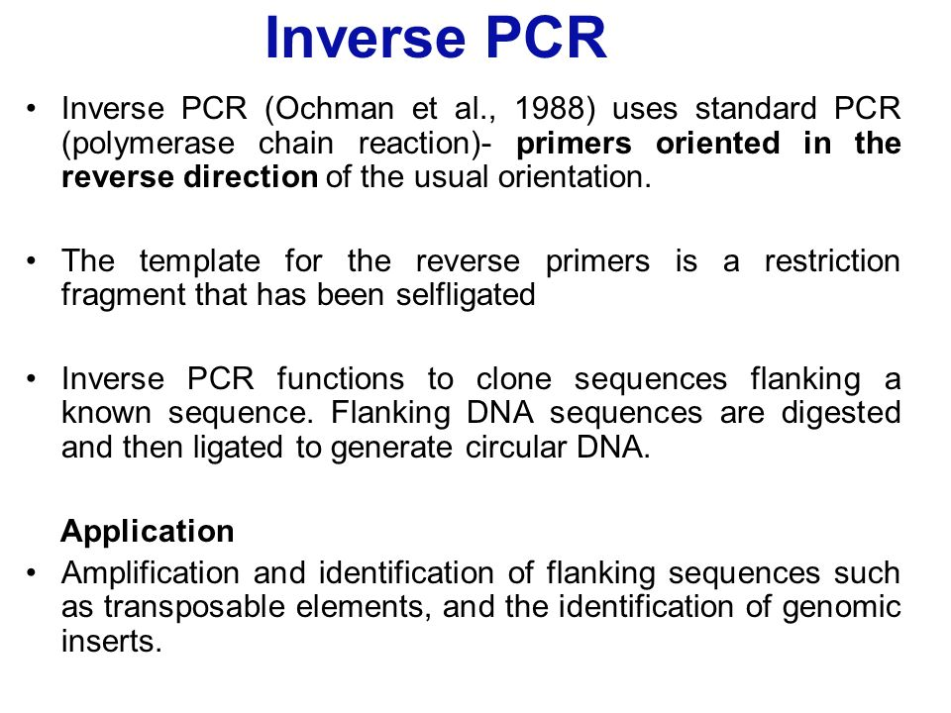
. Conventional PCR :
gives result only at the end of the reaction while Real Time PCR displays the data of amplification during the run after each cycle.
Conventional PCR results are in the form of bands in the gel whereas in Real Time PCR Ct or threshold value gives the measure of quality and quantity of the product.
Conventiona PCR is used to detect presence or absence of certain genomic fragments
Conventional PCR is more time consuming as it uses gel electrophoresis to analyze the amplified PCR products. In contrast, real-time PCR is less time consuming as it can detect amplifications during the early phases of the reaction
Purpose of probe in southern blotting?
Southern blotting is the transfer of DNA fragments from an electrophoresis gel to a membrane support, resulting in immobilization of the DNA fragments, so the membrane carries a semipermanent reproduction of the banding pattern of the gel. After immobilization, the DNA can be subjected to hybridization analysis, enabling bands with sequence similarity to a labeled probe to be identified
southern blotting Probes probes Labeled material to detect a target. For DNA: 20-30 nucleotides, complementary to a region in the gene or DNA.

What is RT-PCR?
Reverse transcription PCR (RT-PCR) uses mRNA rather than DNA as the starting template. First, the enzyme reverse transcriptase uses the mRNA template to produce a complementary single-stranded DNA strand called cDNA in a process known as reverse transcription.
waht is adapter and linker?
Linkers and Adapters - Linkers are short stretches of double stranded DNA of length 8-14 bp and have recognition site for 3-8 RE. These linkers are ligated to blunt end DNA by ligase. Because of the high concentration of these small molecules present in the reaction, the ligation is every efficient when compared with blunt-end ligation of large molecules.
The cohesive ends are generated by digesting the DNA with appropriate RE that generates cohesive ends by cleaving in the linkers. The problem with linker is that the sites for the enzyme used to generate cohesive ends may be present in the target DNA fragment. This drawback limits the use of linkers for cloning.
Adapters are linkers with cohesive ends or a linker digested with RE, before ligation. The most widely used definition is cut linkers also called as adapters.
They are not perfectly double stranded non single stranded. By adding adaptors to the ends of a DNA, sequences that are blunt can be converted into cohesive ends.
Limitations of pcr?

limitations
 Contamination risk
 Primer complexities
 Primer-binding site complexities
 Amplifies rare species
 Detection methods
Type iii and type iii difference?
Difference bw type !! And type!!s
Type II
▪ Most of the useful R-M system is Type II
▪ Type II enzymes recognize a defined sequence and cut within it
Type IIs
▪ Type IIs systems have similar cofactors and structure to type II but restriction occurs at a distance
from recognition site that limits their usefulness
What is Assembly PCR?
Assembly PCR used to assemble two or more pieces of DNA into one piece
Assembly PCR is the synthesis of long DNA structures by performing PCR on a pool of long oligonucleotides with short overlapping segments, to assemble two or more pieces of DNA into one piece
It involves an initial PCR with primers that have an overlap and a second PCR using the products as the template that generates the final full-length product.
Waht is southern blotting?
The Southern blot is used to detect the presence of a particular piece of DNA in a sample by a molecular probe.
Southern Blotting is named after its inventor, the British Biologist Edwin Southern (1975).

Identify DNA sequence (gene) of interest.
 Identified DNA may be a small piece of DNA or a mutation.
procedure
 DNA is extracted from cells, leukocytes.
 DNA is cleaved into many fragments by restriction enzyme (e.g, BamH1, EcoR1 etc)
 The resulting fragments are separated on the basis of size by electrophoresis.
 The DNA fragments are denatured and transferred to nitrocellulose membrane for analysis.
 The labeled probe is added to the blocked membrane in buffer and incubated for several hours to allow the probe molecules to find their targets.
 Blot is incubated with wash buffers containing NaCl and detergent to wash away excess probe.
 Radioactive probes enable autoradiographic detection.
Why we use probe in southern blotting?
southern blotting Probes
probes
 Labeled material to detect a target.
 For DNA: 20-30 nucleotides, complementary to a region in the gene or DNA.
Mini primer pcr?
 Mini Primer PCR uses a thermostable polymerase (S-Tbr) that can extend from short primers as short as 9 or 10 nucleotides.
 This method permits PCR targeting to smaller primer binding regions, and is used to amplify conserved DNA sequences, such as the 16S (or eukaryotic 18S) rRNA gene.
 PCR that can extend from short primers.
What is Nomenclature of smith and nathans in enzyme fragment?

A suitable system was proposed by Smith and Nathans (1973)
▪ The species name of host organisms is identified by the first letter of genus and first two letters of specific epithet
▪ E. coli = Eco
▪ H. influenzae = Hin
▪ Strain identification is written as EcoK
▪ In case, host strain has several restriction and modification systems, these are identified by roman numerals, for example, in case of H. influenzae
▪ HindI, HindII, HindIII etc
▪ All restriction enzymes have general name endonuclease R and modification-methylase M followed by the system name, for example, in case of H. influenzae
▪ R. HindIII or M. HindIII

Calculate restriction sites every four, six, eight.?
The number and size of fragments generated by restriction enzyme depend on the frequency of occurrence of the target site in the DNA to be cut
▪ Four base recognition site occurs every 44 (256) bp
▪ Six base recognition site occurs every 46 (4096) bp
▪ Eight base recognition site occurs 48 (65,536) bp
What is DNA ligase Activity?

Mechanism of DNA ligase DNA ligase ▪ An enzyme that creates a phosphodiester bond between the 3’ end of one DNA segment and the 5’ of another DNA ligase ▪ E. coli and phage T4 encode enzyme, DNA ligase, which seals single stranded nicks between adjacent nucleotides in a duplex DNA chain i). Joining covalently annealed cohesive ends by DNA ligase ii). Joining blunt-ended fragments by DNA ligase from phage T4 infected E. coli iii). The third utilizes the enzyme terminal deoxynucleotidyltransferase to synthesize homopolymeric 3’ single stranded tails at the ends of fragments DNA ligase can repair the nicks produced after the association of cohesive ends of DNA strands

Blank reaction negative control?
Blank reaction
 Controls for contamination
contains all reagents except DNA template.
Negative control
 Controls for specificity of the amplification reaction contains all reagents and a DNA template lacking the target sequence.
Principal of RT Q pcr?
RQT PCR 3
Real Time PCR is a technique in which fluoroprobes bind to specific
target regions of amplicons to produce fluorescence during PCR.
Real Time PCR is used to measure the quantity of a PCR product.
The fluorescence, measured in Real Time, is detected in a PCR cycler with
an inbuilt filter flurometer.
It is the method of choice to quantitatively measure starting amounts of
DNA, cDNA or RNA.
Quantitative real-time PCR is often confusingly known as RT-PCR (Real
Time PCR) or RQ-PCR.
QRT-PCR or RTQ-PCR are more appropriate contractions.
QRT-PCR methods use fluorescent dyes, such as Sybr Green, or
fluorophore-containing DNA probes, such as TaqMan, to measure the
amount of amplified product in real time.
Q-PCR is commonly used to determine whether a DNA sequence is
present in a sample and the number of its copies in the sample.
WGA principal?
Mechanism of wga
Whole genome amplification (WGA) is a group of procedures that allow amplification to occur at
many locations in a genome.
1st Step of RT PCR ?
First step of RT-PCR
-first strand reaction
Synthesis of cDNA using oligo dT primers (37°C) one hour

