; Modifying clrscr subroutine to clear the screen with Green background and
; Printing VUID at top right corner with attribute byte value as last non-zero digit of VUID
[org 0x0100]
jmp start
message: db 'BC250212345' ; YOUR VUID TO BE PRINTED
length: dw 11 ; length of the message

; Modify clrscr subroutine to clear the screen with Green background
clrscr: push es
push ax
push di
mov ax, 0xb800
mov es, ax ; point es to video base
mov di, 0 ; point di to top left column
nextloc: mov word [es:di], 0x0720 ; clear next char on screen
add di, 2 ; move to next screen location
cmp di, 4000 ; has the whole screen cleared
jne nextloc ; if no clear next position
pop di
pop ax
pop es
ret

; subroutine to print a string
; takes x position, y position, string attribute, address of string
; and its length as parameters
printstr: push bp
mov bp, sp
push es
push ax
push cx
push si
push di
;;; WRITE YOUR CODE HERE ;;;

pop di
pop si
pop cx
pop ax
pop es
pop bp
ret 10
;;; END of printstr CODE ;;;

start: call clrscr ; call the modified clrscr subroutine

mov ax, 30 ; PUT X POSITION VALUE TO PRINT VUID ON TOP RIGHT CORNER
push ax ; push x position
mov ax, 20 ; PUT Y POSITION VALUE TO PRINT VUID ON TOP RIGHT CORNER
push ax ; push y position
mov ax, 5 ; LAST NON-ZERO DIGIT OF YOUR VUID AS THE ATTRIBUTE
push ax ; push attribute
mov ax, message
push ax ; push address of message
push word [length] ; push message length

call printstr ; call the printstr subroutine

mov ax, 0x4c00 ; terminate program
int 0x21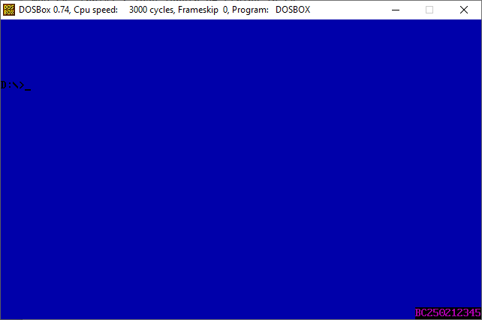
Bc23040998222

