History of English Language
(ENG501)

Virtual University of Pakistan
Table of Contents
Lesson No. | Lesson Title | Topics | Pg. No.
Lesson 01 | Introduction to Language | Topic 1 to 5 | 3
Lesson 02 | What do we Study in the History of a Language? | Topic 6 to 10 | 6
Lesson 03 | Basic Terms related to Language and Language History | Topic 11 to 15 | 9
Lesson 04 | Introduction to English Language | Topic 16 to 20 | 11
Lesson 05 | Importance of History of English Language | Topic 21 to 25 | 14
Lesson 06 | Historical Development of (English) Language and Related Terms-Part-1 | Topic 26 to 30 | 19
Lesson 07 | Historical Development of (English) Language and Related Terms-Part 2 | Topic 31 to 35 | 21
Lesson 08 | Main Stages in the Development of English Language | Topic 36 to 40 | 24
Lesson 09 | Introduction to Old English: Birth of English- Prehistoric to Germanic History | Topic 41 to 45 | 26
Lesson 10 | Some Historical Facts about Old English | Topic 45 to 50 | 30
Lesson 11 | Features of Old English: Pronunciation and Vocabulary | Topic 51 to 55 | 34
Lesson 12 | The Grammar of Old English | Topic 56 to 60 | 36
Lesson 13 | Discussion on Samples of Old English | Topic 61 to 65 | 38
Lesson 14 | Moving towards Middle English: The Norman Conquest (1066-1200) | Topic 66 to 70 | 42
Lesson 15 | The Re-establishment of English in Middle English Period | Topic 71 to 75 | 46
Lesson 16 | Middle English in 14th and 15th Centuries | Topic 76 to 80 | 50
Lesson 17 | Features of Middle English: Writing and Pronunciation | Topic 81 to 85 | 53
Lesson 18 | The Grammar of Middle English | Topic 86 to 90 | 55
Lesson 19 | Vocabulary of Middle English and Moving towards Standardization | Topic 91 to 95 | 58
Lesson 20 | Discussion on Samples of Middle English | Topic 96 to 100 | 62
Lesson 21 | History of English from 1500 to 1650 -Part 1 | Topic 101 to 105 | 67
Lesson 22 | History of English from 1500 to 1650-Part 2 | Topic 106 to 110 | 70
Lesson 23 | History of English from 1500 to 1650-Part 3 | Topic 111 to 115 | 73
Lesson 24 | History of English from 1500 to 1650-Part 4 | Topic 116 to 120 | 78
Lesson 25 | Overview of the Development of Renaissance English | Topic 121 to 125 | 84
Lesson 26 | History of English from 1650 to 1800-Part 1 | Topic 126 to 130 | 87
Lesson 27 | History of English from1650 to 1800-Part 2 | Topic 131 to 135 | 92
Lesson 28 | History of English from1650 to 1800 -Part 3 | Topic 136 to 140 | 97
Lesson 29 | History of English from1650 to 1800 -Part 4 | Topic 141 to 145 | 102
Lesson 30 | Introduction to Modern English | Topic 146 to 150 | 106
Lesson 31 | Standardization of English in the 19th and 20th Century | Topic 151 to 155 | 110
Lesson 32 | 19th and 20th Century English: Tendencies | Topic 156 to 160 | 114
Lesson 33 | Expansion of the General Vocabulary in Today’s English | Topic 161 to 165 | 118
Lesson 34 | English as World Language | Topic 166 to 170 | 124
Lesson 35 | Introduction to American English | Topic 171 to 175 | 130
Lesson 36 | American Vs British English: A Comparison | Topic 176 to 180 | 137
Lesson 37 | Australian English | Topic 181 to 185 | 143
Lesson 38 | South-Asian English | Topic 186 to 190 | 148
Lesson 39 | English language in 21st Century: Features of Englishes | Topic 191 to 195 | 153
Lesson 40 | Future of English | Topic 196 to 200 | 159

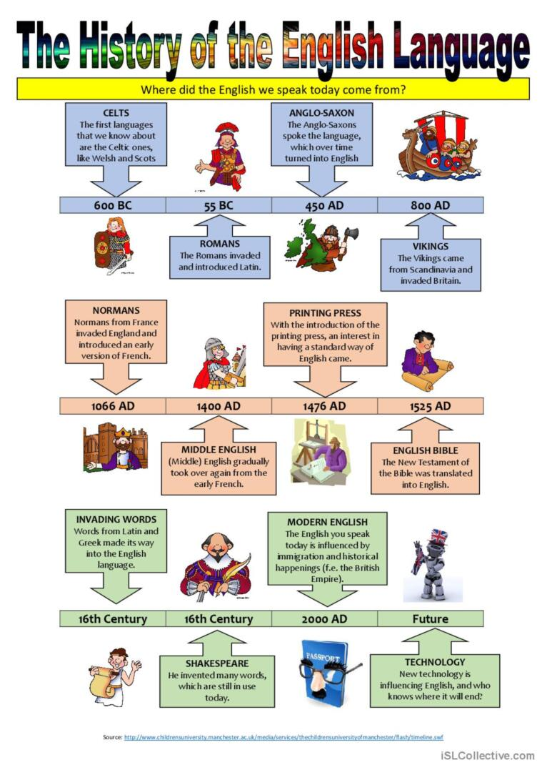

Lesson 01
INTRODUCTION TO LANGUAGE
Topic- 001: What is Language?
Language is a method of human communication, either spoken or written, consisting of the use of words in a structured and conventional way. Language is any nonverbal method of expression or communication.
Language is a system of ordinary/usual spoken or written symbols by means of which human beings, as members of a social group, express themselves. Hence, Language is a tool through which we can express ourselves.
In this lecture, with reference to the following definitions, it is discussed that the term language is used in various ways:
- “The words, their pronunciation, and the methods of combining them used and understood by a community.” (Definition of Language by Merriam-Webster https://www.merriam-webster.com/dictionary/language)
- A systematic means of communicating ideas or feelings by the use of conventionalized signs, sounds, gestures, or marks - the language of mathematics.
- A formal system of signs and symbols (such as calculus in logic) including rules for the formation and transformation of expressions.
- Form or manner of verbal expression; specifically style- the beauty of Shakespeare's language.
- The vocabulary and phraseology belonging to an art or department of knowledge- the language of diplomacy medical language.
- Specific words especially in a law or regulation e.g. the police were diligent in enforcing the language of the law.

Topic – 002: Features of Language
There are certain features of human language that distinguish it from other means of communication.
- Displacement: It is the ability to talk about times, places and people other than the ‘here and now’: to say things which we know to be false. Language is a system of ordinary/usual spoken or written symbols by means of which human beings, as members of a social group, express themselves. Hence, Language is a tool through which we can express ourselves.
- Arbitrariness: There is no “natural” connection between a linguistic form and its meaning. This means that there is no direct link between words and the meanings attached to them. One cannot exactly specify that why an open-bowled shape drinking vessel is known as a ‘cup’.
- Productivity: This is the ability to continually create new expressions and novel utterances. Creativity or open-endedness means that the potential number of utterances in any human language is infinite. New words can be coined in any language. Language is variable

- Cultural Transmission: We may inherit brown eyes and dark hair but we do not inherit language. We acquire a language in a culture. E.g. If a child is born in Pakistan, but within two months since he has been born, he moves to Africa, then, he would be having no clue of Urdu (a language spoken in Pakistan) rather, he would have a good grip on Igbo, Somali, Yoruba (regional langauges spoken in Africa).
- Duality: Human language is organized at two levels or layers simultaneously. We have a physical level at which we can produce individual sounds, like n, b and i. But, beyond this we can organize a variety of sentences. This shows that we can create new innovative words with individual sounds. E.g. (n, i, b) may create bin or nib.

Topic – 003: Elements that Make a Language
The most basic element of a natural language is its words. And, the rather fluid rules governing the usage of the words are generally called its grammar. Firstly, meanings ascribed to words change constantly. Secondly, grammar is no longer thought of simply as a set of rules governing structure and usage. Rather, grammar is seen as a way to describe what can be observed as recurring language patterns and the way those patterns function in different cultures and subcultures.
Words: Generally, a word does not look, sound or feel like the thing it denotes. But, as the word's meaning is already known to both sender and receiver, this does not matter. Whenever a word is used, it represents the thing(s) that it is known to represent. You may have thought that why a ‘needle’ is termed as a ‘needle’ or why a ‘compuer’ is called as a ‘computer’. Why can’t we call a needle a computer or vice versa. Thus, this is a distinctive feature of language and we learn this through our culture/environment.

Grammar: Despite the invaluable assistance provided by the context in which they are used, words still require some further help to do their job effectively. That help comes in the form of grammar. Grammar influences the order in which words appear, and also dictates small but important changes in their form, which add vital temporal or relational information.
Speech and Writing: The knowledge of words and grammar allows the creation of properly organized groups of words, which together with the context can provide very useful information to the receiver. Whatever we speak or write is an amalgamation of words that are put in order through the knowledge of Grammar to convey our messages to the receivers/listeners.

Topic – 004: Birth and Life of a Language
The origin of language in the human species has been the topic of scholarly discussions for several centuries. There is no consensus on the origin or age of human language. Languages are thoroughly organic entities. Each one is complex and versatile, constantly shifting according to the needs of those who use it.
When social, political or environmental changes occur, they create a gap in a language, and allow its individual speakers to use creativity and problem-solving skills to generate a solution. Successful changes to the language are spread quickly and often intuitively. The concept of “language birth” is in fact a misnomer of some sort. The birth involves no pregnancy and delivery stages.
The term refers to a stage (not a point in time) in a divergence process, during which a variety is acknowledged. Post facto is structurally different from its ancestor. For instance, no particular point in time can be associated with the emergence of creoles as separate vernaculars, different from the colonial European languages from which they evolved. Language birth cannot be predicted.
The recognition of separateness is made possible by a cumulative accretion of divergence features relative to an ancestor language, regardless of whether linguists consider contact with other languages.
Topic – 005: Growth and Death of a Language
Languages are thoroughly organic entities. Each one is complex and versatile, constantly shifting according to the needs of those who use it.
When social, political or environmental changes occur, they create a gap in a language, and its individual speakers use creativity and problem-solving skills to generate a solution. Successful changes to the language are spread quickly and often intuitively.
Languages sometimes die out, usually because of competition from another language. When a language officially becomes ‘extinct’ is sometimes difficult to determine: for instance, many histories of English state that Cornish ‘died out’ in 1777 when the last native speaker died. Therefore, languages die when there is no native speaker left to speak that language. But, languages can be preserved and revived.
However, a small number of speakers continued to use and write in the language, and by the middle of the nineteenth century, a revival was in process. The revival gathered pace in the twentieth century, and, according to Ethnologue, a number of people now use it as first language, some 1,000 use it as their everyday language, and 2,000 others speak it fluently.
A language can also become dead in another way. Nobody speaks Classical Latin today as spoken by Julius Caesar, or Classical Greek as spoken by Pericles, or the Old Icelandic spoken by the heroes of the Norse sagas. So Classical Latin and Classical Greek and Old Icelandic are dead languages. But, although dead, they have not died: they have changed into something else. Overall, Languages take birth, live, grow, die, and sometimes are reborn.

Lesson 02
WHAT DO WE STUDY IN THE HISTORY OF A LANGUAGE?
Topic – 006: Origin of a Language
We simply don’t know how language originated. The ability to produce sound and simple vocal patterning (a hum versus a grunt, for example) appears to be in an ancient part of the brain that we share with all vertebrates (fish, frogs, birds). But that isn’t human language.
We suspect that some type of spoken language must have developed between 100,000 and 50,000 years ago, well before written language (about 5,000 years ago). Yet, among the traces of earlier periods of life on earth, we never find any direct evidence or artifacts relating to the speech of our distant ancestors that might tell us how language was back in the early stages. Perhaps because of this absence of direct physical evidence, there has been no shortage of speculation about the origins of human speech.
The Divine Source in the biblical tradition, God created Adam and “whatsoever Adam called every living creature that was the name thereof.” Alternatively, following a Hindu tradition, language came from Sarasvati, wife of Brahma, creator of the universe. Quran also gives us some information regarding the issue. In most religions, there appears to be a divine source that provides humans with language.
The Natural Sound Source: The fact that all modern languages have some words with pronunciations that seem to echo naturally occurring sounds could be used to support this theory. It has also been suggested that the original sounds of language may have come from natural cries of emotion such as pain, anger and joy. We normally produce spoken language on exhaled breath.
The Social Interaction Source: The sounds of a person involved in physical effort, especially when that physical effort involved interaction= hums, grunts, groans. So, human sounds, however they were produced, must have had some principled use within social interaction.
The Physical Adaptation Source: Instead of looking at types of sounds, we can look at the types of physical features humans possess, especially those that are distinct. Some effects of this type of change can be seen in physical differences between the skull of a gorilla and that of a Neanderthal man from around 60,000 years ago.
The Tool-making Source: Some believe that manual gestures may have been a precursor of language.

The Genetic Source: At birth, the baby’s brain is only a quarter of its eventual weight and the larynx is much higher in the throat, allowing babies, like chimpanzees, to breathe and drink at the same time.
Topic – 007: Family of a Language: How does the Family Matter?
Family Trees
In 1786, a British government official in India, Sir William Jones made an observation about Sanskrit. Sanskrit has a wonderful structure; more perfect than the Greek, more copious than the Latin, and more exquisitely refined, yet both of them have a stronger affinity in the roots of verbs and in the forms of grammar, it could possibly have been produced by accident. He suggested that a number of languages from very different geographical areas must have some common ancestor. It was clear, however, that this common ancestor could not be described from any existing records, but had to be hypothesized on the basis of similar features existing in records of languages that were believed to be descendants.
Topic – 008: Stages in the Development of a Language
If we look at change in a language from the perspective of divergent development, we can understand how languages born, grow, change, and develop. To understand the concept, imagine a situation where one language is spoken in two small adjacent villages. In each village the process of language change will take place through the usage. However, the process would be of slow change; and these changes will not be identical in the two villages. In other words language would diverge.
Now let us assume there is some rivalry between the two villages. In this case they will even take pride in these differences and divergences because they would think these differences of language give them their identity and make them unique.Now, if we focus on one of these villages, within the single village speech will remain fairly uniform as the speakers are in constant contact.
Suppose now people of one of the villages do a migration to a far off distant country. Naturally the rate of divergence increases because they no longer influence one another.After a few hundred years these two varieties of the same language spoken in these two villages will become two new and independent languages. In fact they will be no longer mutually intelligible. When two languages have evolved in this way from some earlier single language, we say that they are related. The development of related languages from an earlier parent language can be represented diagrammatically as a family tree. Each of the Romance languages has developed its own morphology and syntax, but they all bear signs of their common origin in Latin.

Topic – 009: Language Families & Family Trees: Examples
The process of divergent development, formation of new languages, occurred many times in human history. Now over six thousand different languages are present in the world.Many of them belong to some group of related languages, and some of these groups are very large, constituting what we can call language families.
Through divergent development a language may itself give rise to further languages by a continuation of the same process (a whole complex family of languages with various branches) some more nearly and some more distantly related.
So, in Mesopotamia there were the East Semitic languages, Babylonian and Assyrian, while around the eastern shores of the Mediterranean were the West Semitic languages, such as Moabite, Phoenician, Aramaic and Hebrew. The East Semitic languages have died out and the most successful have survived. Semitic language is undoubtedly Arabic, a South Semitic. Also Syriac, Ethiopian and Hebrew survived, but the Semitic languages are themselves related to another family, the Hamitic languages, and at some time in the remote past (long before 3000 BC) there must have been a single Hamito-Semitic language, the common ancestor of all Semitic and Hamitic languages.
Topic – 010: Future Possibilities of the Growth of a Language
Following points are discussed under this topic:
- What are the future lines of development of a language and what factors influence the future of a language?
- Which factors need to be considered before coining any new word?
- Do we need Arts and Sciences to be taught in any specific language, let’s say English, to preserve it?
- This process of divergent development leading to the formation of new languages has occurred many times in human history.
- Today there are over six thousand different languages in the world.
- What has been the line of development? And what will be the future line of development? What will be the number in future? How will that be determined? Does the past precedence mean a constant increase in number? No definite answers. Probably past is not going to be a precedent. Why and how? What is the predicted status of English in future? How does it relate to future languages/dialects? What are the future implications of the status of English?

Lesson 03
BASIC TERMS RELATED TO LANGUAGE AND LANGUAGE HISTORY
Topic – 011: Phonology and Historical Development of a Language
How every language including English develops phonologically through times?
Phonology is the study of how sounds are organized and used in natural languages. The phonological system of a language includes, an inventory of sounds and their features, and rules which specify how sounds interact with each other. Considering this, Phonology decides which word is going to be pronounced as what e.g where the sound ‘c’ would be of ‘ka’ or ‘sa’ as representaed in ‘cat’, or ‘censor’. Phonological Development refers to forming and using speech sounds to clearly communicate language. As more sounds of a language are acquired, language becomes clearer; as well as pronunciation, fluency, and intonation improves. There are approximately 44 speech sounds in English. Speech sounds used in combination with other speech sounds produce an oral language.
Intonation involves the following:
- Pitch – how high or low a voice is when producing a sound; the highness or lowness of tone.
- Stress – how low or soft a word is spoken; the force with which a sound is produced.
- Juncture – the pauses or connections between words, phrases, and sentences; the relationship between one sound and the other co-occurring sounds.
Like many other languages, English has a wide variation in pronunciation, both historically and from dialect to dialect. In general, however, the regional dialects of English are largely similar (but not identical in phonological system). Among other things, most dialects have vowel reduction in unstressed syllables and a complex set of phonological features that distinguish stops, affricates and fricatives.
Topic – 012: Morphology and Historical Development of a Language
In Linguistics, morphology is the branch of grammar devoted to the study of the structure or forms of words, primarily through the use of the morpheme construct. It is traditionally distinguished from syntax.A morpheme is a unit of meaning. It does not necessarily relate to the "word count" or "syllable count" of an utterance. The term grammar is often used to refer to morphology (the study of word forms) and syntax (the study of sentence structure) together.
Morphemes are the smallest meaning-bearing units of a language. In linguistics, morphology is the study of words, how they are formed, and their relationship to other words in the same language.It analyzes the structure of words and parts of words, such as stems, root words, prefixes and suffixes. Morphology has two main subdivisions, namely inflection and derivation. Inflection deals with patterns of word structure that are determined by the role of words in sentences. Derivation creates new words with different meanings, e.g. maltreat from treat.Compounding is a combination of nouns, adjectives, verbs, adverbs or prepositions to form complex words.
Topic – 013: Semantics and Historical Development of a Language
In linguistics, semantics is the subfield that is devoted to the study of meaning, as inherent at the levels of words, phrases, sentences, and larger units of discourse. Semantics is also closely linked to the subjects of representation, reference and denotation. Semantics is the field which enables us to differentiate between than and then, meet and meat, etc. Thus, how these meanings are evolved over the time and how the meanings have shifted and became obsolete, all is studied under Semantics.
Why study of meaning is significant in the study of history of a language? Meanings change over time. Changes in meaning are as common as changes in form. Like the latter they can be motivated internally or externally. The most neutral way of referring to change is simply to speak of semantic shift which is to talk of change without stating what type it is. That should and would are originally past tense in meaning is clear from their uses in Old English texts, such as Beowulf.
Topic – 014: Pragmatics and Historical Development of a Language
Pragmatics
It is a subfield of linguistics that studies the ways in which context contributes to the meaning. Unlike semantics, which examines meaning that is conventional or "coded" in a given language, pragmatics studies how the transmission of meaning depends on the context of the utterance, any pre-existing knowledge about those involved, the inferred intent of the speaker, and other factors.
Whereas, semantics studies that how the transmission of meaning depends on structural and linguistic knowledge (e.g., grammar, lexicon etc.) of the speaker and listener. In this respect, pragmatics explains how language users are able to overcome apparent ambiguity, since meaning relies on the manner, place, time etc. of an utterance. E.g, You and your friend are sitting in a room, and he has a wood-made puzzle in his hand and suddenly he says, ‘Can you crack this puzzle?’, he doesn’t mean to make you break the puzzle pieces rather just solve them’.

Topic – 015: Syntax and Historical Development of a Language
Syntax is the arrangement of words and phrases to create well-formed sentences in a language. In linguistics, syntax is the set of rules, principles, and processes that govern the structure of sentences in a given language, specifically word order and punctuation. The term syntax is also used to refer to the study of such principles and processes. In the field of linguistics syntactic change is the change in the syntactic structure of a natural language.
Syntax seems to change more slowly than phonology or morphology. If one regards a language as vocabulary cast into the mold of a particular syntax (with functional items maintaining the basic structure of a sentence and with the lexical items filling in the blanks), syntactic change no doubt plays the greatest role in modifying the physiognomy of a particular language. Syntactic change affects grammar in its morphological and syntactic aspects and is one of the types of change observed in language change.

Lesson 04
INTRODUCTION TO ENGLISH LANGUAGE
Topic – 016: What is English? & The Importance of English Language
It seems sensible to begin an exploration of the English language by determining what we mean by ‘English’. If we want to study its development, its use and its status, it’s worth clarifying exactly what it is. You probably get on perfectly well on a day-to-day basis without ever having to reflect on what exactly comprises the language. Probably many of you use it on a daily basis for various purposes. In other words, speaking and reading English is something you just do without paying much heed.
This is how Dr. Johnson defined it in his dictionary of the English language, composed back in the mid-eighteenth century: “ENGLISH. adj. Belonging to England; thence English is the language of England”. Of course, in today’s world, English is much more than this. English has spread extensively in the two and a half centuries since Johnson’s time.
Modern dictionaries mostly augment Johnson’s definition by adding something about its global scope. The Chambers Dictionary (11th edition): “A Germanic language spoken in the British Isles, USA, most parts of the Commonwealth, etc”. The Oxford English Dictionary extends this slightly further: “Of or relating to the West Germanic language spoken in England and also used in many varieties throughout the world”. All these definitions link the language with the people who speak it now or who spoke it in the past. All are social definitions of the language describing it not in terms of the structure – but in terms of communities. So, the language does not exist as an abstract entity. It is something people actually use.
Topic – 017: English: Whose Language?
In this topic, the following points are discussed:
Who were the original speakers of English and who are the speakers now?
Whose Language is it? English people speak it but that is not the exact answer as it is spoken in many parts of the world. The English speak it. Yes, but who else speaks it? A growing perception is that English is now the world’s lingua franca that operates as a means of communication for people across the globe who do not share a mother tongue and live in a globalized society,may be the language of England. English people speak it. It is spoken in many parts of the world.
- Who owns it?
- Somebody who is born in England
- What kind of experience he has?
- Do you learn it as your native language or second language?
Compare this experience with the people who were brought up in England. How does it shape and form their identities? Think of your identity and other’s identity. Various dialects decide not only your identity but also others for example American English, Australian English, Ireland English, Indian English, Paklish or Pinglish etc. To belong to an upper class or lower class, your language will also decide this question. The languages also decide the social status of a man. For instance, in our society, we long for the people who can speak English in a fluent way.
Topic – 018: Where is English Spoken Today?
Today, English is the second or third most popular mother tongue in the world, with an estimated 350-400 million native speakers. But, crucially, it is also the common tongue for many non-English speakers over the world. A quarter of the globe’s population - maybe 1½-2 billion people can understand it. But best recent estimates of first languages suggest that Mandarin Chinese has around 800-850 million native speakers, while English and Spanish both have about 330-350 million each.
Topic – 019: Facts and Figures about English Language
Over 400 million people use the English vocabulary as a mother tongue, only surpassed in numbers, but not in distribution by speakers of the many varieties of Chinese. Over 700 million people speak English as a foreign language. Did you know that of all the world's languages (over 2,700) English is arguably the richest in vocabulary; and that the Oxford English Dictionary lists about 500,000 words, and there are a half-million technical and scientific terms still un-catalogued?
Three-quarters of the world's mail, telexes and cables are in English. More than half of the world's technical and scientific periodicals are in English. English is the medium for 80% of the information stored in the world's computers. English is the language of navigation and aviation. Five of the largest broadcasting companies in the world (CBS, NBC, ABC, BBC and CBC) transmit in English, reaching millions and millions of people all over the world.
Topic – 020: Significance of English Language in Pakistani Context
Pakistan was part of a large area in South Asia which had been under the British control for about ninety years, from the mid-nineteenth century onwards. During the period of British control, English was the main language of administration and it became fairly widely known through formal education. Also during that period, several other languages of the region were used as identity symbols for various ethno-nationalist and religious movements.
Because English had not been associated with any of these movements it could be seen as neutral in relation to them. Ideologically useful to the post-independence government of Pakistan trying to unify a newly established political entity while at the same time carrying on the day-to-day tasks of education and administration. These factors favored keeping English as an official language. However, its retention was strongly opposed by religious parties ‘who felt that maintaining the status of English symbolized a new form of colonization’ (Mahboob and Ahmar, 2008, p. 245). They wanted an Islamic state with a local language. In response, successive governments in the first thirty years of the postcolonial period passed recommendations to develop and elevate the status of other languages, Urdu in particular, but did little to implement them before 1977.
General Zia-ul-Haq paved the way for more comprehensive Islamisation and an attempt at Urdunisation in all domains. For example, in 1978 all schools were instructed to move towards Urdu as sole medium of instruction. Schools for the elite continued to teach in English and the demand for English medium education grew, even – covertly – among government supporters. However, soon there was realization that they had embarked on this policy too hastily and
without adequate planning. Language policy in subsequent governments has also promoted English. However, according to Article 251 of the Constitution of the Islamic Republic of Pakistan, Urdu should be preserved as an official language having the status of the national language of Pakistan.
For more detailed information, watch this supplementary video:
https://www.youtube.com/watch?v=YEaSxhcns7Y

Lesson 05
IMPORTANCE OF HISTORY OF ENGLISH LANGUAGE
Topic – 021: How to Study the History of a Language? Some Samples.
Language in general is ability inherent in us. Specific languages such as English are systems that result from that ability. We can know the underlying ability only through studying the actual languages that are its expressions. Thus, one of the best reasons for studying languages is to find out about ourselves, about what makes us persons.
A good approach to studying languages is the historical one. To understand how things are, it is often helpful to know how they got to be that way. The orthographic joke of George Bernard Shaw is very relevant to share here. According to him, in English fish might be spelled ghoti (gh as in enough, ‘o’ as in women, and ‘ti’ as in nation). The only way to understand the anomalies of spelling is to study the history of language. Present-day pronunciation and meaning of Cupboard do not suggest ‘a board for cups’ so this is also something we need history to explain.

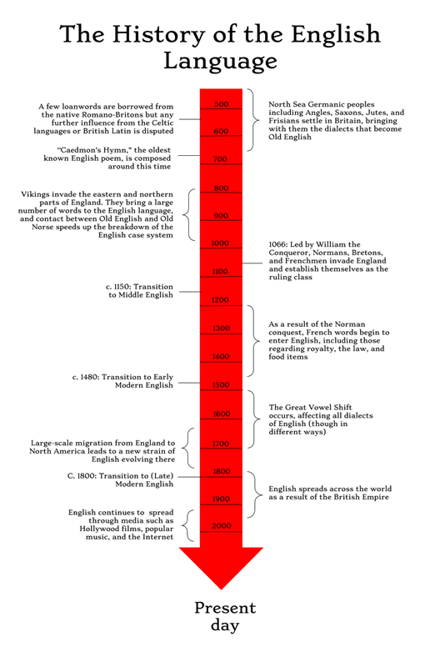

Topic – 022: Why and How to Trace the History of English Language?
Why and how linguists have attempted to trace and document the history of (English) language? To what extent is modern-day English the same language as that introduced to the British Isles one and a half millennia ago? Some of the vocabulary is no longer regularly used in contemporary English. There is indeed a fair amount of continuity between Old English and Modern English, albeit that surface features such as spelling conventions have changed quite considerably.
Topic – 023: Are Periods in the History of English Language Fixed?
In this topic, the following points are discussed:
- To what extent is modern-day English the same language as that introduced to the British Isles one and a half millennia ago?
When the language was spoken in Europe, it is known as pre -Old English.
Key Events in the Old English Period
- 449 Angles, Saxons, Jutes, and Frisians began to occupy Great Britain.
- 597 Saint Augustine of Canterbury arrived in England to begin the conversion.
- 730 The Venerable Bede produced his Ecclesiastical History of the English People, recording the early history of the English people.
- 787 The Scandinavian invasion began with raids and in 865 they occupied northeastern Britain and began a campaign to conquer all of England.
- 871 Alfred became king of Wessex, retaking the city of London, securing the kingship of all England for himself and his successors, and producing or sponsoring the translation of Latin works into English.
- 991 The English were defeated at the Battle of Maldon.
- 1000 The manuscript of the Old English epic Beowulf was written about this time.
- 1016 Canute became king of England, establishing a Danish dynasty in Britain.
- 1042 The Danish dynasty ended with the death of King Hardicanute, and Edward the Confessor became king of England.
- 1066 Edward the Confessor died and was succeeded by Harold, last of the Anglo-Saxon kings, who died at the Battle of Hastings while fighting against the invading
army of William, duke of Normandy, who was crowned king of England on
December 25.
- Key events in the Middle English period The Middle English Period 1100-1500
- 1066 The Normans conquered England, replacing the native English nobility with Anglo-Normans and introducing Norman French
- 1204 King John lost Normandy to the French, beginning the loosening of ties between England and the Continent.
- 1258 King Henry III issued the first English-language royal proclamation since the Conquest
- 1337 The Hundred Years’ War began and lasted until 1453, promoting English nationalism.
- 1348 -50 The Black Death killed an estimated one-third of England’s population.
- 1362 The Statute of Pleadings was enacted, requiring all court proceedings to be conducted in English.
- 1381 The Peasants’ Revolt as the first rebellion of working-class people
- 1400 Geoffrey Chaucer died, having produced a highly influential body of English poetry.
- 1430 The Chancery office (where legal records were deposited) began record- keeping in a form of East Midland English, which became the written standard of English.
- 1476 William Caxton brought printing to England
- 1497 John Cabot sailed to Nova Scotia, foreshadowing English territorial expansion.
- Key events in the early modern period THE Early Modern English Period 1500-1800
- 1534 The Act of Supremacy
- 1549 The Book of Common Prayer was adopted and became an influence on English literary style.
- 1558 At the age of 25, Elizabeth I became queen of England.
- 1590– 1611 William Shakespeare wrote the bulk of his plays.
- 1600 The East India Company (the British Raj in India)
- 1604 Robert Cawdrey published first English dictionary
- 1607 Jamestown, Virginia, was established as the first permanent English settlement in America.
- 1642–48 The Puritan Revolution overthrew the monarchy and established a military dictatorship, which lasted until the Restoration of King Charles II in 1660.
- 1660 The Royal Society was founded to promote scientific knowledge.
- 1670 Hudson’s Bay Company=trade= settlement in Canada.
- 1688 The Glorious Revolution
- 1702 The first daily newspaper was published in London
- 1719 Daniel Defoe published
- Robinson Crusoe is sometimes identified as the first modern novel in English.
- 1755 Samuel Johnson published his Dictionary of the English Language
- 1775–83 The American Revolution resulted in the foundation of the first independent nation of English speakers outside the British Isles.
- 1788 The English first settled Australia near modern Sydney.
- Key Events In The Late Modern Period Late Modern English -1800 to Present (A time of expansion in geography, in speakers, and in the purposes for which it is used).
- 1805 Battle of Trafalgar and British naval supremacy.
- 1806 The British occupied Cape Colony in South Africa
- 1828 Noah Webster’s American Dictionary of the English Language was published.
- 1840 In New Zealand sovereignty was given to the British crown.
- 1857 A proposal at the Philological Society of London led to work that resulted in the New English Dictionary (1928), reissued as the Oxford English Dictionary
- 1861–5 The American Civil War abolished slavery
- 1898 The four-month Spanish-American War and United States as a world power
- 1906 The first public radio broadcast was aired.
- 1914 – 18 World War I
- 1922 The British Broadcasting Company was established
- 1927 The first motion picture with spoken dialog, The Jazz Singer, was released.
- 1936 The first high-definition television service was established by the BBC
- 1939–45 World War II
- 1947 British India was divided into India and Pakistan
- 1983 The Internet was created.
- 1992 The first Web browser for the World Wide Web was released.
Topic – 024: Sample Texts from Different Periods of English Language
A lot of linguistic change occurred in English over the times. The extent to which the English language has changed in the past thousand years can be seen by looking at a few passages of English from different periods. In order to understand how change has taken place over time, it is convenient to see the same material handled by different writers at different points in history.
So, in this session a short passage from the Bible is taken as a sample text. It is then examined as how it has been translated into English at different times. In fact the passage is from chapter XV of the Gospel. The first version that is taken is from a twentieth-century translation, the New English Bible, published in 1961. Then the same passage is examined as it appeared in the famous King James Bible of the year 1611. Thirdly, the same passage is taken as it is rendered by John Wycliffe, the first person to translate the entire Bible into English. He died in 1384, and his translation probably dates from the last few years of his life. Through a comparison and contrast of various linguistic features of this same text taken from three different times in history, it is exhibited how English language has changed over times semantically, syntactically and orthographically.
Topic – 025: Other Texts of English Language
A lot of linguistic change has occurred in English horizontally -over space. When constant communication takes place among the people speaking a language, individual differences become merged in the general speech of the community. This means that English language has varieties that differ from each other as we examine them being used at different places. To exhibit this point various texts are used in this session. Text 1 is a ‘cowboy poem’ from the Arizona region. Gail I. Gardner wrote it in 1917 and it became an immediate favorite, recited and put to music by others. Its distinctive features are discussed in this session.

This is a story of two cowboys who run into the devil on their way home from a bar. We find it almost all intelligible, although there are one or two dialect words (some of them related specifically to their profession) which might be a little obscure. The second text used in this session to elaborate the points under discussion is a poem by Robert Alan Jamieson who was born in 1958 in the crofting community of Sandness on Shetland. His poem ‘Varg’, with a translation ‘The difficult and messy business of living’ is used to exhibit how English language used in a particular region and community can be very different.
Before we begin our discussion related to the history of English language , the following material will provide a quick glance at the historical perspective:
https://www.youtube.com/watch?v=aEH2GkuRIHs

Lesson 06
HISTORICAL DEVELOPMENT OF (ENGLISH) LANGUAGE AND RELATED TERMS-PART-1
Topic – 026: Types and Possibilities of Changes in (English) Language
Language is always changing, evolving, and adapting to the needs of its users. Why Does Language Change? There are several reasons. First, because the needs of speakers change. New technologies, new products, and new experiences require new words. For example, Cell Phone, Text Message, email, Personal Computer, Reboot, Colonoscopy, etc. are all the new words coined as per their use. Consider texting: originally it was called text messaging, because it allowed one person to send another text rather than voice messages by phone. Another reason is that no two people have had exactly the same language experience. For example, the abbreviations like FOMO, DM, TTYL have also been coined due to technological advancements and the trend of writing long flowery sentences has been changed to writing more concise texts.
We all know a slightly different set of words and constructions, depending on our age, job, education level, country etc. We pick up new words and phrases from all the different people we talk with, and these combine to make something new and unlike any other person's particular way of speaking. Was English more elegant in the past or is it today? The fact that language is always changing doesn't mean it's getting worse; it's just becoming different. Language will never stop changing; it will continue to respond to the needs of the people who use it. Like everything else in nature, the English language is a work in progress.
Topic – 027: Synchronic Changes in Language
Synchronic Linguistics is the study of a language at a given point in time. A synchronic approach (from Greek συν- "together" and χρόνος "time") considers a language at a moment in time without taking its history into account. The time studied may either be the present or a particular point in the past; synchronic analyses can also be made of dead languages, such as Latin. Synchronic linguistics is contrasted with diachronic linguistics (or historical linguistics), the study of a language over a period of time.
Topic – 028: Synchronic Changes in Language Part 2
Synchrony and Diachrony are: two different yet complementary viewpoints in linguistic analysis. One can approach all different aspects of language, such as grammar, syntax, semantics, phonology etc., from two different points of view. Synchronic linguistics tries to understand the functioning of language at a single point of time, without reference to earlier or later stages. Synchronic linguistics, now usually precedes the study in terms of diachronic linguistics.
Topic – 029: Tracing Synchronic Changes in English
Scope of a Synchronic Study
A synchronic linguist may focus on grammatical phenomena such as word order, negation, and features of clause-linking. S/he may take a specific interest in the mechanisms by which change is introduced into the language system and diffused through communities of speakers.
There can be a cross-linguistic and typological comparison. This can involve a close investigation of specific grammatical phenomena in various languages, with a view to identifying the precise details of where they differ or are the same may. It may focus on investigating the wider patterns of linguistic variation and language typology.
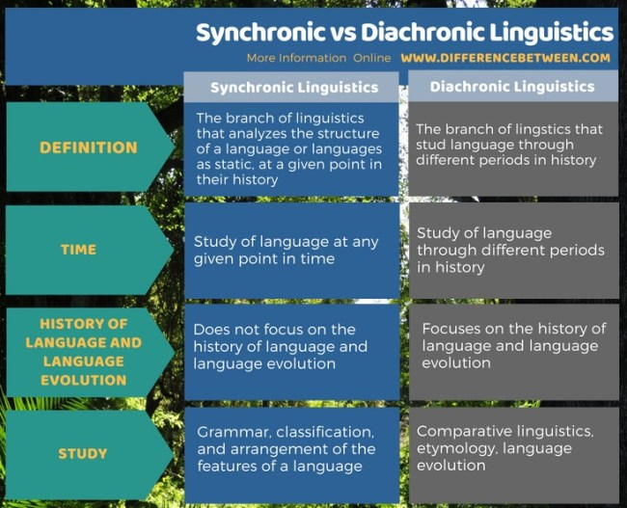

Topic – 030: National and International Context to Exemplify Synchronic Changes
How synchronically English is different at phonological level? It is exemplified that Australian English has the same inventory of phonemes as RP, but nearly all the vowels are realized differently. Different instances are given from Australian Phonology, for example, /a/ and /e/ are closer than in RP, so that to English ears Australian pan sounds like pen. In the same way a comparison between BrE & AmE Pronunciation is made. For example sound /r/ in GA and RP is compared. In GA the letter ‘r’ is pronounced in all positions, but in RP it is only pronounced before vowels (e.g. very, paragraph).This session also provides a list of Cultural & Ethnic American Eng. Varieties which include the following:
  - African American Vernacular
  - Cajun Vernacular
  - Hawain Pidgin
  - Latino Vernacular Englishes
  - Chicano English
  - Miami English etc.
- A list of Regional and Local varieties is also provided which includes:
  - Eastern New England
  - Boston
  - Rhode island
  - Southeast Super region
  - Midland etc.
For more detailed understanding, watch this supplementary video.
https://www.youtube.com/watch?v=SpjTR-nKZK8

Lesson 07
HISTORICAL DEVELOPMENT OF (ENGLISH) LANGUAGE AND RELATED TERMS-PART 2
Topic – 031: Diachronic Changes in Language
Diachronic linguistics is one of the two main temporal dimensions of language study identified by Swiss linguist Ferdinand de Saussure. Diachronic linguistics is the scientific study of language change over time. Principal concerns include: to describe and account observed changes in particular languages Diachronic linguistics is the study of language through different periods in history. It maps the shifts and fractures and mutations of languages over the centuries. In gross outline, it is similar to evolutionary biology, which maps the shifts and transformations of rocks.
Topic – 032: Diachronic Changes in (English) Language: Some Terms
In this topic, the following points are discussed:
- Scope and Concerns:
  - To describe and account for observed changes in particular languages
  - To reconstruct the pre-historic languages and to determine their relatedness and grouping them into language families
  - To develop general theories about how and why language changes
  - To describe the history of communities
  - To study the history of words, i.e. etymology
- The Family Tree Model
- First attempt at depicting the relationship between languages.
- It has assumptions:
- The Regularity Hypothesis
- The Relatedness Hypothesis

The Wave Model
The idea is that instead of having definite delineations between languages, there are “waves” of linguistic change which affect some languages but not others, and tend to spread out to other languages nearby. This is a necessary prerequisite for doing serious work on the diachronic development of a language.
Language Contact
The social and linguistic phenomenon by which speakers of different languages interact with one another, leading to a transfer of linguistic features
- A major factor in language change
- Prolonged language contact generally leads to bilingualism or multilingualism.
Topic – 033: Tracing Diachronic Changes in English-Examples
Syntactic Change
Syntactic change is a type of natural language variation that refers to changes in the grammar of a language. This change can be caused or facilitated both by Socio- cultural factors and by language-internal factors. A syntactic change generally unfolds much more slowly, sometimes taking hundreds of years to run its course to completion. Drift is used in linguistics to describe a slow and imperceptible change in a given direction. One of the best known instances of this is the gradual development from synthetic to analytic in the history of English.
Synthetic vs. analytical languages
An analytic language is a language that organizes words and grammar by a strict word order instead of inflections, or word endings that show grammar. In Chinese, sentences are mostly in the SVO (subject-verb-object) word order. So the sentence must be "I eat noodles", not "I noodles eat" or "eat I noodles". What is important is that all the words are in the correct order.
All languages are either synthetic or analytical. A synthetic language shows grammatical relationships through inflectional change in the words, whereas an analytical language represents the grammatical relationships through word order. English was once synthetic, but over time has become an analytical language.
Masculine, Feminine and Neuter
In Old English, gender was applicable to words as well as their case. To understand this concept, it is important to know that when English uses gender, they are not implying that everything is a boy and girl or vice versa, but simply referring to class synthetic languages. English no longer uses grammatical genders, and only uses biological gender in the case of him, her and it. Other languages however still use grammatical gender, for example French. The process of analogy
occurs when a particular ending or rule becomes so popular that it becomes the 'normal' choice and all new words follow the same process when conjugated.
Topic – 034: Diachronic Changes: Some Examples from History
Semantic Change is the evolution of word usage—usually to the point that the modern meaning is radically different from the original usage. In diachronic linguistics semantic change is a change in one of the meanings of a word. Every word has a variety of senses and connotations, which can be added, removed, or altered over time.
Topic – 035: Marking the Axis Synchronically and Diachronically
What is synchronic? What is diachronic? Greek Etymology of these Terms: The -chron- part they share comes from Greek khronos, meaning "time" (or "pertaining to time“).The prefix syn- means "together", "with" The prefix dia- means "through” Both can be used to describe an approach, a phenomenon or an activity by analyzing its behaviour with regard to a timeline. Examples such as of the game of chess are used in this session to make the difference clear. Linguistics, in Saussure's time, approached the problem of the multiplicity of languages by trying to trace each of them back to a handful of common sources (like evolutionary biologists).

Lesson 08
MAIN STAGES IN THE DEVELOPMENT OF ENGLISH LANGUAGE
Topic – 036: Why and How to Study English Language through Division in Stages
Why should the history of English be studied? English, with all its vagaries and inconsistencies, remains the single most important and influential language in today’s world. Throughout history, it has repeatedly found itself in the right place at the right time. English-speaking Britain was the leading colonial nation in the 17th and 18th Century, as well as the leader of the Industrial Revolution in the 18th and 19th Century.
In the late 19th and 20th Century, English-speaking America was the leading economic power, and was also at the forefront of the electronic and digital revolution of the late 20th Century. But, it has also proved itself the most flexible and resilient of languages, remarkable for its ability to adopt and absorb vocabulary from other cultures. Its continued vitality is evidenced by the number and diversity of its worldwide variations today.
Topic – 037: Confusion and Issues Related to Division in Stages
There are many books and many websites describing the journey of the English language from its ancient origins to today’s dynamic and powerful communication tool. There are varied purposes, varied intended readerships, and varied patterns. Some follow it in minute and excruciating technical details and some are brief one-page summaries. One may wonder, do we really need another? So, it is established that it is significant to study the history of English language. But how can we study it? We need to trace the development of the English language from one stage to the other. The evolution of English in the 1,500 years of its existence in England has been an unbroken one. The topic shows the development of the English language from its Indo-European origins, through Old English and Middle English to Early Modern English and Late Modern English. Like all divisions in history, the periods of the English language are matters of convenience and the dividing lines between them purely arbitrary.
Topic – 038: Main Stages in the Development and History of English Language: Division of Early Stages
The recorded history of the English language begins, not on the Continent, where we know its speakers once lived, but in the British Isles, where they eventually settled. During the period when the language was spoken in Europe, it is known as pre-Old English for it was only after the English separated themselves from their Germanic cousins that we recognize their speech as a distinct language and begin to have records of it.

English is a West Germanic language that originated from Anglo-Frisian dialects brought to Britain in the Mid. 5th to 7th centuries AD by Germanic invaders and settlers from what is now northwest Germany, west Denmark and the Netherlands. The Middle English Period ranges from 1100 to 1500.The beginning and ending dates of the Middle English period, though somewhat arbitrary, are two points in time when ongoing language changes became particularly noticeable.
This includes grammatical changes about 1100 and pronunciation changes about 1500. The term middle indicates that the period was a transition between Old English and early Modern English. The beginning of the period is marked with The Normans conquest of England in 1066 replacing the native English nobility with Anglo-Normans and introducing Norman French as the language of government in England. Towards the end of this period in 1476 William Caxton brought printing press to England which had a strong impact on English in the coming times.
Topic – 039: Main Stages in the Development and History of English Language: Division of Later Stages
The Early Modern English Period (1500-1800) was transformative for both England and the language. Sixteenth to eighteenth centuries were a time of revolutionary development opening the way for English to become a world language. Towards the end (1775 – 83) the American Revolution resulted in the foundation of the first independent nation of English speakers outside the British Isles. 1788 The English first settlement/settled in Australia near modern Sydney. Late Modern English (1800 to Present) the history of English since 1800 has been a story of expansion in geography, in speakers, and in the purposes for which English is used. Geographically, English was spread around the world, first by British colonization and empire-building, and more recently by American activities in world affairs.
Topic – 040: Main Stages in the Development and History of English Language: Movement from Recent to Future Stages
What is the current stage of the development of English language? In today’s world, English can be seen everywhere. The status of English can be observed easily, we need no evidence for the precedence. English has spread to many parts of the word. What are the possibilities for future? We have various varieties of English for example, American English, South Asian English like, Pakistani, Indian, Indonesian English etc. How can we relate the divergent spread of English and the future of English? English has spread into so many identities and diversities. Should we talk about “World English” or “World Englishes”? This leads to a very serious concerns or questions*/ . Would English should be one language or many varieties should be considered one or other varieties and this is very difficult to answer. What is the role of science, technology and media in future developments? Both the kind of push and pull forces are there. But we can say with surety that English will be a language of future.

For more detailed information, watch this supplementary video:
https://www.youtube.com/watch?v=iSSTv8-2358

Lesson 09
INTRODUCTION TO OLD ENGLISH: BIRTH OF ENGLISH- PREHISTORIC TO GERMANIC HISTORY
Topic – 041: The Language in England before English
English was introduced in the middle of the fifth century and has a career extending through 1,500 years only. What we know of the earliest inhabitants of England is derived wholly from the material remains. The classification of these inhabitants is consequently based upon the types of material culture that characterized them in their successive stages. Before the discovery of metals, human societies were dependent upon stone. Generally speaking, the Stone Age is thought to have lasted in England until about 2000 B.C., although the English were still using some stone weapons in the battle of Hastings in 1066.
Stone Age gradually gave way to bronze, as bronze was eventually displaced by iron about 500 or 600 B.c.1. Because the Stone Age was of long duration, it is customary to distinguish between an earlier and a later period, known as the Paleolithic (Old Stone) Age and the Neolithic (New Stone) Age. Paleolithic humans were the earliest inhabitants of England. They were short of stature, were short-legged, with low foreheads and poorly developed chins. Lived in the open under rock shelters or, later, in caves.
The humans whose remains are found in the latest Paleolithic strata are distinguished by a high degree of artistic skill. But representations on pieces of bone or the walls of caves tell us nothing about the language of their designers. “Neolithic” is likewise a convenient rather than scientific term. They possessed a superior kind of stone implement, and generally a higher culture. It was a dark race of slightly larger stature than the Paleolithic population.
The Celtic languages in England had two divisions: Gaelic or Goidelic branch and the Brythonic branch. Celtic was probably the first Indo-European tongue to be spoken in England. One other language, Latin, was spoken rather extensively for a period of about four centuries before the coming of English.
Topic – 042: The History of Roman Conquest
It was in A.D. 43 that the Emperor Claudius decided to undertake the actual conquest of the island. With the knowledge of Caesar’s experience behind him, he did not underestimate the problems involved. Accordingly an army of 40,000 was sent to Britain and within three years it had subjugated the peoples of the central and southeastern regions. Subsequent campaigns soon brought almost all of what is now England under Roman rule.

The progress of Roman control was not uninterrupted. A serious uprising of the Celts occurred in A.D. 61 under Boudicca (Boadicea), the widow of one of the Celtic Chiefs, and 70,000 Romans and Romanized Britons are said to have been massacred. Under the Roman Governor Agricola (A.D. 78–85) the northern frontier was advanced to the Solway and the Tyne, and the conquest may be said to have been completed.
The Romans never penetrated far into the mountains of Wales and Scotland. Eventually they protected the northern boundary by a stone wall stretching across England at approximately the limits of Agricola’s permanent conquest. The district south of this line was under Roman rule for more than 300 years.
Topic – 043: Romanization of the Island
It was inevitable that the military conquest of Britain should have been followed by the Romanization of the province. Where the Romans lived and ruled, there Roman ways were found. Four great highways soon spread fanlike from London to the north, the northwest, the west, and the southwest, while a fifth cut across the island from Lincoln to the Severn.
Numerous lesser roads connected important military or civil centers or branched off as spurs from the main highways. Several hundred towns, with their Roman houses and baths, temples, and occasional theaters, testify to the introduction of Roman habits of life. The houses were equipped with heating apparatus and water supply, their floors were paved in mosaic, and their walls were of painted stucco—all as in their Italian counterparts.
Roman dress, Roman ornaments and utensils, and Roman pottery and glassware seem to have been in general use. By the third century, Christianity had made some progress in the island, and in A.D.314, bishops from London and York attended a church council in Gaul. Under the relatively peaceful conditions that existed everywhere except along the frontiers, where the hostile penetration of the unconquered population was always to be feared, there is every reason to think that Romanization had proceeded very much as it had in the other provinces of the empire. The difference is that in Britain, the process was cut short in the fifth century.
Topic – 044: The Latin Language
Among the other evidences of Romanization must be included the use of the Latin language. A great number of inscriptions have been found, all of them in Latin. The majority of these proceeds no doubt from the military and official class and, being in the nature of public records, were therefore in the official language. They do not in themselves indicate a widespread use of Latin by the native population. Latin did not replace the Celtic language in Britain as it did in Gaul.

Its use by native Britons was probably confined to members of the upper classes and some inhabitants of the cities and towns. Occasional graffiti scratched on a tile or a piece of pottery, apparently by the worker who made it, suggest that in some localities Latin was familiar to the artisan class. Outside the cities there were many fine country houses, some of which were probably occupied by the well-to-do. The occupants of these also probably spoke Latin.
Tacitus tells us that in the time of Agricola, the Britons, who had hitherto shown only hostility to the language of their conquerors, now became eager to speak it. At about the same time, a Greek teacher from Asia Minor was teaching in Britain, and by A.D. 96 the poet Martial was able to boast, possibly with some exaggeration, that his works were read even in this far-off island.
On the whole, there were certainly many people in Roman Britain who habitually spoke Latin or upon occasion could use it. But its use was not sufficiently widespread to cause it to survive, as the Celtic language survived the upheaval of the Germanic invasions. Its use probably began to decline after 410, the approximate date at which the last of the Roman legions were officially withdrawn from the island.
Topic – 045: Germanic Conquest and Anglo-Saxon Civilization
About the year 449, an event occurred that profoundly affected the course of history. In that year, as traditionally stated, began the invasion of Britain by certain Germanic tribes, the founders of the English nation. The events of these years are wrapped in much obscurity. But we can form a general idea of their course.
The traditional account of the Germanic invasions goes back to Bede and the Anglo- Saxon Chronicle. Bede in his Ecclesiastical History of the English People, completed in 731, tells us that the Germanic tribes that conquered England were the Jutes, Saxons, and Angles. The location of the Germanic tribes that invaded England is still a matter of dispute. The above map presents the traditional view, based upon the rather late testimony (eighth century) of Bede. An alternative opinion places the Angles on the middle Elbe and the Jutes near the Frisians.
Anglo-Saxon Civilization
It is difficult to speak with surety about the relations of the newcomers and the native population. In some districts where the inhabitants were few, the Anglo-Saxons probably settled down beside the Celts in more or less peaceful contact. In others, as in the West Saxon territory, the invaders met with stubborn resistance and succeeded in establishing themselves only after much fighting.
Many of the Celts undoubtedly were driven into the west and sought refuge in Wales and Cornwall, and some immigrated across the Channel to Brittany. In any case, such civilization as had been attained under Roman influence was largely destroyed. The Roman towns were burnt

and abandoned. Town life did not attract a population used to life in the open and finding its occupation in hunting and agriculture.
In time, various tribes combined either for greater strength or, under the influence of a powerful leader, to produce small kingdoms. Seven of these are eventually recognized, Northumbria, Mercia, East Anglia, Kent, Essex, Sussex, and Wessex, and are spoken of as the Anglo-Saxon Heptarchy. But the grouping was not very permanent. In early seventh century Northumbria gained political supremacy over a number of the other kingdoms and held an undoubted leadership in literature and learning as well. In the eighth century this leadership passed to Mercia. Finally, in the ninth century, Wessex under the guidance of Egbert (802–839) began to extend its influence, until in 830 all England, including the chieftains of Wales, acknowledged Egbert’s over lordship. The result can hardly be called a united kingdom, but West Saxon kings were able to maintain their claim to be kings of all the English and under Alfred (871–889) Wessex attained a high degree of prosperity and considerable enlightenment.
For more detailed information, watch these supplementary videos:
https://study.com/academy/lesson/history-of-the-english-language-influences-development.html
https://www.youtube.com/watch?v=aEH2GkuRIHs

Lesson 10
SOME HISTORICAL FACTS ABOUT OLD ENGLISH
Topic – 046: The Names: English and England
The Celts called their Germanic conquerors Saxons indiscriminately, probably because they had had their first contact with the Germanic peoples through the Saxon raids on the coast. Early Latin writers, following Celtic usage, generally call the Germanic inhabitants of England Saxons and the land Saxonia. But soon the terms Angli and Anglia occur beside Saxons and refer not to the Angles individually but to the West Germanic tribes generally.
Æthelbert, king of Kent, is styled rex Anglorum by Pope Gregory in 601.A century later Bede called his history the Historia Ecclesiastica Gentis Anglorum. In time, Angli and Anglia become the usual terms in Latin texts. From the beginning, however, writers in the vernacular never call their language anything but Englisc (English). The word is derived from the name of the Angles (OE Engle) but is used without distinction for the language of all the invading tribes.
In like manner, the land and its people are early called Angelcynn (Angle-kin or race of the Angles), and this is the common name until after the Danish period. From about the year 1000 England (land of the Angles) begins to take its place. The name English is thus older than the name England. It is not easy to say why England should have taken its name from the Angles. Possibly a desire to avoid confusion with the Saxons who remained on the continent and the early supremacy of the Anglian kingdoms were the predominant factors in determining usage.

Topic – 047: Time Period of Old English
In this topic, the following points are discussed:
- How many main divisions?
- Are clear-cut divisions possible?
The Origin and Position of English
The English language of today is the language that has resulted from the history of the dialects spoken by the Germanic tribes who came to England. It is impossible to say how much the speech of the Angles differed from that of the Saxons or that of the Jutes. The differences were certainly slight. Even after these dialects had been subjected to several centuries of geographical and political separation in England, the differences were not great.
English mainly belongs to the Low West Germanic branch of the Indo-European family. This means that it shares certain characteristics common to all the Germanic languages. The period from 450 to 1150 is known as Old English. It is sometimes described as the period of full inflections, because during most of this period the endings of the noun, the adjective, and the verb are preserved more or less unimpaired. This period was over in the twelfth century. From 1150 to 1500, the language is known as Middle English.
Topic – 048: Facts & Events of Old English Period
By 700, the Anglo-Saxons had occupied most of England (the exceptions being Cornwall and an area in the north-west) and also a considerable part of southern Scotland. Wales remained a British stronghold. Anglo-Saxons and Britons: Debate continues as to the exact nature of the Anglo-Saxon settlements. The Germanic language of the incomers became the dominant one, and there are few traces of Celtic influence on Old English. The number of Celtic words taken into English in the whole of its history has been very small. The names of some English towns were taken over from the Britons, for example London and Leeds. Among county names, Kent and Devon are Celtic.
These few Celtic words in Old English were merely a drop in the ocean. Even in English place-names, where Old British left its biggest mark, Celtic forms are far outnumbered by English ones and only in areas where the Anglo-Saxons penetrated late, Celtic names are common for villages. There are an enormous number of place-name elements of English derivation.
Topic – 049: Historical Facts and Events of Old English…continues
The failure of Old British to influence Old English to any great extent does not mean that the Britons were all killed or driven out. There is in fact evidence that a considerable number of Britons lived among the Anglo-Saxons. But, their language quite possibly had no prestige compared with that of the Anglo-Saxons. Whether or not the prestige associated with the language of political elite would have been sufficient in itself to achieve the replacement of Old British with Old English remains an open question.
The Old English word ‘wealh’, which originally meant ‘foreigner’, seems usually to have been used to mean ‘Briton, Welshman’, but is also used to mean ‘servant, slave’ in some texts, which illustrates both the survival of Britons among the Anglo-Saxons and their low status. Whatever their exact origins, these groups were in any case closely related in language and culture, and eventually came to regard themselves as one people. For example, the word Engle ‘the Angles’ came to be applied to all the Germanic settlers in Britain. And, the related adjective Englisc was similarly applied to all these peoples and their language, not just to the Angles.
Political union came slowly.

In the early days there was a medley of petty kingdoms, and some of their names are preserved in the modern counties. So, Essex, Middlesex and Sussex were the realms of the East, Middle and South Saxons. Norfolk and Suffolk were the north and south folk of the East Angles. Different kings managed to establish their sovereignty over other kingdoms at various times, but these dominations were often personal and temporary. In very broad terms, we can see a gradual shift southwards of the centers of power and civilization.
In the seventh century, Northumbria was very powerful, and was a great center of learning. In the eighth century, this leadership passed to Mercia, and in the ninth century to Wessex. And, it was the kings of Wessex who finally unified the country. From tenth century onwards, the unity of England was durable: the king might be Danish, like Cnut, or half-English, like Edward the Confessor, or Norman French, like William the Conqueror.
Topic – 050: Writing System of Old English
Christianity and Writing: We know little about the Anglo-Saxons until after their conversion to Christianity, which introduced them to the use of the Roman alphabet for writing extensive texts. As elsewhere in medieval Europe, writing was in the hands of clerics. So we learn little about the ways of the heathen English from their writings. Some evidence of pre-Christian traditions has, however, remained fossilized in the language. The heathen gods ‘Tīw’, ‘Wōden’, ‘Thunor’ (‘thunder’, corresponding to the Scandinavian Thor) and ‘Frīg’ have given their names to Tuesday, Wednesday, Thursday and Friday. But, these names are translations of the Latin ‘martis dies’ (‘day of Mars’), ‘mercurii dies’ (‘day of Mercury’),’ iovis die (‘day of Jove’) and ‘veneris dies’ (‘day of Venus’),
More remarkably, the goddess ‘Ēastre’ has probably given her name to the Christian festival of Easter, apparently because the pre-Christian English had a month named after her which usually fell around the time of year when the Christian festival of Easter took place. The pagan deities named in the days of the week are also commemorated in place-names such as Tuesley, Wednesbury and Thunderfield. Pagan cult sites are attested by place-names like Harrow (OE hearh ‘temple’) and Wye in Kent (OE wīg ‘idol, shrine’).
The conversion of the English to Christianity began in about the year 600, and took a century to complete. It was carried out from two directions, the Celtic church penetrating from the northwest and the Roman church from the south-east. With Christianity came the Latin model of writing. The English already had one form of writing, “runes”, but these were used only for short inscriptions, not for texts of any length. Runes had been used by the Germanic peoples from at least the third century AD, for carving or scratching inscriptions on stone, metalwork or wood.

The word book (OE bōc) originally meant ‘beech’, while it is clear that the OE verb wrītan could mean both ‘write’ and ‘scratch’. The word rune (OE rūn) also meant ‘mystery, secret’, and some inscriptions were perhaps thought to have magical power.
It is unclear how and where the runic alphabet originated, but it has clear similarities with Greek and Italic alphabets (among which the Roman alphabet is best known and the one we use today). Because of their use in inscriptions, runes have acquired a decidedly angular form, as straight lines are easier to scratch (especially into wood) than curved lines.
The best-known inscriptions are the Scandinavian ones. And, the earliest English inscriptions use forms of the runic alphabet that closely resemble those in contemporaneous use elsewhere in Germanic-speaking areas. However, the English in the seventh century developed a distinctive form of the runic alphabet which, from its first six letters, is known as the ‘futhorc’ (fuþorc).
When the clerics introduced writing to England, they used a version of the Latin alphabet, but eked it out with runic symbols from the futhorc: for example, they used the symbol ƿ (‘wynn’) to represent the OE /w/ phoneme. In modern editions of OE texts it is customary to give the Latin letters their modern form, to use w instead of ‘wynn’, and to use special symbols only for some of the letters that represent a departure from the Latin alphabet It is also common in modern editions to mark long vowels by putting a macron (short horizontal line) over them, while leaving the short vowels unmarked; the original OE manuscripts do not mark vowel-length.

Lesson 11
FEATURES OF OLD ENGLISH: PRONUNCIATION AND VOCABULARY
Topic – 051: Pronunciation of Old English
Vowel and consonant sounds and their representations in written form were quite different. Old English had a single phoneme consisting of a pair of voiced and voiceless allophones, where Modern English has two separate phonemes. The Old English arrangement was not inherited from Proto-Germanic, but arose in prehistoric Old English by processes of assimilation. The term came from assimilate or assimilation. Old English contain six vowel symbols a, e, i, o, u and y, and a seventh one, a, called ‘ash’. All these represent both long and short vowels. The vowel sounds of Old English, Early West Saxon are described in videos for practice.
Topic – 052: The Vowel Sound of Old English
All the symbols represent pure vowels, not diphthongs. To represent diphthongs, the Anglo-Saxons used digraphs (sequences of two symbols): ‘ea, eo, io and ie.’ The Vowel Sound of Old English: The pronunciation of Old English words commonly differs somewhat from that of their modern equivalents. The long vowels in particular have undergone considerable modification.
Old English script normally uses sixteen consonant symbols, which in modern editions are usually reproduced as ‘b, c, d, f, g, h, l, m, n, p, r, s, t, t, d and w’. Many of the symbols present no difficulty: the letters ‘b, d, l, m, p, t and w’ each represent a single phoneme which can be pronounced as in Modern English. Old English had no symbol v: the symbol ‘f’ was used to represent both [f] and [v]. The reason is that, in Old English, [f] and [v] were members of the same phoneme: they were allophones.
Topic – 053: Some more Features of Pronunciation of Old English
Old English had differences from the Modern English not only in vowel sounds and their representations but also in consonant sounds and their representations. Turning now to consonants, the use of double consonants was different from the one we are used to. In Modern English spelling, we use double-consonant symbols in two-syllable words to show that the preceding vowel is short. But a single consonant symbol is used if the preceding vowel is long or is a diphthong, as in writer and coping.
But in Old English this is not so: the fact that a single consonant symbol is used tells us nothing about the length of the preceding vowel. The Old English words for ‘written’ and ‘copper’ are ‘writen’ and ‘copor’; these had short vowels, and were probably pronounced [writen] and

[kopor]. However, we do find OE spellings with doubled consonants, like ‘bucca or gatbucca’ hegoat and ‘cuppe’ cup. In such words the double-consonant symbol indicates that the consonant was in fact pronounced double or long, rather as in Modern Italian or Modern Swedish.
Old English made use of two characters to represent the sound of th: þ and ð, thorn and eth, respectively, as in the word ‘wiþ’ (with) or ‘ðā’ (then), which we no longer employ. English language has undergone a lot of change. We cannot read Old English without special study. It looks stranger than French. In general, the differences that one notices between Old and Modern English concerns spelling and pronunciation, the lexicon, and the grammar.
Topic – 054: Introduction to Vocabulary of Old English
As far as the Vocabulary of Old English is concerned, to enlarge itself, it depended on its own resources than on borrowings. From Proto-Indo-European, the Germanic languages had inherited many ways of forming new words, especially by the use of prefixes and suffixes. Similar formations have led to such Modern English pairs as merry and mirth, slow and sloth, strong and strength, true and truth. Many prefixes could be added to verbs. Old English formed new words by compounding. The difference is that an affix is a bound morpheme, whereas a compound word is formed by the joining of two or more free morphemes.
Topic – 055: Characteristics of Vocabulary of Old English
With reference to the characteristics of vocabulary of Old English we need to understand that it had borrowings from other languages. Especially there were borrowings for the concepts and institutions of Christianity. Christianity related words were borrowed from Latin and from Greek. Sometimes existing words were simply transferred to Christian use, as with ‘Easter, hell and holy’. Sometimes new words were coined from native elements.
When the Norman Conquest brought French into England as the language of the higher classes, much of the Old English vocabulary appropriate to literature and learning died out and was replaced later by words borrowed from French and Latin. Differences between the language of the earliest written records (about A.D. 700) and that of the later literary texts. Nearly all of Old English literature is preserved in manuscripts transcribed in this region.
For more detailed information, watch these supplementary videos:
https://www.youtube.com/watch?v=FSiIUjilD3M&list=PLFcqLx-AP5lZsvqYjgovUXi0HXQiTVjJK
https://www.youtube.com/watch?v=IFK1KPAE3Xw

Lesson 12
THE GRAMMAR OF OLD ENGLISH
Topic – 056: Features of Grammar of Old English
Old English Syntax
One of the most obvious features of syntactic style in any language is the degree to which grammatical and semantic relationships are expressed by subordinate clauses. A high proportion of long sentences with subordination, as in the prose of Edward Gibbon or Henry James or the poetry of John Milton, are known as hypotactic style. Whereas shorter sentences and a higher proportion of principal clauses, as in the prose of Ernest Hemingway, is paratactic. Because of its inflectional system, old English had greater freedom of word-order than Modern English.
Topic – 057: Nouns and Pronouns in Old English
The inflection of the Old English noun indicates distinctions of number (singular and plural) and case. Case system is somewhat simpler than that of Latin and some of the other Indo-European languages. Thus the Old English noun has only four cases. The endings of these cases vary with different nouns, but they fall into certain broad categories or declensions. There is a vowel declension and a consonant declension, also called the strong and weak declensions, according to whether the stem ended in Germanic in a vowel or a consonant, and within each of these types there are certain subdivisions.
Pronouns: From the frequency of its use and the necessity for specific reference when used, the personal pronoun in all languages is likely to preserve a fairly complete system of inflections. Old English shows this tendency not only in having distinctive forms for practically all genders, persons, and cases but also in preserving addition to the ordinary two numbers, singular and plural, a set of forms for two people or two things — the dual number.
Indo-European had separate forms for the dual number in the verb as well, and these appear in Greek and to a certain extent in Gothic. They are not found, however, in Old English, and the distinction between the dual and the plural was disappearing even from the pronoun in Old English. Pronouns: The dual forms are shown, however, in the following table of the Old English personal pronoun:

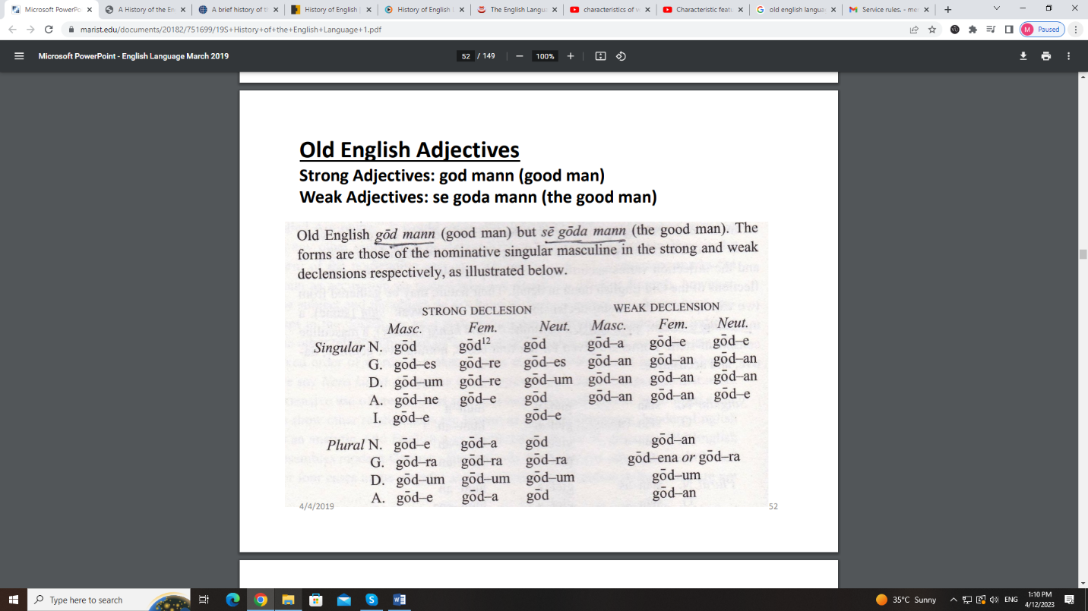

Topic – 058: Adjectives and Articles in Old English
An important feature of the Germanic languages is the development of a twofold declension of the adjective: one, the strong declension, used with nouns when not accompanied by a definite article or similar word (such as a demonstrative or possessive pronoun). The other, the weak declension, is used when the noun is preceded by such a word. So: ‘gōd mann’ (good man) but ‘sē gōda mann’ (the good man).
The forms are those of the nominative singular masculine in the strong and weak declensions respectively. We can see this aspect of Old English in contrast with Modern English. This complexity was unnecessary, so with the passage of time it as removed. In fact this elimination resulted in a great advantage. With reference to the use of articles, as far as the definite article is concerned, like German, its sister language of today, Old English possessed a fully inflected definite article. The session also invites to make its comparison with Urdu as well as with modern English.
Topic – 059: Verbs in Old English
The inflection of the verb in the Germanic languages is much simpler than it was in Indo- European times. A comparison of the Old English verb with the verbal inflection of Greek or Latin will show how much has been lost. Old English distinguished only two simple tenses by inflection, a present and a past, and, except for one word, it had no inflectional forms for the passive as in Latin or Greek. A peculiar feature of the Germanic languages was the division of the verb into two great classes:

- Weak and strong
- Regular and irregular (in Mod E).
They unfortunately suggest an irregularity in the strong verbs. In Old English, if we exclude compounds, there were only a few over 300 of them, and even this small number falls into several classes. Nowadays these verbs have different vowels in the present tense, the past tense, and the past participle. In some verbs, the vowels of the past tense and past participle are identical, as in break, broke, broken, and in some all three forms have become alike in modern times (bid, bid, bid). In Old English, the vowel of the past tense often differ in the singular and the plural; or, to be more accurate, the first and third person singular have one vowel while the second person singular and all persons of the plural have another.
Topic – 060: Overall Language System in Old English
Review of Old English:
- Very old German vocabulary was prevalent
- There were a lot of word endings (inflations)
- Evolved from 450 AD to 1066 AD
- After 800 AD, Old Norse mixed with Old English in the North and East of England
What was the overall language system of Old English and how specifically prefixes and suffixes were used? Old English exhibited a generous use of prefixes and suffixes. They were used to form new words from old words or to modify or extend the root idea. This use resembles modern German. Prefixes in old English were a fertile resource in word building; and particularly a feature in the formation of verbs.

Lesson 13
DISCUSSION ON SAMPLES OF OLD ENGLISH
Topic – 061: Old English Literature: Phonology & Morphology
In this topic, the following points are discussed:
In literature, a language displays:
- Its full power
- Its ability to convey thoughts in a vivid form
- Its ability to record emotions
The literature of the Anglo-Saxons is:
- The richest
- And most significant of any preserved among the early Germanic peoples.
Two types of this literature brought to England by the Germanic conquerors from their continental homes and preserved for a time in oral tradition. It is influenced by reintroduction of Christianity into the southern part of the island at the end of the sixth century. Two streams mingle in Old English literature. These are pagan and the Christian. Both the traditions constantly overlay.
Topic – 062: Old English Literature: Semantics & Syntax
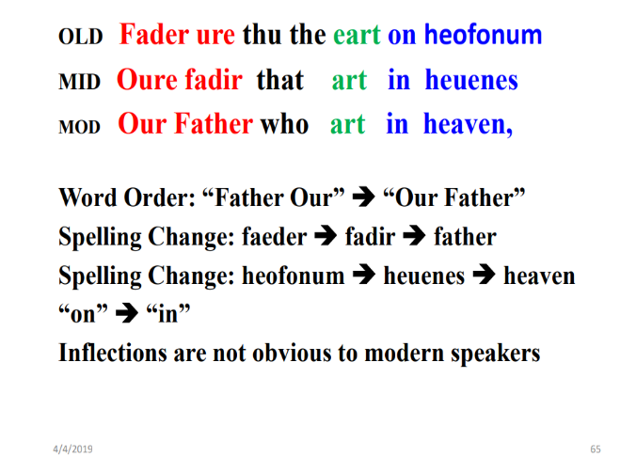
In this topic, the following points are discussed:
Use pf Pronouns: tū (singular)- gē (plural) Today we use you in both cases. In old English: thou and thee were singular, and ye and you plural, but in Middle English times, the custom arose of using ye/you as a polite or deferential way of addressing a single person, and this usage spread; thou and thee gradually dropped out of use in everyday speech, and finally disappeared (except in some dialects, where they persist to this day).
The topic also provides certain examples to prove the points. For example:

- I say also to you, brother Eadweard, now you me of this
- Ic secge eac de, brodor Eadweard, nu du me tyses
- Asked, that you do unrighteously that you the
- Bade, tat ge dod unrihtlice tat ge da
- English customs abandon which your fathers held and
- Engliscan teawas forlatad te eowre faderasheoldon
- And heathen men’s customs love who
- Hadenra manna teawas lufiad te
- Notice how relative clauses are introduced.
In the phrase ‘se beo[t] amansumod te hadenra manna teawas hylt’, we have the word ‘te,’ which I have is glossed as ‘who’.In the phrase ‘ge da Engliscan teawas forlatad te eowre faderas heoldon’ we see the same word, ‘te,’ but here the Old English appropriate gloss is ‘which’, as it is referring to the ‘teawas’ (‘customs’) rather than a person or people. Who and which did exist in Old English (hwā, hwilc) but were indefinite or interrogative pronouns, not relatives. For the relative function, old English used the indeclinable particle ‘te’, or the declinable pronoun ‘se’ (identical in form with the definite article), or the two together.
Topic – 063: Old English: Sample 1 & Discussion
In this topic, a hands-on experience of analyzing an OLD ENGLISH TEXT was given with different examples.

Vocabulary
Opens, for example, with a formulaic phrase, ‘so-and-so spoke’. The stock of conventional poetic diction was very large, because of the need for alliteration: there were numerous words for warrior (beorn in the passage), for weapons (asc), and for horse, ship, prince, etc.
Topic – 064: Old English: Sample 1 & its Features
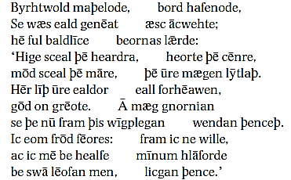
In this topic, phonological features and their representation was discussed and examined by showing relevant texts and examples.

Topic – 065: Towards Middle English: The Norman Conquest (1066-1200)
In this topic, students will learn how to independently apply their knowledge of Old English to examine any given text.
From the prologue of the Anglo-Saxon Chronicle, a yearly history of important events, written in the ninth century.
A word-for-word translation is given.
Brittene igland is ehta hund mila lang-
Britain island is eight hundred miles long
7 twa hund brad- 7 her sind on bis
& two hundred broad & here are in this.
The words ‘brittisc’ and ‘brines’ do not have today's meaning. They refer to the Celtic tribes that used to inhabit Britain. In fact, ‘brittisc’ and ‘wilsc’ were one and the same language - Brito- Welsh – That is why the writer says that there are five languages and then appears to list six.

Lesson 14
MOVING TOWARDS MIDDLE ENGLISH: THE NORMAN CONQUEST (1066-1200)
Topic – 066: Towards Middle English: The Norman Conquest (1066-1200)
Norsemen and Normans: During the latter part of the Old English period, two different groups of non-English speakers invaded the country. Both groups were Scandinavian in origin. Old Norse (ON) and Old French (OF), Who were they? Their origin is discussed. What is the Norman Conquest, 1066? And, what is its influence on English language? What the language would have been like if William the Conqueror had not succeeded in making good his claim. It would have pursued much the same course as the other Germanic languages, retaining perhaps more of its inflections and preserving a predominantly Germanic vocabulary. It is also discussed how word stock of English is affected by these events of the history. If this event had not taken place, word formation in English would have been limited to the characteristic methods of word formation from within language and it would have been resulted in incorporating less freely from outside the language.
Resultantly English would have lacked the enormous number of French words that today make English seem, on the side of vocabulary, almost as much a Romance as a Germanic language. The Norman Conquest changed the whole course of the English language.
Topic – 067: Origin of Normandy &Norman Settlement
Normandy: on the northern coast of France, directly across from England, a district extending some seventy-five miles back from the Channel. Name is derived from the bands of Northmen who settled there in the ninth and tenth centuries. A generation after Alfred reached an agreement with the North-men in England; a somewhat similar understanding was reached between Rollo, the leader of the Danes in Normandy, and Charles the Simple, king of France.
The next one and a half centuries witnessed how masterful dukes raised the dukedom to a position of great influence. Normans readily adopted the French civilization. They injected fresh vigor into what they borrowed, profited from French military forces and took important features of Frankish law. Accepted Christianity and constructed Norman cathedrals. Locals gave up their own language and learned French. Consequently, Old Scandinavian tongue disappeared rapidly. Second duke sent his son to Bayeux to learn something of the speech of his forefathers.
11th Century:
At the time of the Norman Conquest, the civilization of Normandy was French. Normans were most advanced people. Before Norman Conquest, there was a close contact between the two people. Æthelred(1002) married a Norman wife and during exile took refuge at the duke of Normandy. His son Edward, brought up in France, was more French than English. In 1042, Edward the Confessor was restored to the throne and he supported Norman friends.
The result of all this was a strong French atmosphere. In this context Edward died as childless, which led to the issue of choice of a successor. Godwin, earl of the West Saxon emerged as successor, but he was challenged by William, the duke of Normandy.
To cut it short, William had won the battle of Hastings, but had not yet attained the English crown. However, when the Southeast of England was burnt, the citizens of London surrendered and he was crowned on Christmas Day 1066.
Following important points about The Norman Settlement are worth readable:
- William’s victory at Hastings was more than a mere substitution of one monarch for another.
- Norman prelates were gradually introduced into all important positions in the church.
- For example, the two archbishops were Normans. Also, English abbots were replaced.
- In 1075, 13 out of 21 abbots who signed the decrees of the Council of London were English. Interestingly twelve years later only three were left.
Topic – 068: Use of French Language and Literature
The Use of French by the Upper Class
The members of the new ruling class were sufficiently predominant to continue to use their own language. This was natural enough. For 200 years after the Norman Conquest, French remained the language of ordinary intercourse among the upper classes in England.
French Spread Through:
- Intermarriage
- Association with the ruling class: numerous people of English extraction found it to their advantage to learn French
- Distinction was not ethnic but was largely social.
Language of the masses was English. A French soldier who settled on a manor with a few hundred English peasants would soon learn the language of the people among whom his lot was cast.
An instructive parallel to the bilingual character of England in this period is furnished by the example of Belgium today. Here we find Flemish and French (Walloon) in use side by side. (Flemish is only another name for the Dutch spoken in Belgium). Circumstances promoted the continued use of French. Until the beginning of the thirteenth century, there was a close connection of upper class between England and the continent. From the time of the conquest, the kings of England were likewise dukes of Normandy. English kings spent time there. The Conqueror and his sons were in France for about half of their respective reigns. Except for Henry I, no English king until Edward IV (1461–1483) sought a wife in England, it is easy to see how continentally minded English royalty was and how natural the continued use of French at the English court was. Same was the case of nobility. The English nobility was an Anglo-French aristocracy. They had possessions on the continent. They frequently contracted continental marriages and spent much time in France. To please the court and the nobility, naturally all the literature that was written was also heavily influenced by French.
Topic – 069: The Attitude Towards English
There is no reason to think that the preference that the governing class in England showed for French was anything more than a natural result of circumstances. The idea that the newcomers were actively hostile to the English language is without foundation. It is true that English was now an uncultivated tongue, the language of a socially inferior class. This session also discusses that till 1200 what was happening? What was the attitude of the king and the upper classes? Why they were indifferent? What were the reasons of indifference? They did not cultivate English, though had acquaintance with it. The reason was that their activities in England did not necessitate it. Their constant concern with continental affairs made French useful.
Topic – 070: Fusion and Diffusion of French and English
In the years following the Norman Conquest, the sting of defeat and the hardships incident to so great a political and social disturbance, they were gradually forgotten. People accepted the new order as something accomplished. They accepted it as a fact and adjusted themselves to tithe fusion of Normans and English was rapid, but not more rapid than national interest. When a distinction is made, it soon comes to be between the English, meaning all people of England, and the French, meaning the inhabitants of France. This early fusion of French and English in England is quite clear from a variety of evidences. For instance, one of the examples is marriages of Normans to English women.
Evidence
In (1072 – 1079) Wulfstan brought about some sort of spiritual federation between the monks of Worcester and six other English monasteries. In Short, Norman Nobles identified themselves with their new country, founded monasteries, and chose burial in their adopted land rather than in Normandy.
The fusion seems to have gone forward rapidly in the reign of Henry I. “Now that the English and Normans have been dwelling together, marrying and giving in marriage, the two nations

have become so mixed that it is scarcely possible to-day, speaking of free men, to tell who is English, who of Norman race.” French was the language of the court and the upper classes, English the speech of the mass of the people.
The question to be asked is really twofold:
(1) When and how generally did the upper class learn English?
(2) How far down in the social scale was knowledge of French at all general?

Lesson 15
THE RE-ESTABLISHMENT OF ENGLISH IN MIDDLE ENGLISH PERIOD
Topic – 071: Changes after 1200 & Loss of Normandy
Changing Conditions After 1200
The change in conditions after 1200 led to the re-establishment of English during the period of 1200–1500. Shortly after 1200 conditions changed. England lost an important part of its possessions abroad. The nobility gradually relinquished their continental estates. This led to a feeling of rivalry that developed between the two countries. An anti-foreign movement in England culminated in the Hundred Years’ War. During the century and a half following the Norman Conquest, French had been not only natural but more or less necessary to the English upper class. But, in the thirteenth and fourteenth centuries its maintenance became increasingly artificial. For a time certain new factors helped it to hold its ground, socially and officially. Meanwhile, social and economic changes affecting the English-speaking part of the population were taking place. In the fourteenth century, English won its way back into universal use, and in the fifteenth century French totally disappeared.
The Loss of Normandy
The first link in the chain binding England to the continent was broken in 1204 when King John lost Normandy. John married Isabel of Angouleme (1200). As far as the reason of this marriage is concerned, he loved her and had certain political advantages in mind as well. She was at the time formally betrothed to Hugh of Lusignan, the head of a powerful and ambitious family. John, anticipating hostility from the Lusignans, attacked them. They appealed for redress to their common overlord, the king of France. In this entire context, Philip saw an opportunity, and summoned John (1202) to appear before his court at Paris. However, John said, as king of England he was not subject to the jurisdiction of the French court. Now this was a point of contention. On the day of the trial the English king did not appear in the court and the court declared his territory confiscated. Philip proceeded at once to carry out the decision of the court and invaded Normandy. Soon John’s supporters deserted him; and finally Normandy was lost to the English crown.
The question, what was the impact of the loss of Normandy? In fact as far as English language is concerned, it was advantageous for English language. Now England emerged as a first concern. Now England was on the way of becoming not merely a geographical term but once more a nation.

Topic – 072: Nobilities & French Reinforcement
Loss of Normandy had Certain Consequences.
It brought to a head the question of whether many of the nobility owed their allegiance to England or to France. After the Norman Conquest a large number held lands in both countries. A kind of interlocking aristocracy existed, so that it might be difficult for some of the English nobility to say whether they belonged more to England or to the continent. Some steps toward a separation of their interests had been taken from time to time. On several occasions, Henry I confiscated the English estates of unruly Norman barons. But in 1204, the process of separation was greatly accelerated, for by a decree of 1204–1205 the king of France announced that he had confiscated the lands of several great barons. For the most part, the families that had estates on both sides of the Channel were compelled to give up one or the other. Sometimes they divided into branches and made separate terms. Sometimes great nobles preferred their larger holdings in England and gave up their Norman lands. An incident in 1244 sped up the process. This was the address of king of France. He asserted: “As it is impossible that any man living in my kingdom, and having possessions in England, can competently serve two masters, he must either inseparably attach himself to me or to the king of England.”
So people had to relinquish their properties either in England or in France. Knowing this the king ordered that all people of the French nation, and especially Normans, who had possessions in England, should be disseized of them. So after 1250, there was no reason for the nobility of England to consider itself anything but English. And, the most valid reason for its use of French was gone.
French Reinforcements
This is when the country experienced a fresh invasion of foreigners, this time mostly from the south of France. This was the time of foreign invasion. In short, in the course of Henry III’s long reign (1216–1272), the country was eaten up by strangers. Even London “was full to overflowing, not only of Poitevins, Romans, and Provengals, but also of Spaniards, who did great injury to the English. Thus, French reinforcement took place.
Topic – 073: English & French in the 13th Century
The thirteenth century must be viewed as a period of shifting emphasis upon the two languages spoken in England. The upper classes continued for the most part to speak French, as they had done in the previous century, but the reasons for doing so were not the same. Shift of French from a mother tongue inherited from Norman ancestors to a cultivated tongue took place. It was supported by social custom and by business and administrative convention.

Meanwhile, English made steady advances. By the middle of the century, when the separation of the English nobles from their interests in France had been completed, English was becoming a matter of general use among the upper classes. Adoption of French words into the English language took place. There was shift in literature as well. All that was written in French was now translated into English. By the close of the century, some children of the nobility spoke English as their mother tongue and had to be taught French through the medium of manuals equipped with English glosses. The knowledge of French, even of those who attempted to use it in this period was scanty.
Topic – 074: The Hundred Years’ War
In the course of the centuries following the Norman Conquest, the connection of England with the continent had been broken. It was succeeded by a conflict of interests and a growing feeling of antagonism that culminated in a long period of open hostility with France (1337–1453). The active interference of France in England’s efforts to control Scotland, led Edward III to finally put forth a claim to the French throne and to invade France. The great victories of the English at Crécy (1346) and Poitiers (1356) fanned English patriotism to a white heat, though this auspicious beginning of the struggle was followed by a depressing period of reverses and though the contest was interrupted by long periods of truce. In the reign of Henry V, England again enjoyed a brief period of success, notably in the victory against great odds at Agincourt (1415). But the success did not continue after the young king’s death, and the exploits of Joan of Arc (1429) marked the beginning of the end. Probably the intervals between the periods of actual fighting were too long and the hindrances to trade and other intercourse too discouraging. The feeling that remained uppermost in the minds of most people was one of animosity, coupled with a sense of the inevitability of renewed hostilities. It was impossible to forget that French was the language of an enemy country Hundred Years’ War is probably to be reckoned as one of the causes contributing to the disuse of French.
Topic – 075: The Rise of Middle Class
What helped English to recover its former prestige?
- Improvement in the condition of the masses
- Rise of a substantial middle class
Since importance of a language largely depends upon the importance of people who speak it, with the rise of middle class English also had uplift in its status as their language. During the latter part of the Middle English period, the condition of the laboring classes was rapidly improving. Among the rural population villeinage was dying out. Fixed money payments were gradually substituted for the days’ work. The process by which these changes were

being brought about was greatly accelerated by an event that occurred in the year 1349. This event is known in the history as “The Black Death”. It was in the summer of 1348 that in the Southwest of England, first case of this plague were reported. These were the first cases of a disease that in its contagiousness and fatality exceeded anything previously known.
The Black Death spread rapidly over the rest of the country, reaching its height in 1349.40 percent of the parish clergy died of the plague. Death rate during the plague approximated 30 percent. The effects of so great a calamity were naturally serious. Mortality was greatest among the lower social orders. The question arises why mortality was greatest among the lower social orders? The answer is simple: because their life style was poor, hygiene conditions were bad and affordability to medicine was very low. The result of these deaths was a labor shortage which consequently gave rise to increase in wages.
Impact of the Black Death:
A general spirit of discontent prevailed. It culminated in the Peasants’ Revolt of 1381.There was an increase in the economic importance of the laboring class. There was also an increase in the importance of the English language which they spoke. This also led to the rise of the craftsmen and the merchant class. By 1250, there had grown up in England about two hundred towns with populations from 1,000 to 5,000; some, like London or York, were larger. These towns became free, self-governing communities, electing their own officers, assessing taxes in their own way, trying their own cases, and regulating their commercial affairs. They were engaged in trade or in the manufacturing of crafts. Each town was independent, wealthy and powerful, standing halfway between the rural peasant and the aristocracy. Such changes in the social and economic life benefited particularly the English speaking part of the population.
For more detailed information, watch this supplementary video:
https://www.youtube.com/watch?v=ZsfcOpQjfE0

Lesson 16
MIDDLE ENGLISH IN 14TH AND 15TH CENTURIES
Topic – 076: General Adoption of English - 14th Century
Why and how the general adoption of English in the 14th century took place? English was everywhere and was spoken by everyone. As evidence we can see that polite literature of England was written in English. Also as a result of or impact of the Black Death, English spread rapidly in the monasteries. Death of forty-seven monks and abbot St. Albans in 1349 also added to the speed of spread, because now they were replaced with monks who were speakers of English. Furthermore, there was a shift of writers from French to English. Chaucer’s court spoke English, even if its members commonly wrote and often read French. Romances owned by Richard II in 1385 were in French, but he spoke English fluently. Robert of Brunne, who wrote his Chronicle in 1338, implies that French is chiefly the language of two groups, the educated classes and the French. Remark of an editor of a chronicle written in French (1381) is very apt as he said: “it is the French of a man who is obviously thinking in English”. In short outside the royal family and the governing class English was the language best understood.
Topic – 077: English in Law Courts- 14th Century
Some people who lived at court knew French, but, the old and the young, learned and unlearned, all understand the English language. Elkhatib, A. S. (2021, September 12). The reestablishment of English, 1200-1500 (Chapter 6). Academia.edu.
French was the language of lawyers and of the law courts down to 1362. Also Church people commonly spoke French. French was the language of conversation in the monasteries of St. Augustine at Canterbury and St. Peter at Westminster. Chaucer’s prioress spoke French, though she told her tale to the Canterbury pilgrims in English. But clerks of the younger generation seem to have been losing their command of the language. Also French was known to government officials. It was the language of parliament and the language of local administration.
French was a means of communication for Business transactions of town councils and the guilds were in French. However, we find scattered instances of the intrusion of English. When Edward III called a parliament in 1337 to advise him about his claim to the throne of France, the lawyer addressed in English, although French was still the usual language of Parliament. It was in 1362 that the Chancellor opened Parliament for the first time with a speech in English. English appears in the acts of towns and guilds. It was in 1388 Parliament required all guilds to submit a report in English. This was a step to restore English. Since long French had been the language of all legal proceedings. But in1356 the mayor and aldermen of London ordered the proceedings to be in

English. Custom dies hard so the statute was not fully observed at once. But, it was the official recognition of English.
Topic – 078: English in the Schools- 14th Century
From a time shortly after the Conquest, French had replaced English as the language of the schools. A statement of Ranulph Higden in the fourteenth century shows that in his day the use of French in the schools was quite general. At the end of the first book of his Polychronicon (c. 1327), a universal history widely circulated, he attributes the corruption of the English language which he observes in part to this cause. After 1349 English began to be used in the schools and by 1385 the practice had become general. This topic also touches it in comparison with the example of Pakistan.
Topic – 079: Increasing Ignorance of French- 15th Century
The writers of the beginning of the fourteenth century asserted that they had seen many nobles who could not speak French. By the fifteenth century speaking French fluently was accomplishment. Even writing French was less common. In 1400, George Dunbar, earl of March wrote to the king in English: “And, noble Prince, marvel ye not that I write my letters in English, for that is more clear to my understanding than Latin or French. “Another case was of a letter from Richard Kingston, dean of Windsor, who addressed the king (1403). He begins bravely enough in French, but towards the close shifts to English.
An incident that occurred in 1404 seems at first sight to offer an extreme case. The king of France had refused to recognize Henry IV when he seized the English throne. Finally an attempt was made to settle the matter by negotiation. In negotiations, the English ambassadors complained about the use of French. They asked to use Latin. Twice they spoke of French as being as unknown as Hebrew. Before middle of 15th century, it was necessary to have a “Secretary in the French language” among the government officials By the end of the century, Caxton could write: “For the mooste quantyte of the people vnderstonde not latyn ne frensshe here in this noble royame of englond.”
Topic – 080: French: Language of Culture and Fashion
When French went out of use as a spoken language in England, not only was its sphere more restricted but the reasons for its cultivation changed. In the first decade of the fifteenth century, John Barton wrote a ‘Donet François’, a treatise intended for adults who wished to learn French. It is interesting to note the three reasons he gives for Englishmen’s learning the language. He says nothing about their need for it to communicate among themselves. First, it will enable them to communicate with their neighbors of the realm of France. Secondly, the laws are largely in French. Thirdly, he says: gentlemen and women willingly write to each other in French. First

reason is valid even today. Second and third reasons however, have become a heritage of the past. But French being so long the mark of the privileged class was and is still:
- The language of culture
- The language of fashion
- The language of style
- The language of sophistication
This feeling was strengthened in the eighteenth century and it is present in the minds of many people today.

Lesson 17
FEATURES OF MIDDLE ENGLISH: WRITING AND PRONUNCIATION
Topic – 081: Use of Middle English in Writing
The last step that the English language had to make in its gradual ascent was its employment in writing. The use of Latin for written communication and record was due: Partly to a habit formed at a time when most people who could write at all could write Latin; Partly to its international character; partly to the feeling that it was a language that had become fixed while the modern languages seemed to be variable, unregulated, and in a constant state of change. Modern languages began to encroach upon writing in Latin at a time when French was still the language of the educated and the socially prominent. French is the first language in England to dispute the monopoly of Latin in written matter. In Fifteenth century English succeeds in displacing both. In private and semi-official correspondence French is at its height at about 1350. The earliest English letters appear in the latter part of the century, but there are few before 1400.
After 1450, English letters are everywhere the rule. It was adoption of English for official records and English for the records of towns and guilds. About 1430 a number of towns translated their ordinances and their books of customs into English. English becomes general in their transaction after 1450.Apparently the brilliant victories of the English over the French at Agincourt gave the English, a pride in things English. The end of this reign and the beginning of the next mark the period at which English begins to be generally adopted in writing. If we want a round number, the year 1425 represents very well the approximate date.
Topic – 082: Middle English Literature
The literature written in England during the Middle English period reflects the changing fortunes of English. Literature is a mirror of times and also a mirror of language/s used during the times. So, literature written in England during the Middle English period also reflects the times and language choices of the times. During the time, French was the language best understood by the upper classes, the books they read or listened to were in French. All of continental French literature was available for their enjoyment. The literature in English that has come down to us from this period (1150–1250) is almost exclusively religious.
Such incentives were most often found among members of the religious body, interested in promoting right living and in the care of souls. The separation of the English nobility from France by 1250 and the spread of English among the upper class is manifest in the next hundred

years of English literature. Types of polite literature that had hitherto appeared in French now appeared in English. The period from 1350 to 1400 is a period of Great Individual Writers.
Geoffrey Chaucer (1340–1400) is the greatest English poet before Shakespeare. He is famous for his The Canterbury Tales. The general prologue of these tales provides a matchless portrait gallery of contemporary types. The varieties of the tales provide a veritable anthology of medieval literature.
Topic – 083: Changes in Pronunciation: Middle English
Many changes in pronunciation took place in the transition from Old to Middle English. Middle English phonology is necessarily somewhat speculative. When it comes to preserving any language, only a written form of a language is preserved. We have a very large text corpus of Middle English, which shows that ME dialects vary greatly over both time and place. In contrast with OE and Modern English, spelling was phonetic rather than conventional. Words were spelled according to how they sounded. There was no formalized system and no accuracy like today.
Topic – 084: Middle English: Changes in Vowel Sounds
Late OE and Early ME vowel-lengthening happened in Late Old English period but became apparent in ME period. In many cases the vowels were shortened again during the ME period, but long vowels remained in some dialects, especially before the groups ‘ld, mb and nd’. This lengthening did not take place, however, if the consonant group in question was immediately followed by a third consonant. This accounts for the difference in vowel between child and children. The word ‘wind’ ‘moving air’ probably has its short vowel by analogy with words like windmill, where the third consonant prevented the lengthening from taking place.
Topic – 085: Comparison of OE & ME Spellings
In this lecture, the following points are discussed:
Languages change over time- English changed over time. Spellings in English language also changed. Old English did not disappear overnight at the Norman Conquest. In writing, the West Saxon literary tradition was continued for long. In less than a century we can say that the Old English period is over, and that Middle English has begun. The Conquest makes it look more sudden than it really was, by introducing new spelling conventions. An established literary language like late West Saxon tends to be conservative in its spelling. Changes occur in pronunciation, but the scribes often go on writing the words in the traditional way. But the Norman scribes disregarded traditional English spelling, spelt the language as they heard it, and used conventions of Norman French. Consequently, many changes that had not been reflected in OE spelling, or which had appeared only in occasional spellings, now emerged clearly.

New Spelling Conventions
The new orthography gave English writings quite a new look. A number of new consonant symbols were introduced. Symbol g was introduced for the stops represented by OE ʒ, and the OE symbol was retained only for the fricatives. So, there was a great transition in spelling from OE to ME.
The following material elaborates the development of English language through Middle ages:
https://www.slideshare.net/muridke/middle-english-lecture-7

Lesson 18
THE GRAMMAR OF MIDDLE ENGLISH
Topic – 086: Middle English: A Period of Change
The Middle English period (1150–1500) was marked by momentous changes in the English language.
Nature of changes:
These changes were more extensive and fundamental than those that have taken place at any time before or since. Some of them were the result of the Norman Conquest and following conditions. Others were a continuation of tendencies that had begun to manifest themselves in Old English. This second type would have gone on even without the Conquest. There was an increase in speed of process due to Norman invasion. It removed conservative influences.
Types of Changes:
- Mainly both, grammar and vocabulary
- Changes of almost every aspect and type took place.
Changes in Grammar
Changes in the grammar reduced English from a highly inflected language to an extremely analytic one.
Changes in Vocabulary
These involved the loss of a large part of the Old English word-stock and also the addition of thousands of words from French and Latin.
Topic – 087: Nouns & Pronouns in Middle English
In early Middle English only two methods of indicating the plural remained fairly distinctive. At that time, it was difficult to predict that the -s would become the almost universal sign of the plural that it has become. Until the thirteenth century, the -en plural enjoyed great favor in the

south, being often added to nouns which had not belonged to the weak declension in Old English. But in the rest of England, the -s plural (and genitive singular) of the old first declension

(masculine) was apparently felt to be so distinctive that it spread rapidly. Fifty years later, it had conquered the rest of the Midlands, and by the 14th century it had definitely been accepted all over.
Pronoun
The decay of inflections that simplified noun, also affected pronoun. So, now pronoun also depended less upon formal indications of gender and case. For instance - demonstrative pronoun, of the numerous forms of ‘sē, sēo, þæt,’ we have only the and that surviving through Middle English and continuing in use today. A plural ‘tho’ (those) was survived to Elizabethan times. All the other forms indicative of different gender, number, and case disappeared in most dialects early in the Middle English period. Overall nouns and pronouns were simplified. It relied more upon juxtaposition, word order, and the use of prepositions to make clear the relation of words in a sentence.
Topic – 088: Adjectives in Middle English
In the adjective, the leveling of forms had even greater consequences. Partly as a result of the sound-changes that took place over time, partly through the extensive working of analogy, the form of the nominative singular was early extended to all cases of the singular. In the same way, that of the nominative plural to all cases of the plural, it is both in the strong and the weak declensions. The result was that in the weak declension there was no longer any distinction between the singular and the plural: both ended in -e (blinda> blinde and blindan>blinde).This was also true of those adjectives under the strong declension whose singular ended in-e. By 1250 the strong declension had distinctive forms for singular and plural only in certain monosyllabic adjectives which ended in a consonant in Old English Under the circumstances the only ending which remained to the adjective was often without distinctive grammatical meaning. Its use was not governed by any strong sense of adjectival inflection.
Topic – 089: The Middle English: Strong and Week Verbs
Middle English: Strong and Week Verbs
What happened apart from some leveling of inflections and the weakening of endings in accordance with the general tendency? The principal changes in the verb during this were the serious losses suffered by the strong conjugation. This conjugation, although including some of the most important verbs in the language, was relatively small as compared with the large and steadily growing body of weak verbs.
How verbs were formed?

An occasional verb developed a strong past tense or past participle by analogy with similar strong verbs. New verbs formed from nouns and adjectives or borrowed from other languages were regularly conjugated as weak.
Losses among the Strong Verbs
Nearly a third of the strong verbs in OE died out early in the ME. 90 of them have left no traces in written records after 1150. Some of them may have been current for a time in the spoken language, but except where an occasional verb survives in a modern dialect, they are not recorded. Its use was not governed by any strong sense and circumstances led to these changes. Now this was the language chiefly of the lower classes. It consequently was largely away from the restraining influences of education; and was also away from any literary standard. So it was natural that many speakers should apply the pattern of weak verbs to some which were historically strong.
Topic – 090: Loss of Grammatical Gender
One of the consequences of the decay of inflections was the elimination of grammatical gender. The gender of Old English nouns was not often determined by meaning. Moreover, the gender of nouns in Old English was not so generally indicated by the declension as it is in a language like Latin. Instead it was revealed chiefly by the concord of the strong adjective and the demonstratives. These by their distinctive endings generally showed, at least in the singular, whether a noun was masculine, feminine, or neuter. The inflections of these gender-distinguishing words were reduced to a single ending for the adjective. The weakening of inflections and the confusion and loss of the old gender proceeded in a remarkably parallel course. However, in North Inflections weakened earliest, grammatical gender disappeared first. Whereas in South they lingered longer as decay of inflections was slower.
For more detailed information, watch this supplementary video:
https://www.youtube.com/watch?v=7yv852vGy98

Lesson 19
VOCABULARY OF MIDDLE ENGLISH AND MOVING TOWARDS STANDARDIZATION
Topic – 091: Middle English Syntax
Leveling of inflections= syntactic and semantic relationships that had been signaled by the endings on words now became ambiguous. Whereas in Old English, the grammatical functions of two consecutive nouns were clear from their endings in, say, the nominative and dative cases, in Middle English their functions might be uncertain. The most direct way to avoid this kind of ambiguity is through limiting the possible patterns of word order. This is the time when we notice a shift from a highly synthetic stage of Old English to the highly analytic stages of Late Middle English and Modern English.
The process of development can be seen in the Peterborough Chronicle. Peterborough Chronicle was written in installments from 1070 to 1154. This text of the Anglo-Saxon Chronide spans the period from Old English to Early Middle English. In the continuations of the text it is possible to trace different aspects. First a significant loss of inflections, afterwards a corresponding rigidity of word order, is making clear the direction of cause and effect. Process of development and the reality of Middle English as a separate stage of the language can grammatically, phonologically and lexically be seen in the patterns of subject and verb. All of these patterns are still possible even in the last years of the Peterborough Chronicle. Thus, the word order looked much like that of Old English at a time when the inflectional system looked much like that of Modern English. These changes which affected the grammatical structure of English after the Norman Conquest were not the result of contact with the French language. Certain idioms and syntactic usages that appear in Middle English are clearly the result of such contact. And as its most recent editor puts it: “before our eyes English is beginning to change from a synthetic language to an analytic one. In fact the Norman Conquest removed authority that a standard variety of English would have and made it easier for grammatical changes to go forward unchecked.
Topic – 092: Middle English Vocabulary
French Influence on the Vocabulary
Loss of inflections and simplification of grammar was indirectly due to the use of French. But for vocabulary it was much more direct. The two languages lived side by side for such a long time and had such intimate relations that a considerable transference of words from one language to the other was natural and expected.

Nature of Interchange
When we consider the nature of this change, following aspects are of great significance:
- Mutual & Frequent
- No comparison in history
- Neither sudden nor immediately apparent
- Began slowly
- Had a varying tempo
Fashion, Meals, and Social Life
Since upper class sets the standard in fashion and dress, the number of French words belonging to this class was great. Following are examples of such words:
fashion, dress, apparel, gown, robe, garment, attire, cape, cloak, coat, frock, collar, veil, train, petticoat. Embroidery, pleat, buckle, button, tassel, plume.
Verbs like embellish and adorn also came from the same domain. Examples of colors include:
blue, brown, scarlet, saffron, russet, and tawny. Jewel, ornament, brooch, ivory, and enamel are significant examples from the domain of fashion.
Examples of precious stones include: turquoise, amethyst, topaz, garnet, ruby, emerald, sapphire, pearl, diamond, as well as crystal and coral.
Examples from Domestic Life:
Curtain, couch, chair, cushion, screen, lamp, lantern, chandelier, blanket, quilt, coverlet, towel, and basin indicate articles of comfort or convenience.
Examples from Government and Administration
French ruled for more than 200 years so we have words such as government, govern, administer. We also have:
- Crown, state, empire, realm, royal, authority, sovereign, majesty, court, council, tax parliament, treaty assembly, alliance, record, revenue.
- Titles of offices: chancellor, treasurer, chamberlain, marshal, governor, councilor, minister, warden, mayor, constable etc.
Examples from Law
French was the language of the law courts so, all the legal vocabulary comes from French. For example names of crimes: felony, trespass, assault, arson, larceny, fraud, slander, adultery
Examples from Army and Navy:
Control of the army and navy was in the hands of French people so naturally French military terms were used. Examples include: army, navy, peace, enemy, arms, battle, combat, skirmish, defense, ambush, retreat, soldier, garrison, guard, and spy. Also Officers: captain, lieutenant and sergeant are French words.
Examples from Art and Medicine:
- Words: art, painting, sculpture, music, beauty, color, figure, image, tone are French.
- In architecture and building: cathedral, palace, mansion, chamber, ceiling, chimney, latch etc. are examples.
- Word Literature and other words from this domain such as, poet, prose, romance, story, chronicle, tragedy, prologue, preface, title, volume, chapter, parchment, paper, and pen.
Examples from Science:
- Physician, surgeon, pain, gout, jaundice, paralytic, plague, stomach, pulse, remedy, ointment, balm, sulphur, poison.
Topic – 093: Borrowings in Middle English
A large proportion of the words borrowed from French were thoroughly popular in character, that is, words current in the everyday French were spoken in England. French words were used by hundreds in popular speech. This made it easier for the entrance of literary words as well. Literature was a channel in the Middle English period and in the fifteenth century it became the principal source for this transfer. In fact, Middle English literature was based directly on French originals so it had French words
Latin Borrowings in Middle English
Latin borrowings differed from the French. They were less popular. They gained admission generally through the written language. Latin was spoken among men of learning and ecclesiastics, so certain words came directly into spoken English. Latin words were small in comparison to entering by way of literature. In a single work like Trevisa’s translation of the De Proprietatibus Rerum of Bartholomew Anglicus we meet with several hundred words taken over from the Latin original. The fourteenth and fifteenth centuries were especially prolific in Latin borrowings. An anonymous writer of early fifteenth century says, it is not easy to translate from Latin into English, because “there ys many wordes in Latyn that we have no propre Englysh accordynge therto.”

Topic – 094: The Rise of Standard English
The Rise of Standard English: Variety of local dialects led to a standard written language towards the end of the fourteenth century. In fifteenth century, it won a general recognition and since then it is the recognized standard in both speech and writing. East Midland district contributed the most to the formation of this standard. It became the basis, particularly, of the dialect of London. It had several causes. Firstly, this region occupied a middle position between the extreme divergences of the north and south.
It was less conservative than the Southern dialect. It was also less radical than the Northern. In its sounds and inflections, it represents a compromise. Also, the East Midland district was the largest and most populous of the major dialect areas. The land was more valuable than the hilly country to the north and west. Another factor, more difficult to evaluate, was the presence of the universities, Oxford and Cambridge, in this region. In 14th century, the monasteries were playing a less important role in the dissemination of learning. The two universities had developed into important intellectual centers.
Topic – 095: Importance of London Standard
By far, the most influential factor in the rise of Standard English was the importance of London as the capital of England. Importance of London Standard was due to certain reasons: London was, and still is:
  - The political capital of England
  - Commercial center of England
  - Seat of the court of the highest judicial tribunals
  - Focus of the social and intellectual activities
London economy was especially important as “an engine of communication and exchange”, which enabled ideas and information to be distributed and business to be done. It had a constant migration. So, other languages had to mingle with the London idiom. The influence was reciprocal. London English took as well as gave. People took back with them the forms and usages of the great city. So, the history of Standard English is almost a history of London.

The Spread of the London Standard
In the latter part of the fifteenth century, the London standard had been accepted, at least in writing, in most parts of the country. Introduction of printing in 1476 was a reason and a new influence of great importance in the dissemination of London English. London was the center of book publishing. Caxton, the first English printer, used the current speech of London. In the sixteenth century, the use of London English had become a matter of principle as well as practice.

Lesson 20
DISCUSSION ON SAMPLES OF MIDDLE ENGLISH
Topic – 096: Middle English Sample and its Features
In this lecture, students are given a first-hand experience of examining a Middle English text and explore its features. The language of Chaucer may be taken as representing with enough accuracy, the dialect of London at the end of the fourteenth century. It is prevailingly East Midland with some Southern and Kentish features. The latter are a little more prominent in Chaucer than in the nonliterary London documents of the same date. Among the usual East Midland, developments may be noted OE ‘ā as ō’: so notice: ‘goon’. Example: ‘Than longen folk to goon on pilgrimages’.
Topic – 097: Middle English Sample Discussion
In this topic, a text from Geoffrey Chaucer of Canterbury Tales 1387 has been selected. After completing this topic, students will have some practice in examining Middle English writings.
Notice ‘o’
- To ferne halwes, couthe in sondry londes;
- And specially, from every shires ende
- Of Engelond, to Caunterbury they wende,
Notice the unrounding of OE to i: in Swich ,
- And bathed every veyne in swich licour,
- Also notice Kentish e in lest (OE lyst)
- In curteisye was set ful muche hir lest.
Characteristic of East Midland is the loss of the prefix y– and the retention of the final -n: holpen dronken holden.
Examples
- And smale fowles maken melodye,
- That slepen al the night with open yë,

- (So priketh hem nature in hir corages):
- Than longen folk to goon on pilgrimages
- (And palmers for to seken straunge strondes)
The influence of South is evident in the loss of -n in unknown, write etc.
Topic – 098: Activity based on Sample
Text Source used in this session is from East Midland, Cable, T. (2013). A Companion to Baugh and Cable's A History of the English Language. Routledge. It is used to exemplify the features of Middle English writings.
Cethegrande is a fis
ðe moste ðat in water is;
ðat tu wuldes seien get,
gef ðu it soge wan it flet,
ðat it were an eilond
ðat sete one ðe se sond
Translation
The cetegrande (whale) is a fish, the greatest that is in water; so that
thou wouldst say, if thou saw it when it floats, that it was an island that set on the seasand.
ðis fis ðat is unride,
ðanne him hungreð he gapeð wide;
ut of his ðrote smit an onde,
ðe swetteste ðing ðat is on londe; 10
ðer-fore oðre fisse to him dragen;
Translation
This fish, that is enormous, when hungry gapes wide; out of its throat it casts a breath, the sweetest thing that is on land; therefore other fishes draw to it.

Topic – 099: Phonological and Morphological Features: Middle English
In this topic, the Phonological and Morphological features of the Middle English are discussed with the help of sample texts.
“ta te castles uuaren maked, ta fylden hi mid deoules and yuele men. ta namen hi ta men te hi wenden dat ani god hefden, bathe be nihtes and be daies, carlmen and wimmen, and diden heom in prisun, and pined heom efter gold and syluer untellendlice pining, for ne uuaren naure nan martyrs swa pined alse hi waron.”
Translation
When the castles were made, then filled they (them) with devils and evil men. Then seized they the people that they believed possessed any property, both by day and by night, both men and women, and put them in prison, and tortured them (with) indescribable torments in order to get gold and silver, for never were martyrs so tortured as they were.
This is very early Middle English, and not very easy for the modern reader.
“Me henged up bi the fet and smoked heom mid ful smoke. Me henged bi the tumbes other bi the hefed, and hengen bryniges on her fet. Me dide cnotted strenges abuton here haued and uurythen it dat it gade to the”
Translation
They (‘One’) hanged (them) up by the feet and smoked them with foul smoke. They hanged (them) by the thumbs or by the head, and hung mail-coats on their feet. They put knotted cord about their heads and tightened it so that it entered the brains.
The orthography of the passage still shows the influence of the OE scribal tradition, for instance in the use of a and of the spelling sc for [∫] (for example, scort ‘short’).
For [w], too, it sometimes uses wynn (here represented by <w>, as in waron ‘were’), but often instead uses uu (uuaren ‘were’), and for [v] it most often uses u, not f (for example, deoules ‘devils’). It uses both thorn and eth, but alongside these is now found th (bathe ‘both’), and instead of cw we see the French spelling qu (quarterne ‘cell, dungeon’, from OE weartern).
OE ā is still represented by a, not o (for example, ta ‘when’, mare ‘more, greater’), presumably because the change of ā to ǭ had not yet taken place in the part of the East Midland area where the text was written.
For the nouns, the normal plural in the passage is -(e)s (castles, bryniges), and in several words this is used where in Old English there was a different one, for example tumbes and snakes.
This had the OE plural forms tuman and snacan. There is however one plural ending -en, in the word halechen ‘saints’, from OE hālgan.
Topic – 100: Middle English: Semantics and Syntax
In this topic semantic and syntactic features of Middle English are discussed with the help of sample texts.
“ta te castles uuaren maked, ta fylden hi mid deoules and yuele men. ta namen hi ta men te hi wenden dat ani god hefden, bathe be nihtes and be daies, carlmen and wimmen, and diden heom in prisun, and pined heom efter gold and syluer untellendlice pining, for ne uuaren naure nan martyrs swa pined alse hi waron.”
Translation
When the castles were made, then filled they (them) with devils and evil men. Then seized they the people that they believed possessed any property, both by day and by night, both men and women, and put them in prison, and tortured them (with) indescribable torments in order to get gold and silver, for never were martyrs so tortured as they were.
“Me henged up bi the fet and smoked heom mid ful smoke. Me henged bi the tumbes other bi the hefed, and hengen bryniges on her fet. Me dide cnotted strenges abuton here haued and uurythen it dat it gade to the harnes.”
Translation
They (‘One’) hanged (them) up by the feet and smoked them with foul smoke. They hanged (them) by the thumbs or by the head, and hung mail-coats on their feet. They put knotted cord about their heads and tightened it so that it entered the brains.
There are certain points of grammar which remind us of Old English. The pronouns of the third-person plural are the English forms hi, heom and her(e), not the Scandinavian they, them, their.
Syntax
Some examples of V–S–O order (such as, ‘then seized they the people’).
“ta te castles uuaren maked, ta fylden hi mid deoules and yuele men. ta namen hi ta men te hi wenden dat ani god hefden, bathe be nihtes and be daies, carlmen and wimmen, and diden heom in prisun, and pined heom efter gold and syluer untellendlice pining, for ne uuaren naure nan martyrs swa pined alse hi waron.”

Translation
When the castles were made, then filled they (them) with devils and evil men. Then seized they the people that they believed possessed any property, both by day and by night, both men and women, and put them in prison, and tortured them (with) indescribable torments in order to get gold and silver, for never were martyrs so tortured as they were.
Despite these resemblances to Old English, however, there are also decided differences. This is especially seen in the inflections, which are very much reduced compared to Old English. Adjectives have lost almost all their endings: there is a plural -e on some of them (such as yuele), but otherwise nothing.
For example, ‘mid ful’ smoke would in Old English have been ‘mid fūlum smocan’, with inflections for the dative singular. The definite article is almost invariably ‘te’ or ‘the’, as in ‘te castles and bi the fet’, There is one example of the plural ta (in ta men). In Old English, of course, the definite article was fully declined. The equivalent of ‘bi the fet’ would have been be ‘tǣm fōtum’, the preposition be governing the dative. An interesting case’ be nihtes’ and ‘be daies’. A halfway house between the Old English ‘nihtes and dages’, in which the genitive inflection ‘-es’ has an adverbial force, and the modern by night and day. The ME writer has introduced the preposition by, but has also retained the OE –es ending.

.

Lesson 21
HISTORY OF ENGLISH FROM 1500 TO 1650 -PART 1
Topic – 101: Middle to Modern English 1500-1650
In this topic, the following points are discussed:
What are the reasons of the shift from Middle English to Modern English?
All Middle English long vowels underwent extensive alteration during this period. However, short vowels, in accented syllables, remained comparatively stable. If we compare Chaucer’s pronunciation of the short vowels with ours, we note only two changes of importance, those of ‘a’ and ‘u’. In some cases, this ME a represented an OE æ(at, apple, back), and the new pronunciation was therefore a return to approximately the form that the word had had in Old English. It is the usual pronunciation in America and a considerable part of southern England today. The change the u underwent was what is known as unrounding. In Chaucer’s pronunciation this vowel was like the u in full. By the sixteenth century, it seems to have become in most words the sound we have in but (e.g., cut, sun; love, with the Anglo-Norman spelling of o for u). So far as the short vowels are concerned, it is clear that a person today would have little difficulty in understanding the English of any period of the language. 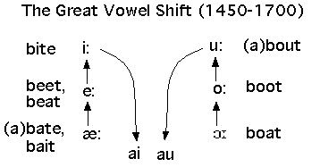
Topic – 102: The Great Vowel Shift
In this topic, the following points are discussed:
What does the Great Vowel Shift in the history of English language mean?
The situation is very different when we consider the long vowels. In Chaucer’s pronunciation, these had still their so-called “continental” value—that is, a was pronounced like the a in father and not as in name. Also in Chaucer’s pronunciation e was either like the e in there or the a in mate, but not like the ee in meet.

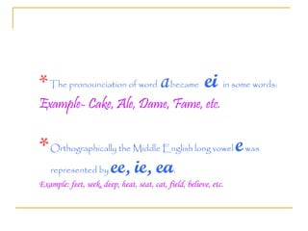

But in 15th century= a great change was under way. All the long vowels gradually came to be pronounced with a greater elevation of the tongue and closing of the mouth. Most of the long vowels had approximately acquired their present pronunciation at least by the sixteenth century. The change occurred at the end of the seventeenth century and had become general by the middle of the eighteenth. The spelling of English had become fixed in a general way before the shift and therefore did not change when the quality of the long vowels changed. Consequently, our vowel symbols no longer correspond to the sounds they once represented in English and still represent in the other modern languages.
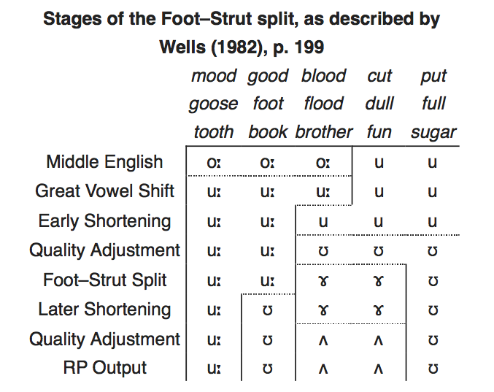

Topic – 103: The Weakening of Unaccented Vowels
In this topic, the following points are discussed:
A little observation and reflection shows us that in unaccented syllables too, the spelling does not accurately represent the pronunciation today. This is because in all periods of the language, the vowels of unstressed syllables have had a tendency to weaken and then often to disappear. This is true of all parts of a word. The weakening is especially noticeable in words from French where an accented vowel came to be unaccented in English. In recent times, the quality of the vowel has been restored to something like its earlier character, but even when the vowel has been restored in standard speech, the weakened form is generally apparent in informal speech and in the dialects.
Topic – 104: Changing Socio-historical Context (1500-1650)
In this topic, the following points are discussed:
To understand language change during this time, we need to understand the relationship between social conditions and language change during the Renaissance. Particular events often have recognizable and far-reaching effects. The Norman Conquest and the Black Death are typical instances. But there are also more general conditions that come into being and are no less influential. The Modern English period’s beginning can be placed at 1500. There were certain new conditions that previously did not exist or were present in only a limited way. They caused English to develop along somewhat different lines from those that had characterized its history in the Middle Ages.
New Factors
  - Printing press
  - Rapid spread of popular education
  - Increased communication
  - Means of communication
  - Growth of specialized knowledge
  - Emergence of various forms of self-consciousness about language
  - Invention of printing about the middle of the fifteenth century
  - Exercised a far reaching influence on all the vernacular languages of Europe.
  - Introduced into England about 1476 by William Caxton.
  - Printing made rapid progress.
  - A century later manuscript books were seldom seen and never used
Topic – 105: Language Change: Renaissance
In this topic, the following points are discussed:
At the public level, a similar self-consciousness has driven issues of language policy over the past four centuries. Long before “language policy” acquired its modern meaning (A language policy is a body of ideas, laws, regulations, rules and practices intended to achieve the planned language change in the societies, group or system). The beginnings of this public discussion are evident in the sixteenth-century defense of English, and debates about orthography and the enrichment of the vocabulary. Anxiety about language policy and a new urgency in the second half of the 17th century could be felt. From the 18th century, proposals for an academy were presented. There was a growing self-consciousness about the shape of English language. With the growth of specialized knowledge, English language needed new vocabulary, also because now Latin became less and less the vehicle for learned discourse. The rapid accumulation of new knowledge and less publishing of specialized and learned works in Latin also played a role.
Self-consciousness about language had two aspects: individual & public.

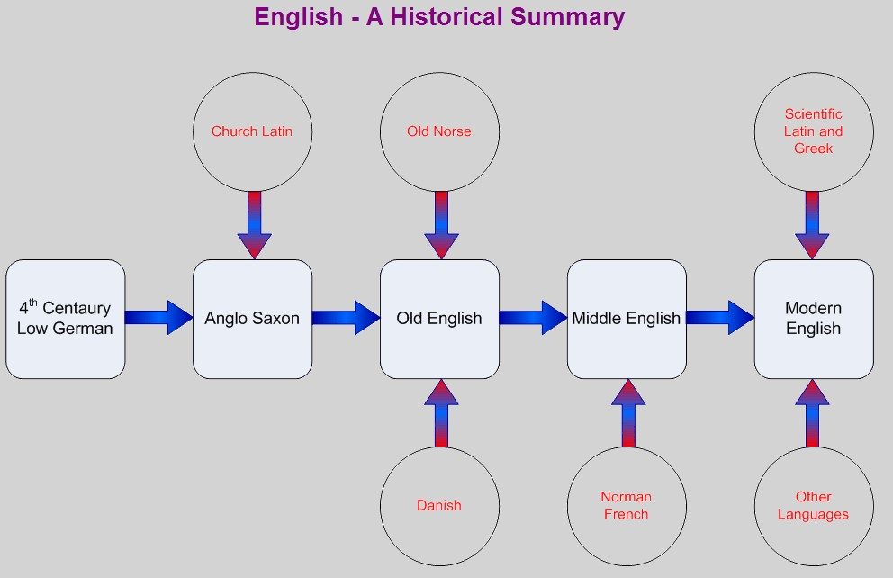

Lesson 22
HISTORY OF ENGLISH FROM 1500 TO 1650-PART 2
Topic – 106: Changing Vocabulary (1500-1650)
In this topic, the following points are discussed:
Factors Behind:
  - The Norman Conquest
  - The Black Death
  - More general - less influential.
Certain of these new conditions come into play, that previously had not existed at all or were present in limits. These conditions caused English to develop along somewhat different lines from those that had characterized its history in the Middle Ages.
- Further Factors:
  - Printing press
  - Rapid spread of education
  - Increased communication
- Effect on Vocabulary
- Both radical and conservative
- Radical in terms of vocabulary
- Conservative in terms of grammar
A radical force means anything that promotes change in language. Now these conditions are favorable to the spread of ideas and stimulating to the growth of the vocabulary.Apart from the special effects of the Norman Conquest, in the Middle Ages, changes in vocabulary were not so great.
Topic – 107: Changing Grammar (1500-1650)
In this topic, the following points are discussed:
The case of grammar was opposite to vocabulary. Changes in vocabulary were radical. On the other hand, treatment of grammar was conservative. The question is, what do we mean by conservative? It means that which tends to preserve the existing status. There was a relationship of various agencies in this regard:
  - Printing press
  - The reading habit
  - The advances of learning
  - Science
  - Increased communication
The paradox of the situation was favorable to the spread of ideas and was stimulating to the growth of the vocabulary. But it created social consciousness to work actively toward the promotion and maintenance of a standard, especially in grammar and usage. So, changes in grammar have been relatively slight. But, in the Middle English period changes in grammar were revolutionary.
Topic – 108: Problem of Orthography (1500-1650)
In this topic, the following points are discussed:
For the English, as for the French and the Italians, in the 16th century the question of orthography or “right writing,” as Mulcaster preferred to call it, was important. Generally speaking, the spelling of the modern languages in the Middle Ages had attempted with fair success to represent the pronunciation of words. The same is true of English, though Norman scribes introduced considerable confusion.
How did they do so? The answer is:
- They tried to write a language that they imperfectly knew.
- Followed pronunciation to create spelling.
- Carried French habits.
The confusion was increased when certain spellings gradually became conventional while the pronunciation slowly changed. Reason was because the corresponding word in Latin was so spelled. For example (debitum, dubitare)
In the Sixteenth Century:
The variability of English spelling existed and there was an instability that people felt. There were limits to its variety and inconsistency. Spelling varied more from writer to writer. Spellings also varied according to education and temperament. In spellings, Mulcaster’s contribution cannot be denied. His contribution was of moderation. He could see the futility of trying to make it phonetic, and was willing to compromise. The basis of his reform, therefore, was custom or usage. This he defines not as the practice of the ignorant, but that “wherein the skillful and best learned do agree.” Overall we can notice that in the first half of the next century, a tendency towards uniformity increased steadily. Fixation of English spelling is generally associated with Dr. Johnson. In The New World of English Words published (1658) by Milton’s nephew Edward Phillips, the compiler says: “As for orthography, it will not be requisite to say any more of it then may conduce to the readers direction in the finding out of words,” .
Spelling was one of the problems that the English language began consciously to face in the sixteenth century. During the period from 1500 to 1650, it was fairly settled.

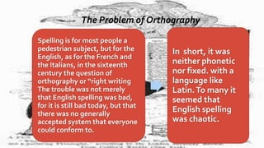

Topic – 109: Issues and Struggles for Recognition
In this topic, the following points are discussed:
The English had attained an established position as the language of popular literature. But a strong tradition still sanctioned the use of Latin. The Renaissance was a time of “revival of learning.” Records of Greek civilization became once more available. Latin and Greek were the key to the world’s knowledge and were highly esteemed for poetry, oratory, and philosophy.
English faced a competition.
- English had a recent history of:
  - A vulgar tongue
  - Being immature
  - Unpolished with limited resource
  - Could not express abstract ideas
- The real force behind the use of English was:
  - A popular demand,
  - All sorts of men in practical life
  - To share in the fruits of the Renaissance
Topic – 110: The Problem of Enrichment
In this topic, the following points are discussed:
In 1531, Sir Thomas Elyot published The Governour. The name of the work had logic because it had to do with the training of those who in the future would be occupied at court. So, it can be concluded that the need for enrichment of language was realized on a very conscious level. The question was how to handle the problem of enrichment of English? The answer lied in the popular demand. But it needed support and also it needed approval of the elite.

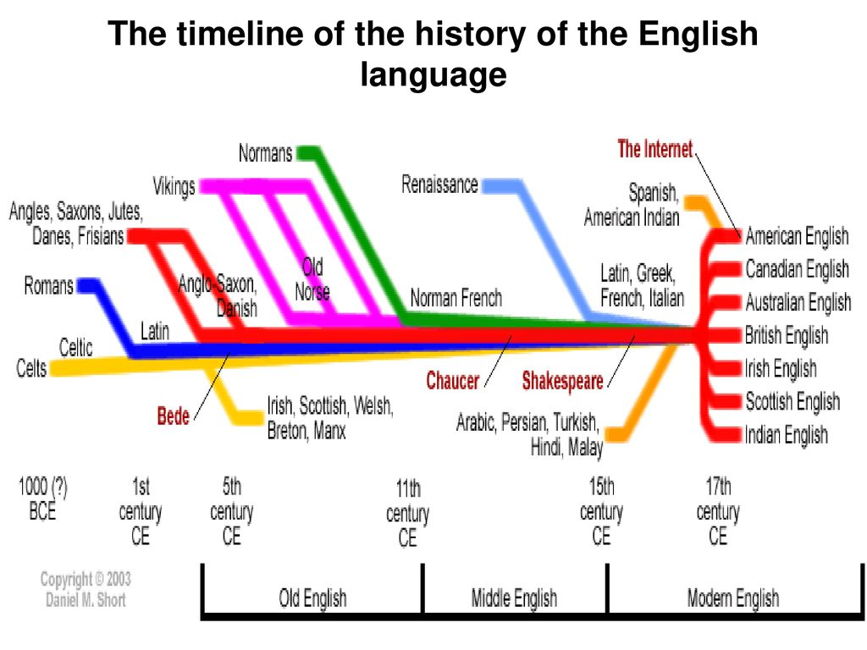

Lesson 23
HISTORY OF ENGLISH FROM 1500 TO 1650-PART 3
Topic – 111: Defence of Borrowing Compromise
In this topic, the following points are discussed:
Dryden asserted, “I trade both with the living and the dead, for the enrichment of our native tongue”. He continued: “We have enough in England to supply our necessity, but if we will have things of magnificence and splendor, we must get them by commerce.” The innovators had precedent on their side. Not only English borrowed, all other languages including Latin and Greek did so too. The strangeness of the new words, they argued, would soon wear off. As Mulcaster observed, we must first become acquainted with any new thing “and make the thing familiar if it seem to be strange”.
Compromise
The opposition to inkhorn terms was at its height in the middle of the sixteenth century. At the end of Elizabeth’s reign, borrowing had gone so far= attack was rather directed at the abuse of the procedure than at the procedure itself. The use of unfamiliar words could easily be overdone.
Enthusiast and the Pedant: It needs to be considered from these perspectives:
- Criticism of reasonable people upon the practice
- Sweeping terms
- Inconsistent with their own usage.
- Puttenham, for example, warned against inkhorn terms. Though he himself admits having to use some of them. He defends the words scientific, major domo, politien (politician), conduct (verb), and others.
- Nobody could wholly avoid the use of the new words.
- Writers differed in extent.
So, the safest course was a middle one, to borrow, but “without too manifest insolence and too wanton affectation.”
Topic – 112: Permanent Additions & Adaptations
In this topic, the following points are discussed:
Exaggeration of a critic like Wilson: He thought that much of the effort to introduce new words into the language was pedantic and ill-advised. Some of the words Wilson ridicules seem forced, but it would be a mistake to conclude all or even a large part of the additions. Many of them are in such common use today= hard to realize that to the Elizabethan, they were strange and difficult. Elyot, for instance, needed a single word for “all maner of lerning”. Some called it the world of science, others the circle of doctrine, but the one word solution came from Greek that is encyclopedia. The words that were introduced at this time were often basic words—nouns, adjectives, verbs.
Examples of Nouns:
Allurement, allusion, anachronism, atmosphere, autograph, capsule, denunciation, dexterity, disability, disrespect, excursion, expectation, jurisprudence etc.
Among Adjectives:
Agile, appropriate, conspicuous, dexterous, expensive, external, habitual, hereditary, impersonal, insane, jocular, malignant
Among the Verbs
Adapt, alienate, assassinate, benefit, consolidate, disregard (introduced by Milton), emancipate, erupt, excavate, exert, exhilarate, exist, extinguish, harass, meditate (which Sidney introduced)
In fact, most of the words are from Latin though some are Greek from where they were opted earlier into Lain. Here are a few examples:
anachronism, atmosphere, autograph.
antipathy, antithesis, chaos, chronology, climax, crisis, critic,
Dogma, emphasis, enthusiasm, epitome, parasite, parenthesis, pathetic, pneumonia, scheme, skeleton, system, tactics
Route of entry of these words was:
Greek words came into English through Latin or French. But in the Renaissance, the renewed study of Greek led to direct introduction.
  - Examples:
Anonymous,, criterion, idiosyncrasy, lexicon, tantalize, thermometer, and tonic.
Adaptation
  - Some words, in entering the language, retained their original form; others underwent change.
  - Climax, appendix, epitome, exterior, delirium, and axis still have their Latin form.
  - Adaptation through cutting off the Latin ending.
  - Conjectural (L. conjectural-is), consult (L. consult-are), exclusion (L. exclusion-em), and exotic (L. exotic-us) show how easily this could be done.
Sometimes:
It is necessary to bring the word into accord with the usual English forms. So, Latin ending -us in adjectives was changed to -ous (conspicu- us>conspicuous) or was replaced by -al as in external (L. externus). Latin nouns ending in -tas were changed in English to -ty (brevity<brevitas). Also nouns ending in -antia, -entia appear in English with the ending -ance, -ence or -ancy, -ency, Adjectives ending in –bilis take the usual English (or French) ending -ble. Examples are consonance, concurrence, constancy, frequency, considerable, susceptible. Overall, we can say that additions in English language took place on a permanent basis either by directly adding words or by adapting and modifying them.
Topic – 113: Giving New Meanings
In this topic, the following points are discussed:
If we trace the history of the English language, we realize that words were borrowed more than once. Latin words episcopus and discus in OE as bishop and dish and were again borrowed later to make our words episcopal and disc (also dais, desk, and discus).
Permanent Additions & Adaptations
In the same way, chaos and malignity were apparently reintroduced in the sixteenth century. Intelligence is used once in Gower and occasionally in the fifteenth century. In The Governour Elyot :
“intelligence is nowe used for an elegant worde where there is mutuall treaties or appoyntementes, eyther by letters or message.”
When second time a word is borrowed, it carries same or a different meaning; both the options or possibilities are equally significant. Word fastidious in 1440 meant ‘proud, scornful’. A century later it was used in more usual Latin sense of ‘distasteful, disgusting.’ However, its modern meaning is ‘hard to please, fussy’ etc. Chaucer uses the words artificial, declination, hemisphere in astronomical senses, but their present use is due to the sixteenth century. The word abject was found earlier in the sense of ‘cast off, rejected,’ but was reintroduced in its present meaning in the Renaissance.
Among the Verbs we find examples of the following:
adapt, alienate, assassinate, benefit, consolidate, disregard (introduced by Milton), emancipate, erupt, excavate, exert, exhilarate, exist, extinguish, harass, meditate (which Sidney introduced)
Topic – 114: Reinforcement through French
It is not always possible to say whether a word is directly from Latin or came indirectly through French. Reason for this uncertainty is that a wholesale enrichment was going on simultaneously in French. The same words were being introduced in both languages. Often the two streams of influence merged. But of course first hand borrowing happened. Word fact represents the Latin factum and not the French fait, which was taken into English earlier as feat. Verbs like confiscate, congratulate, and exonerate are formed from the Latin participle (confiscat-us, etc.) and not from the French confisquer, congratuler, exonerer, The form prejudicate Latin while prejudge represents French prejuger. Instruct and subtract have Latin ancestry (instructus, subtractus).
Why is it so? Well, the French instruire and subtraire would have become in English instroy (like destroy) and subtray (which is found in the fifteenth century).
Conjugation
Is probably a direct importation from Latin (conjugation-em) since the more usual form in French was conjugaison.
Sometimes the occurrence of a word in English earlier than in French (e.g., obtuse) points to the direct adoption from Latin, as confidence, confident, which are in French as confiance, confiant. Still many words have come into English from Latin or French. Verbs like consist and explore could come either from the Latin consistere and explorare or the French consister and explorer. Conformation, conflagration, and many other similar nouns may represent either Latin conformation-em, conflagration-em, or French conformation, conflagration. So adjectives like affable, may represent the Latin affabilis or the French affable, etc. Ultimately, all of these have Latin origin. In many cases, French may have offered a precedent for introducing the Latin words into English and may have assisted in their general adoption.
Topic – 115: Permanent Additions and Adaptations
In this topic, the following points are discussed:
Sixteenth-century purists objected to three classes of strange words, which they characterized as
- Inkhorn terms,
- Oversea language
- Chaucerisms
For the foreign borrowings in this period were by no means confined to learned words taken from Latin and Greek. English vocabulary at this time was borrowing from more than fifty languages which included the following major languages:
- Latin
- Greek
- French
- Italian
- Spanish
Also a great role was played by French Travel and Consumption of French books which is reflected in such words as alloy, ambuscade, bombast, chocolate, comrade, detail, duel, entrance, equip,, essay, explore,, naturalize, probability, progress, shock
But the English also traveled frequently in Italy, observed Italian architecture, and brought back not only Italian manners and styles of dress but also Italian words. Protests against the Italianate Englishman are frequent in Elizabethan literature. Objection was about the impact that it corrupted morals, brought outlandish fashions, “powdered their talk with oversea language.” Nevertheless, Italian words, like Italian fashions, were frequently adopted in England. Words like algebra, balcony, design, granite, piazza, portico, stanza, and volcano began to be heard on the lips of Englishmen or to be found in English books. Many other Italian words were introduced through French or adapted to French forms, words like: battalion, bankrupt, gala, gazette, grotesque, infantry.
From Spanish and Portuguese, English adopted
- Alligator, apricot,, banana, corral,, hammock, hurricane, maize, mosquito, mulatto, negro, peccadillo, potato, rusk, tobacco, and yam.
Reasons that promoted it all included:
- Cosmopolitan tendency,
- Spirit of exploration and adventure
- Interest in the New World

Lesson 24
HISTORY OF ENGLISH FROM 1500 TO 1650-PART 4
Topic – 116: Shakespearean Pronunciation
In this topic, the following points are discussed:
Shakespeare’s pronunciation was not exactly ours, but was like ours. He pronounced [e] for [i] in some words, just as Pope could still say tay for Tea. The falling together of er, ir, ur (e.g., herd, birth, hurt) was under way but not yet completed. As explained earlier, ME ē was sometimes open, sometimes close [ε: e:] and the two sounds were still distinct in Shakespeare’s day, [e:] and [i:] respectively. Consequently, sea [se:] does not normally rhyme with see [si:]. So is the case of heap with keep, speak with seek, etc.
Towards the close of the 15th century, an attempt was made to distinguish them. The closer sound was often spelled with ee or ie (deep, field) while the more open sound was as written ea (sea, clean). But the practice was not consistently carried out.
The two sounds are now identical with a variation in spelling. Also notice a considerable difference in the pronunciation of words containing a. This regularly developed into [u:], as in room, food, roof, root, and it retains this sound in many words today. In some words, the vowel was shortened in the fifteenth century and was unrounded to the sound in blood, flood. In still other words, however, it retained its length until about 1700 but was then shortened without being unrounded, giving us the sound in good, stood, book, foot.
In Shakespeare’s time, there was a much fluctuation in the pronunciation of words containing this Middle English vowel. Consequently, in poetry, flood rhymed blood but mood and good rhymed as well. In Dryden, we have same rhyme: flood—mood—good, the three developments of the sound at the present day. Only in recent times we find it standardized. Also the quality of vowels there were some differences of accent. On the whole, however, we should probably have very little difficulty in understanding Shakespeare’s pronunciation. In Chaucer, it was different because in the fifteenth and sixteenth centuries, the vowels of Middle English, especially the long vowels underwent a wholesale but quite regular shifting. Notice:
‘stone’ in Shakespeare’s pronunciation has become similar to its present pronunciation (stone).
Today the o is followed by a slight u glide [stoun] or [stoUn]
Overall his pronunciation is familiar. We find it modern, easy to read and quite regular/stable.

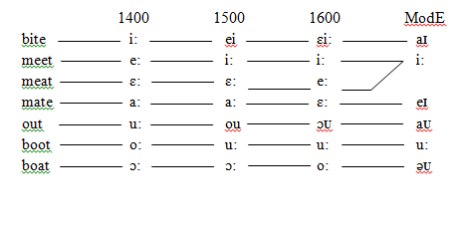
The following video will create the realization of Shakespeare’s influence on everyday English:
https://www.youtube.com/watch?v=alInQ7nzKrI
Topic – 117: Grammatical Features in Renaissance Period
In this topic, the following points are discussed:
English grammar in the sixteenth and early seventeenth century is marked more by the survival of certain forms and usages that have since disappeared than by any fundamental developments. The great changes of reduced inflections of Old English had already taken place. However, retentions of some inflections took place. In fact, Shakespearean reader can notice minor differences of form and in the framing, syntax and idiom. These differences of syntax and idiom although attract attention, are not sufficient to interfere seriously with understanding.
Overall, in terms of grammar and syntax it was a period of stability. Standardization had already taken place. London standard was accepted and people were sticking to it. We may contrast it with vocabulary that was heavily enriched in this period. But, overall grammar and syntax do not show much modification or transition.
Topic – 118: Renaissance Noun, Adj. & Pronoun
In this topic, the following points are discussed:
Noun:
The only inflections retained in the noun were those marking the plural and the possessive singular.
Plurals:
s-plural had become generalized except for a few nouns like sheep and swine with unchanged plurals, and a few others like mice and feet with mutated vowels, no other forms. In the sixteenth century, however, there are certain survivals of the old weak plural in –n. Mostly shift to s- forms took place. For example: fon (foes), kneen (knees), fleen (fleas). All modern forms are used by him. But he sometimes has eyen (eyes), shoon (shoes). We can relate it to today where we still use children and brethren or oxen. An interesting peculiarity of the times is of the his-genitive. In Middle English, the -es of the genitive, being unaccented, was frequently written and pronounced -is, -ys. The ending was thus often identical to the pronoun his, which commonly lost its h when unstressed.
As far as the adjective is concerned, it had already lost all its endings. It no longer expressed distinctions of gender, number, and case. However, chief interest was in the form of the comparative and superlative degrees. Since Old English times, two methods to form comparative and superlative existed: With the endings -er and –est; or with the adverbs more and most. But here we had more variety. Shakespearian comparisons honester, violentest are now replaced by the analytical forms.
Double comparatives were another striking feature. He and his contemporaries have used more larger, most boldest. For example Mark Antony’s This was the most unkindest cut of all is an instance that can be quoted.
The chief development affecting the adjective in modern times has been the gradual settling down of usage so that monosyllables take -er and –est. Most adjectives of two or more syllables (especially those with suffixes like those in frugal, learned, careful, poetic, active, famous) take more and most.
The Pronoun
- Establishment of the personal pronoun in the form that it has had ever since.
Three Changes Were Involved:
- Disuse of thou, thy, thee;
- Substitution of you for ye as a nominative case;
- Introduction of its as possessive of it
In the earliest period of English, the distinction between thou and ye was simply one of number Thou was the singular and ye the plural form for the second person pronoun. In time, however, a quite different distinction grew up.
13th Century:
Singular forms (thou, thy, thee) were used among familiars and in addressing children or inferior rank. Plural forms (ye, your, you) began to be used for respect to superior.
A new possessive neuter: its
The neuter pronoun in OE was declined, hit, his, him, hit, which by merging of the dative and accusative under hit in Middle English became hit, his, hit. In unstressed positions, hit weakened to it. At the beginning of the modern period -the usual form for the subject and object was in use. His remained the proper form of the possessive. Sometimes Shakespeare uses: (when Horatio, describes the ghost in Hamlet): It lifted up it head, or when the Fool in Lear says: The hedge-sparrow fed the cuckoo so long, that it had it head bit off by it young. So, Renaissance had an impact on nouns, adjectives as well as pronouns.
Topic – 119: Verb in Renaissance English Period
In this topic, the following points are discussed:
A casual reader is aware of certain differences of usage in the verb that distinguish it. These differences are sometimes so slight as to give only a mildly unfamiliar tinge to the construction. Lennox asks in Macbeth, Goes the King hence today? = interrogative form without an auxiliary, Should say:
- Does the king go? Or Is the king leaving today?
- Instead of has been, Shakespeare often says is.
Impersonal use of the verb was more common than today. Example: It yearns me not, it dislikes me. Certain differences in Inflection can be noticed. By the end of sixteenth century, some forms like tells, gives, says predominate, though, doth and hath, the older usage may have been more common.
Merchant of Venice
The quality of mercy is not strain’d,
It droppeth as the gentle rain from heaven
Upon the place beneath: it is twice bless’d;
It blesseth him that gives and him that takes:…
A writer toward the middle of the century observes: “howsoever wee use to Write thus, leadeth it, maketh it, noteth it, raketh it, per-fumeth it, etc. Yet in our ordinary speech (which is best to be understood) wee say, leads it, makes it, notes it, rakes it, per-fumes it.”It is altogether probable that during Shakespeare’s lifetime -s became the usual ending for this part of the verb in the spoken language.
In ME, extensive inroads were made in the ranks of the Old English strong verbs. Many of these verbs were lost, and many became weak. A lot of fluctuation and alteration in the past tense and past participle. All reflected in the language of Shakespeare and his contemporaries. Verbs that developed weak forms were bide, crow, crowd, flay, mow, dread, sprout, and wade, Also some strong forms disappeared. A number of weak forms like blowed, growed, shined, shrinked, swinged were in fairly common use, although these verbs ultimately remained strong. Bote as the past tense of bite (like write—wrote) was still in occasional use. Participle baken is more frequent in the Bible than baked. In Shakespeare’s day there was much more latitude in the inflection of the verb than is permitted today.
In the following material there is a brief reflection of English verbs under going changes during Renaissance:
https://slideplayer.com/slide/4883627/
Topic – 120: Renaissance: Usage and Idiom
This topic discusses the usage and idiom in the Renaissance English. In this lecture, the following points have been discussed: Language is not merely a matter of words and inflections. We also need to consider idiom and usage.
Some Examples:
Shakespeare says creeping like snail, with as big heart as thou, in number of our friends, within this mile and half, where modern idiom requires an article in all these cases. On the other hand, where we say at length, at last, Shakespeare says at the length, at the last. Again, usage permitted a different placing of the negative—before the verb—as in such expressions as: I not doubt, it not appears to me, she not denies it.
So Shakespeare could say:
Thou hast spoken no word all this while—nor understood none neither;
I know not, nor I greatly care not; Nor this is not my nose neither; First he denied you had in him no right;
My father hath no child but I, nor none is like to have; Nor never none shall mistress be of it, save I alone.
Prepositions:
Shakespeare says:
I’ll rent the fairest house in it after threepence a bay, we should say at
Our fears in Banquo stick deep,
should say about.
The single preposition of shows how many changes in common idioms have come about since 1600:

One that I brought up of (from) a puppy; he came of (on) an errand to me;
’Tis pity of (about) him; your name…. I know not, nor by what wonder you do hit of (upon) mine;
And not be seen to wink of (during) all the day; it was well done of (by) you;
I wonder of (at) their being here together;
I am provided of (with) a torchbearer; I have no mind of (for) feasting forth tonight;
I were better to be married of (by) him than of another;
That did but show thee of (as) a fool.
Generally idiom and usage claim less attention. But, no picture of Elizabethan English would be adequate without its fair recognition.

Lesson 25
OVERVIEW OF THE DEVELOPMENT OF RENAISSANCE ENGLISH
Topic – 121: Renaissance: General Characteristics
In this topic, the following points are discussed:
The larger spirit of the age is reflected in linguistic matters. A conscious interest in the English language was taken. An attention to its problems is now widely manifested. The fifteenth century had witnessed sporadic attempts by individual writers to embellish their style with “aureate terms.” These attempts show a desire to improve the language, at least along certain limited lines.
But in the16th Century:
- Books and pamphlets, prefaces and incidental observations were published to support linguistic change in English.
- Defended: Against those who were disposed to compare it unfavorably to Latin or other tongues.
- Recognized: its position as the national speech.
- Urged its fitness for learned and literary use.
Overall, this a time that showed a great desire:
- To fix language
- To make it stable
- To modernize it
- To standardize it
The following material will be helpful in comprehending the development of English during Renaissance:
https://www.slideshare.net/ManuellGB/the-renaissance-15001650-by-manuel-gracia-baez
Topic – 122: Conscious Efforts for Development
After completing this topic, students will understand the conscious efforts made during the period for the development of English.
In this topic, the following points are discussed:

A century or two before= upper classes = interested = correct French accent = sent children abroad
Now, English was considered worthy of cultivation. It was to be looked after in the education of the young. Elyot urged that noblemen’s sons should be brought up by those who
“speke none englisshe but that which is cleane, polite, perfectly and articulately pronounced, omittinge no lettre or sillable,”
He observes that he knew some children of noble birth who had “attained corrupte and foule pronunciation” through the lack of such precautions. Also, there was a desire to improve it in various ways—particularly to enlarge its vocabulary and to regulate its spelling. All of these efforts point clearly to a new attitude towards English, an attitude that makes it an object of conscious and in many ways fruitful consideration. So, in this period, we attain something as a standard, and recognizably “modern”
Topic – 123: Standard Literary Language
This is a period of time when standard and recognizably “modern” English developed. The effect of the Great Vowel Shift was to bring the pronunciation within measurable distance of that which prevails today. The influence of the printing press and the efforts of spelling reformers had resulted in a form of written English that offers little difficulty to the modern reader. New vocabulary was introduced but as far as grammar is concerned, it was fixed by this time. In the writings of Spenser, Shakespeare and their contemporaries, a standard literary language is used free from the variations of local dialect. Although Sir Walter Raleigh might speak with a broad Devonshire pronunciation, Spenser and Shakespeare may have traces in their speech of their Lancashire and Warwickshire ancestry, but, they wrote common English without dialectal idiosyncrasies.
So, Puttenham (1589) reminds us:
“herein we are already ruled by th’ English Dictionaries and other bookes written by learned men, and therefore it needeth none other direction in that behalfe.” Some characteristics of the language were not yet completely settled, but the written language in the latter part of the sixteenth century is fully entitled to be called Standard English. The regularization of spellings in this written standard can be seen as early as the mid-fifteenth century in the official documents of Chancery.
Topic – 124: Vigor and Willingness to Venture
English in the Renaissance, at least as we see it in books, was much more plastic than now. People felt freer to mold it to their wills. As far as words were concerned, they were not always distributed into rigid grammatical categories. Adjectives appear as adverbs or nouns or verbs, nouns appear as verbs. In fact, any part of speech as almost any other part,
As Shakespeare wrote “stranger’d with an oath”
He was fitting the language to his thought, not forcing his thought into the mold of grammar. It was in a language, as in many other respects, an age with the characteristics of youth—vigor, a willingness to venture, and a disposition to attempt the untried. The spirit that animated Hawkins and Drake was not foreign to the language of their time. Overall the characteristics of language included vigor, enthusiasm, willingness and keenness.
Topic – 125: What is Left Unsettled?
In this topic, the following points are discussed:
Though a lot of progress was made, a good many features of the language were still unsettled. There still existed a considerable variety of use—alternative forms in the grammar, experiments with new words, variations in pronunciation and spelling. Latitude: clearly permitted among speakers of education and social position. Literary language and good colloquial English= very close. Where one might say, have wrote or have written with equal propriety, as well as housen or houses, shoon or shoes, one must often have been in doubt over which to use. One heard service also pronounced sarvice,
Examples:
- certain—sartin,
- concern—consarn,
- divert—divart,
- clerk—clark,
- smert—smart, etc.
These and many other matters were still unsettled at the close of the period. Their settlement was one of the chief concerns of the next age. Overall this was a time of eagerness, enthusiasm, willingness and acceptance.

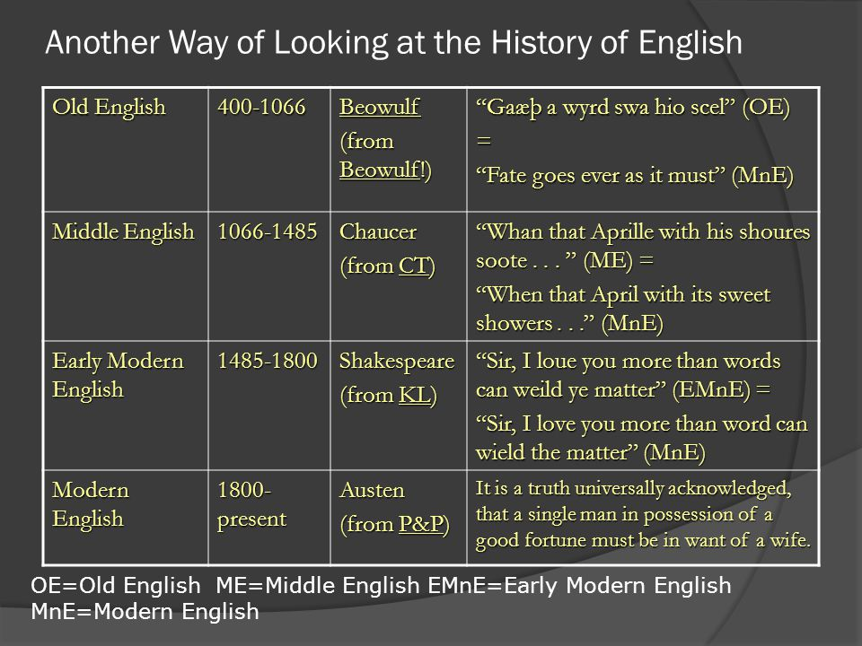

Lesson 26
HISTORY OF ENGLISH FROM 1650 TO 1800-PART 1
Topic – 126: Impact of 17th Century
In this topic, the following points are discussed:
The social, commercial, technological, and intellectual forces that were released in the Renaissance had profound effects on the English language. In the middle and latter part of the seventeenth century, the evolution and interaction of these forces led to a culmination, a series of crises, and an eventual reaction. Both the crises and the responses to them were provoked by transmutations of forces that had energized the Renaissance. These new trends became disruptively intense now.
As far as crisis is concerned, English Civil War (1640) & Restoration of Charles II in 1660 brought instability. However, there was more intellectual turbulence with reference to the matters of language and language use. In comparison to the political turbulence, this was harder to trace. There were new scientists and philosophers vs. religious zeal and occult science accompanied by belief in astrology, alchemy, and witchcraft. Radical Non-conformists and perceived fanatics were lumped together under the label “Enthusiasts” by writers and scientists connected with the Royal Society, and conservative Anglicans. Supporters of rational science, such as Henry More, Thomas Sprat, John Wilkins, and Robert Boyle were disturbed by the “ranting” language of the Enthusiasts. More conservative minds were concerned about the very fact of public expression and the sheer bulk of controversial publications. Learned discourse was no longer confined to elite circles. Also practitioners of Natural Science condemned the Enthusiasts and the old authorities. In fact, it was an open controversy and it was still very difficult for people to conceive that open controversy was either safe or beneficial to society.
Result:
The 17th century had a more focused public consciousness about language. Yet, mostly educated people recoiled from the solution. Thomas Hobbes proposed that all power must reside in a single political authority. In 1660 a proposed solution was that the Royal Society should work as coordinator and clearing house for English scientific endeavors.
Argument:
The English prose of scientists should be stripped of ornamentation and emotive language. It should be plain, precise, and clear. This led to efforts to design universal languages. So, there was an intense awareness of the importance of language in almost every sphere of life. But the Royal Society could not impose its scheme. Nor did the Royal Society create the “plain style”.

Topic – 127: The Temper of 18th Century
In this topic, the following points are discussed:
The first half of the eighteenth century is commonly designated in histories of literature as the Augustan Age in England. The principal characteristics of this age emerged early. But, they maintained their influence throughout the century. However, there were some radical challenges in the final two decades. A search for stability can be noticed in these times. There was a strong sense of order. Adventurous individualism and the spirit of independence of the previous era gave way to a desire for system and regularity. Conformity to a standard that the consensus recognizes was considered to be good. Correctness was an ideal. Attempts were made to formulate rules to define and achieve correctness. Satisfaction in things was much linked to logical explanation. But the powerful new current of scientific rationalism did not sweep away the firmly grounded reverence for classical literature. Latin was still a model and there was a desire for perfection
Topic – 128: Attitude towards English (1650 to 1800)
In this topic, the following points are discussed:
In the early eighteenth-century, efforts to standardize, refine, and fix the English language were made. Now discussions on language take a new turn. Previously, interest was whether English was worthy to replace Latin or not; whether additions in vocabulary were justified or not; and whether a better system of spelling could be introduced or not. Now, for the first time attention to grammar was paid, and it was discovered that grammar was largely un-codified and un-systematized. If we look at the ancient models, we can see that the ancient languages had been reduced to rules; one knew what was right and what was wrong. But in English everything was uncertain. One learned to speak and write as one learned to walk.
Much variation was found even among educated people. This was clearly distasteful to an age that desired an orderly universe. The spontaneous creativity of Shakespeare now led to hesitation and uncertainty. Dryden confessed: he had to translate an idea into Latin. To set the standard of correctness in language, -use of logic- often arriving at entirely false conclusions.
The idea was that English has been and is being daily corrupted; it needs correction and refinement; and it should be fixed permanently and protected from change. In other words, it was desired in the eighteenth century to give the English language a polished, rational, and permanent form. How mistaken were these goals and methods, you will realize in the study of the next periods in the history of the English language.

Topic – 129: The Problem of Refining English Language
In this topic, the following points are discussed:
- Uncertainty was not the only fault. Another fault was the lack of a standard.
- The natural result of all this was:
  - Corruptions
  - Unchecked language
  - Frequent lament was that language had been steadily going down
  - A regretful backward glance at the good old days
It was Dryden’s opinion that “from Chaucer the purity of the English tongue began”. He was not convinced about the downward course of language. For Swift, the golden age was that of the great Elizabethans. His views were that there are corruptions in our language, but very few of the best authors have wholly escaped these. Dr. Johnson also agreed with this opinion. In his Dictionary he says: “I have studiously endeavoured to collect examples and authorities from the writers before the restoration, whose works I regard as the wells of English undefiled, as the pure sources of genuine diction.”
This talk had a sentimental regard for the past, but was not more serious than the perennial belief that our children are not what their parents were. Swift was a conservative. His beliefs were grounded in a set of political and religious, as well as linguistic, opinions. He cherished the principle of authority in church and state; and criticized the skeptical spirit of inquiry proposed by the Royal Society. Swift upheld the classics, but understood the merits of a plain English style, though only when not polluted by crude and careless usages.
George Campbell in his Philosophy of Rhetoric (1776) says: “I shall just mention another set of barbarisms, which also comes under this class, and arises from the abbreviation of polysyllables, by lopping off all the syllables except the first, or the first and second. Instances of this are hyp for hypochondriac, rep for reputation, ult for ultimate, penult for penultimate, incog for incognito, hyper for hypercritic, extra for extraordinary. Happily all these affected terms have been denied the public suffrage”. Swift also opposed the tendency to contract verbs like drudg’d, disturb’d, rebuk’d, fledg’d
Swift also criticized “young preachers, fresh from the universities, who use all the modern terms of art, sham, banter, mob, bubble, bully, cutting, shuffling, and palming, all which, and many more of the like stamp, as I have heard them often in the pulpit, so I have read them in some of those sermons that have made most noise of late.”
Swift’s letter to the Tatler in 1710: he called attention to them again two years later in his Proposal for Correcting, Improving, and Ascertaining the English Tongue. Swift published a letter supposedly “received some time ago from a most accomplished person in this way of writing”: Sir, I cou’dn’t get the things you sent for all about Town.—I thôt to ha’ come down myself, and then I’d ha’ brout’um; but I han’t don’t, and I believe I can’t do’t, that’s pozz.— Tom begins to g’imself airs because he’s going with the plenipo’s ’Tis said, the French King will bamboozl’ us agen, which causes many speculations. …
…The Jacks, and others of that kidney, are very uppish, and alert upon’t, as you may see by their phizz’s.—Will Hazzard has got the hipps, having lost to the tune of five hundr’d pound, thô he understands play very well, nobody better. He has promis’t me upon rep, to leave off play; but you know ‘tis a weakness he’s too apt to give into, thô he has as much wit as any man, nobody more. He has lain incog ever since.—The mobb’s very quiet with us now.—I believe you thôt I banter’d you in my last like a country put.—I sha’n’t leave Town this month, &c.
Swift gives the remedy that the editor should use his position to rid the language of these blemishes.
Topic – 130: The Desire to Fix the Language
In this topic, the following points are discussed:
One of the most ambitious hopes of the eighteenth century was to stabilize the language and establish it in a form that would be permanent. Swift talked about “fixing” the language, and the word was echoed for fifty years by lesser writers who shared his desire and, like him, believed in the possibility of realizing it. The fear of change was an old one. Bacon, at the end of his life had written to his friend, Sir Toby Matthew (1623): “It is true, my labours are now most set to have those works, which I had formerly published,…well translated into Latin…. For these modern languages will, at one time or other, play the bankrupts with books.”
Shortly after the Restoration, the poet Waller wrote (Of English Verse):
But who can hope his lines should long
Last, in a daily changing tongue?
While they are new, Envy prevails;
And as that dies, our language fails….
Poets that Lasting Marble seek,
Must carve in Latin or in Greek;
We write in Sand….
A little later Swift wrote: “How then shall any man, who hath a genius for history equal to the best of the ancients, be able to undertake such a work with spirit and cheerfulness, when he considers that he will be read with pleasure but a very few years, and in an age or two shall hardly be understood without an interpreter?”
Pope echoed the sentiment when he wrote in his Essay on Criticism, And such as Chaucer is, shall Dryden be. All these people believed that by taking thought it would be possible to suspend the processes of growth and decay that characterize a living language. The anonymous author of the pamphlet Vindex Anglicus: or, The Perfections of the English Language Defended and Asserted (1644)12 noted that changes in language are inevitable. James Howell (1630) observed: “that as all other sublunary things are subject to corruptions and decay,… the learnedest and more eloquent languages are not free from this common fatality.

Lesson 27
HISTORY OF ENGLISH FROM 1650 TO 1800-PART 2

Topic – 131: In the Footsteps of Italy and France
In this topic, the following points are discussed:
The three-fold problem of standardizing, refining, and fixing. What had been done in this direction by other countries?
Italy and France:
These countries have always been an inspiration and example. In both of these lands, the destiny of the language had been confided to an academy. In Italy, the most famous was the Accademia della Crusca, founded in1582. Its object was the purification of the Italian language. In 1612, it published a dictionary. The dictionary provoked controversy. It went through several editions. The third edition in 1691 was about 3 volumes; whereas the fourth edition (1729–1738) was about 6 volumes. So, it was taken as an impressive example. Perhaps an even more effective precedent was furnished by France. In 1635, Cardinal Richelieu offered a royal charter to a small group of men, who for several years had been meeting once a week to talk about books and to exchange views on literature. The original group was composed of only six or eight; the maximum membership was set at forty. It was named as French Academy.
Major Aim of the French Academy:
“The principal function of the Academy shall be to labor with all possible care and diligence to give definite rules to our language, and to render it pure, eloquent, and capable of treating the arts and sciences.”
Three Aims:
- To cleanse the language of impurities, both in writing and spoken language
- To establish a certain usage of words
- To compile a dictionary, a grammar, a rhetoric, and a treatise on the art of poetry
The dictionary was the most important project. Work proceeded slowly, but in 1694 it appeared. Thus, while England continued to lament the lack of an adequate dictionary, Italy and France both had apparently achieved this object through the agency of academies.

Topic – 132: An English Academy
In this topic, the following points are discussed:
No doubt the vital incentive to the establishment of an academy in England came from the example of France and Italy. The suggestion occurs early in the seventeenth century. Indeed, learned societies had been known in England from 1572. With the Restoration, discussion of an English Academy became much more frequent. In the very year that Charles II was restored to the throne, a volume was published with the title New Atlantis…Continued by R.H.Esquire (1660) in which, as a feature of his ideal commonwealth, the author pictured an academy “to purifie our Native Language from Barbarism or Solecism, to the height of Eloquence, by regulating the termes and phrases thereof into constant use of the most significant words, proverbs, and phrases, and justly appropriating them either to the Lofty, mean, or Comic stile.” Shortly thereafter, the idea of an academy received support from several influential persons, notably from Dryden and John Evelyn.
In the dedication of the Rival Ladies (1664) Dryden says:
“I am Sorry, that (speaking so noble a Language as we do) we have not a more certain Measure of it, as they have in France, where they have an Academy erected for the purpose, and Indow’d with large Privileges by the present King.”
A few months later, the Royal Society took a step. This society, founded in 1662, was mainly scientific in its interests. But, in December 1664 it adopted a resolution. The Resolution Stated:
“there were persons of the Society whose genius was very proper and inclined to improve the English tongue, Particularly for philosophic purposes, it was voted that there should be a committee for improving the English language; and that they meet at Sir Peter Wyche’s lodgings in Gray’s-Inn once or twice a month, and give an account of their proceedings, when called upon.”
The committee had twenty-two members including Dryden, Evelyn, Sprat, and Waller. Evelyn, once unable to attend, wrote out what he conceived to be the things that they might attempt. He proposed the compilation of a grammar and some reform of the spelling, particularly the leaving out of superfluous letters. This might be followed by a “Lexicon or collection of all the pure English words by themselves; then those which are derivative from others, with their prime, certaine, and natural signification; then, the symbolical: so as no innovation might be us’d or favour’d, at least, ‘till there should arise some necessity of providing a new edition, & of amplifying the old upon mature advice.”
He further suggested collections of technical words, “exotic” words, dialect expressions, and archaic words that might be revived. Finally, the translations might be made of some of the best of Greek and Latin literature, and even out of modern languages, as models of elegance and style.
John Dryden was the moving spirit in this gesture of the Royal Society. Not a pioneer in suggesting the creation of an English Academy but the most consistent advocate However, at the end of the century, the idea was clearly in the air. In 1697, Defoe in his Essay upon Projects devoted one article to the subject of academies.
Topic – 133: Swift’s Proposal
In this topic, the following points are discussed:
By the beginning of the eighteenth century, grounds had been prepared and time was ripe for an authoritative plan for an academy. With the example of Richelieu and the French Academy doubtless in his mind, Swift addressed a letter in 1712 to the earl of Oxford, Lord Treasurer of England. It was published under the title A Proposal for Correcting, Improving, and Ascertaining the English Tongue. After the usual formalities, he then launches an attack against the innovations he had objected to in his paper in the Tatler two years before. The remedy he offered was that a free judicious choice should be made of such persons, as are generally allowed to be best qualified for such a work, without any regard to quality, party, or profession. … These, to a certain number at least, should assemble at some appointed time and place, and fix on rules, by which they design to proceed. What methods they will take, is not for me to prescribe.” The work of this group, as he conceives it, is described in the following terms:
“The persons who are to undertake this work will have the example of the French before them to imitate, where these have proceeded right, and to avoid their mistakes.
… Besides the grammar-part, wherein we are allowed to be very defective, they will observe many gross improprieties, which, however authorized by practice, and grown familiar, ought to be discarded. They will find many words that deserve to be utterly thrown out of our language, many more to be corrected, and perhaps not a few long since antiquated, which ought to be restored on account of their energy and sound.”
The publication of Swift’s Proposal marks the culmination of the movement for an English Academy. Swift’s proposal was objected and opposed by several people, mainly on political grounds. John Oldmixon, published Reflections on Dr. Swift’s Letter to the Earl of Oxford, about the English Tongue. It was a violent attack with political motives. He said “I should rejoice with him, if a way could be found out to fix our Language for ever, that like the Spanish cloak, it might always be in Fashion.” But such a thing is impossible. Swift’s proposal was not followed up properly and no serious effort was made to accomplish the purpose.

Topic – 134: Objection to Academy
In this topic, the following points are discussed:
The idea of establishing an academy died hard. The 18th century showed a growing skepticism. The early enthusiasm was replaced with doubts. Dr. Johnson asserted in the Preface to his Dictionary (1755):
“Those who have been persuaded to think well of my design, require that it should fix our language, and put a stop to those alterations which time and chance have hitherto been suffered to make in it without opposition...With this consequence I will confess that I flattered myself for a while; but now begin to fear that I have indulged expectation which neither reason nor experience can justify. When we see men grow old and die at a certain time one after another, from century to century, we laugh at the elixir that promises to prolong life to a thousand years; …
He said: The French language has visibly changed under the inspection of the academy.
Another ground for objection was moved by a spirit of personal liberty in the use of their language. A policy of no interference appeals to them. After the publication of Johnson’s Dictionary, advocacy of an academy becomes less frequent.
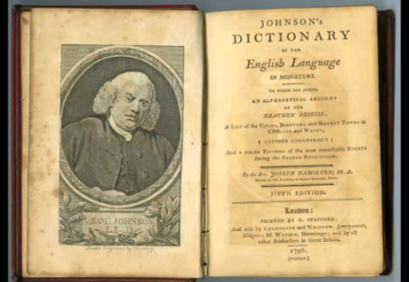
Topic – 135: Johnson’s Dictionary- A Milestone
In this topic, the following points are discussed:
The publication in 1755 of A Dictionary of the English Language, by Samuel Johnson, A.M., in two folio volumes, was hailed as a great achievement. It was justly so regarded. It was the work of one man laboring almost without assistance. It was done in a short space of seven years only.
Defects:
It had defects. Judged by modern standards, it was painfully inadequate. Its etymologies are often ludicrous. It is marred in places by prejudice. It includes a host of words with a very questionable right to be regarded as belonging to the language.
Strengths:
It had positive aspects and virtues as well. It exhibited the English vocabulary much more fully than had ever been done before. It offered a spelling, fixed, even if sometimes badly, that could be accepted as standard. It supplied thousands of quotations illustrating the use of words. Johnson himself remarked in his preface, where his own explanation is inadequate “the sense may easily be collected entire from the examples.”
“Every language,” he says in the preface, “has its anomalies, which, though inconvenient, and in themselves once unnecessary, must be tolerated among the imperfections of human things, and which require only to be registered, that they may not be increased, and ascertained, that they may not be confounded: but every language has likewise its improprieties and absurdities, which it is the duty of the lexicographer to correct or proscribe.”
“The chief intent of it is to preserve the purity, and ascertain the meaning of our English idiom.”
He Sums Up:
- The pronunciation of the language may be fixed.
- Its attainment facilitated.
- Its purity preserved.
- Its use ascertained.
- Its duration lengthened.
- In 1756 Sheridan wrote, “if our language should ever be fixed, he must be considered by all posterity as the founder, and his dictionary as the corner stone.”

Lesson 28
HISTORY OF ENGLISH FROM1650 TO 1800 -PART 3
Topic – 136: The 18th Century Grammarians
In this topic, the following points are discussed:
What Dr. Johnson had done for the vocabulary was attempted for the syntax by the grammarians of the eighteenth century. Books on English grammar had begun to appear in the sixteenth century. In the seventeenth, they were compiled by even such authors as Ben Jonson and Milton. But, they were generally written for teaching foreigners the language or providing a basis for the study of Latin grammar. Only in the 18th century was English grammar viewed as a subject deserving of study in itself. Even then freedom from the notions derived from Latin was something to be claimed as a novelty and not always observed. William Loughton, Schoolmaster at Kensington, wrote Practical Grammar of The English Tongue (1734). It had five editions. He was against those who “have attempted to force our Language (contrary to its Nature) to the Method and Rules of the Latin Grammar.” He goes so far as to discard the terms noun, adjective, and verb, substituting names, qualities, affirmations. In fact, the compilers were the only people with knowledge of the classical languages. They tried to keep the traditional concepts and made an effort that was ill-fitting to an analytic language
The 18th Century Grammarians, the decade beginning in 1760 witnessed a striking outburst of interest in English grammar. A large number of books were written. It had works of men with no special qualifications. Not in the mold of the practical, prescriptive grammars. Overall the questions of grammar and usage had become a matter of popular interest.
Topic – 137: Confusion and Issues Related to Division in Stages
In this topic, the following points are discussed:
The Aims of the Grammarians
The goals of linguistic scholarship vary from author to author in the present century, so one must recognize a variety of concerns in the eighteenth century. Over all eighteenth century grammarians followed:
- A prescriptive tradition of grammar
- Not considering the usage

The Aims of the Grammarians:
- To codify the principles of the language and reduce it to rule.
- To settle disputed points and decide cases of divided usage.
- Point out common errors or what were supposed to be errors, and thus correct and improve the language.
All three of these aims were pursued concurrently. Academy aimed to systematize the facts of English grammar and draw up rules by which all questions could be viewed and decided. In his dictionary, Johnson had declared, “When I took the first survey of my undertaking, I found our speech copious without order, and energetick without rules wherever I turned my view, there was perplexity to be disentangled, and confusion to be regulated”.
But The Grammarians:
- Became lawgivers
- Not content to record facts
- Pronounced judgments
- Of two forms one must be wrong
- They abhorred uncertainty.
- A choice must be made.
- Once a question had been decided, all instances of contrary usage were unequivocally condemned.
The Aims of the Grammarians
Lowth Says:
“The principal design of a Grammar of any Language, is to teach us to express ourselves with propriety in that Language; and to enable us to judge of every phrase and form of construction, whether it be right or not. The plain way of doing this is, to lay down rules, and to illustrate them by examples. But, beside shewing what is right, the matter may be further explained by pointing out what is wrong.”
Overall the questions of grammar and usage had become a matter of popular interest.
Topic – 138: The Beginnings of Prescriptive Grammar
In this topic, the following points are discussed:
To prescribe and to proscribe seem to have been coordinate aims of the grammarians. Many of today’s conventions in books were first stated in this period. The prescriptive distinction between the two verbs lie and lay was first made in the second half of the 18th century. Before that, intransitive lay was not considered a solecism. The expressions had rather, had better were condemned by Johnson, Lowth, and Campbell. It would be possible to point out other matters of usage disputed by grammarians. For Example:
- The proper case after than and as was a question that troubled them.
- (he is taller than I, or me)
- Lowth’s view is accepted till today:
- The pronoun is determined by the construction to be supplied or understood
So,
- He is older than she
- He likes you better than me
Another puzzling question concerned the case before the gerund (I don’t like him doing that or his doing that). His here was opposed by Harris, Lowth, and others; but Webster held that this was “the genuine English idiom” and the only permissible form. His opinion has come to be the one widely held. Finally, we may note that the eighteenth century is responsible for the condemnation of the double negative. Lowth stated the rule that we are now bound by: “Two Negatives in English destroy one another, or are equivalent to an Affirmative.” Thus a useful idiom was banished from polite speech.
Topic – 139: Problems of Prescriptive Grammar
In this topic, the following points are discussed:
While acknowledging the results attained by the eighteenth-century grammarians and reformers, it is necessary to emphasize the serious limitations. Their greatest weakness was that they did not recognize the importance of usage. They did not realize and refused to acknowledge that changes in language are impulsive and can be unreasonable. In fact, they approached most questions through logic and imposed authority. Hence the constant attempt was to legislate one construction into use and another out of use. No recognition was shown for the legitimacy of divided usage. Noah Webster said, when they refused to base their statements on the facts of current use they were refusing to preserve an agreement between books and practice. They were contributing “very much to create and perpetuate differences between the written and spoken language.” Root cause of all this was ignorance of the processes of linguistic change. The historical study of English was still in its infancy. Though the materials were rapidly becoming available, they did not realize their importance.

Topic – 140: Attempts to Reform Vocabulary
In this topic, the following points are discussed:
Many weaknesses characterized the attempts to reform the vocabulary at this time. Everyone felt competent; everyone prescribed; and everyone proscribed.
Swift said:
“I have done my best,” “for some Years past to stop the Progress of Mobb and Banter, but have been plainly borne down by Numbers, and betrayed by those who promised to assist me.”
George Harris objected to expressions such as:
- Chaulking out a way
- Handling a subject
- Driving a bargain
- Bolstering up an argument
In a volume of Sketches by “Launcelot Temple,” the author attacks expressions such as:
- Encroach
- Inculcate
- Purport
- Betwixt
- Methinks
- Subject-matter
Regarding the last expression Subject-matter, he says: “in the Name of everything that’s disgusting and detestable, what is it? Is it one or two ugly words? What’s the Meaning of it? Confound me if I ever could guess! Yet one dares hardly ever peep into a Preface, for fear of being stared in the Face with this nasty Subject Matter.” Campbell says: “I think there is at present a greater risk of going too far in refining, than of not going far enough. The ears of some critics are immoderately delicate.”
Yet he himself has his own list of words to be banned, such as:
- The workmanship of God, for the work of God

- A man of war, for a ship of war
- A merchantman, for a trading vessel
He objected to some words as they have a pleonastic appearance. Such as: unto, until, selfsame, foursquare, devoid, oftentimes, nowadays, downfall, furthermore, further, wherewith. Individual objection to particular expressions was the prevailing attitude. Overall, it was a misguided effort and an interference with the natural course of linguistic history.

Lesson 29
HISTORY OF ENGLISH FROM1650 TO 1800 -PART 4
Topic – 141: Objections to Foreign Borrowings
In this topic, the following points are discussed:
Nature of the 18th Century Concerns
There were fears and apprehension that English was being ruined by the intrusion of foreign words, especially French. Defoe observed “an Englishman has his mouth full of borrow’d phrases…he is always borrowing other men’s language.” His Review (1708) states: I think “using and introducing foreign terms of art or foreign words into speech while our language labours under no penury or scarcity of words is an intolerable grievance.” Shortly before, Dryden had expressed a similar feeling: “I cannot approve of their way of refining, who corrupt our English idiom by mixing it too much with French: that is a sophistication of language, not an improvement of it; a turning English into French, rather than a refining of English by French”. So, French had a strong position to influence English. French was at the height of its prestige. It was used at almost every court in Europe.
The knowledge of the language among the upper classes in England was quite general, equaled only by the ignorance of English on the part of the French. Traveling in France was a necessary part of education and the cultural relations of both the people were very close. Yet danger does not seem to have been acute. The number of French words admitted to the language in the period from 1650 to 1800 was not unusually large. The Oxford English Dictionary records a fair number that did not win permanent acceptance. Those, retained, are very useful words.
Examples: Boulevard, canteen, cartoon, champagne, cohesion, patrol, publicity, routine, syndicate.
Most of these are words that we could ill afford to lose.
Topic – 142: Expansion of the British Empire: Impact
In this topic, the following points are discussed:
During this period, the foundations were being laid for that wide extension of English in the world. The British Empire was not the result of a consciously planned and aggressively executed program. It was a product of circumstances and chance. England entered the race for colonial territory late. End of the fifteenth century witnessed the voyages and these opened up the East and the West to European exploitation. Columbus arrived in the New World in 1492. Vasco de Gama reached India in 1498 by way of the Cape of Good Hope. Their achievements were due to Spanish and Portuguese enterprise. It was only when the wealth of America and India began pouring into Spanish and Portuguese coffers that the envy and ambition of other countries were aroused. The English settlements at Jamestown and Plymouth were the beginning of colonization in North America that soon gave to England the Atlantic seaboard. End of the sixteenth century and the revolt of the Netherlands brought the Dutch into active competition with the Portuguese in the trade with India. Inspired by the Dutch example, in 1600 the East India Company was founded to promote this trade, establishing settlements at Madras, Bombay, and Calcutta.
Borrowings:
  - Mexican words: chili, chocolate, tomato etc.
From Cuba and the West Indies: Barbecue, hammock, hurricane, maize, potato, tobacco;
From Brazil and Other South American regions: Poncho, Tapioca
From India: Bangle, bungalow, cashmere, China, coolie, cot, curry, jungle, jute, loot, mandarin, nirvana, polo, punch, rajah, rupee, sepoy, thug, toddy, tom-tom, and verandah.
- Kangaroo is an interesting example of native words that have passed into universal use.
Topic – 143: Progressive Verb Forms
In this topic, the following points are discussed:
- Impossible to follow here in detail
- Only significant ones can be pointed out.
- One characteristic development in English grammar in the eighteenth century is regarding progressive verb forms.
Where French Says: je chante or German ich singe,
- English may say: I sing, I do sing, or I am singing.
Do-forms are emphatic forms. But, their most important uses are in negative and interrogative sentences (I don’t sing, do you sing?).
To be forms and the present participle are generally called progressive forms. Their most common use is to indicate an action as being in progress at the time implied by the auxiliary. The wide extension of the use of progressive forms is one of the most important developments of the English verb in the modern period.

In Old English, such expressions as he woes lærende (he was teaching) are occasionally found, but usually in translations from Latin. In early Middle English, progressive forms are distinctly rare. Their number increases in the Middle English period and the credit of their development goes to the period since the sixteenth century. The chief factor in their growth is the use of the participle as a noun governed by the preposition on (he burst out on laughing). This weakened to he burst out a-laughing and finally to he burst out laughing. In the same way he was on laughing became he was a-laughing and he was laughing. Today such forms are freely used in all tenses (is laughing, was laughing, will be laughing, etc.).
Topic – 144: Progressive Passive
In this topic, the following points are discussed:
The extension of such forms to the passive (the house is being built) was a later development. It belongs to the very end of the eighteenth century. Old English had no progressive passive. Such an expression as the man is loved, feared, hated is progressive only in so far as the verbs loving, fearing, hating imply a continuous state. But no such force attaches to The man is killed, which does not mean the man is being killed, but indicates a completed act. The construction the man is on laughing was capable also of a passive significance under certain circumstances. Thus, the house is on building can suggest only that the house is in process of construction. This use is found from the fourteenth century on, and in its weakened form the construction is not unknown today.
With some verbs the construction was impossible in a passive sense. Thus, the idea he is always being called could not be expressed by he is always calling. At the end of the eighteenth century, we find the first traces of our modern expression The house is being built. The combination of being with a past participle to form a participial phrase had been in use for some time. Shakespeare says: which, being kept close, might move more grief to hide (Hamlet). This is thought to have suggested the new verb phrase. The earliest instance of the construction that has been noted is from the year 1769. However, it is generally used only in the present and simple past tense (is or was being built). We can hardly say the house has been being built for two years, and we avoid saying it will be being built next spring.
The history of the new progressive passive shows:
That English is a living language. Also, its grammar is not fixed. It will continue to change in the future as it has changed already.

Topic – 145: Summary of Characteristics (1650-1800)
In this topic, the following points are discussed:
Supporters of rational science such, as Henry More, Thomas Sprat, John Wilkins, and Robert Boyle were disturbed by the “ranting” language of the Enthusiasts. Learned discourse was no longer confined to elite circles; it was now being extensively published, in English. Language, it was urged, should be geared for rational, literally prosaic discourse. It was also recommended that the higher or “Liberal Arts” should be brought in closer contact with the baser “Mechanick Arts”. In this way, English prose could facilitate a national unity built around scientific honesty and social utility. The impact of the 17th century was that Royal Society served as coordinator and clearing house for English scientific endeavors.
The impact of the 18th Century was that the first half of the eighteenth century is commonly designated in histories of literature as the Augustan Age in England. In England, the age was characterized by a search for stability. One of the first characteristics to be mentioned is a strong sense of order and the value of regulation. Latin was looked upon as a model and classical precedent was often generalized. First time attention was turned to the grammar. In the eighteenth century, desire was to give the English language a polished, rational, and permanent form. People like Swift opposed the unchecked language change and creativity. From an English Academy, to objection to the Academy and its substitute, to the publication in 1755 of A Dictionary of the English Language, it was a very happening period in terms of language development.

Lesson 30
INTRODUCTION TO MODERN ENGLISH
Topic – 146: Influences on the English in the 19th and 20th Century
In this topic, the following points are discussed:
The events of the 19th & 20th centuries, affecting the English-speaking countries have been of great political and social importance. But in their effect on the language, they have not been revolutionary. British success in the sea and the Napoleonic Wars, culminating in Nelson’s famous victory at Trafalgar (1805) gave England undisputed naval supremacy. The war against Russia in the Crimea (1854–1856) and the contests with princes in India had the effect of again turning English attention to the East. A Democratic basis was set for the first time, which included the reorganization of parliament, the revision of the penal code, the poor laws, the restrictions placed on child labor and other industrial reforms.

The result of all this was a decreased distance between the upper and the lower classes, and an increase in the opportunities for the masses. The establishment of the first cheap newspaper (1816) and of cheap postage (1840) as well as the improved means of travel and communication had an effect. The effect was of uniting more closely the different parts of Britain and of spreading the influence of the standard speech. World wars and the troubled periods following them affected the life of almost everyone and left their mark on the language. Growth in importance of some of England’s larger colonies also had an impact; their eventual in-dependence and the development of the United States increased significance of English. There were developments in the industry, increased public interest in sports and amusements, and improvements in the mode of living have all contributed to the vocabulary. The last two centuries offer an excellent opportunity to observe the relation between a civilization and the language which is an expression of it.
Topic – 147: The Impact of Science

In this topic, the following points are discussed:
The most striking thing about our present-day civilization is probably the part that science has played. Think of the progress in medicine and the sciences auxiliary to it, such as bacteriology, biochemistry etc.
NOW:
Realize the difference that marks off our own day. Reflect upon the relatively short period that separates the Wright brothers, making history’s first powered and controlled airplane flight, from the landings of astronauts on the moon. In every field of science, pure and applied, there has been need in the last two centuries for thousands of new terms. In medicine, we speak of anemia, appendicitis, arteriosclerosis, difficult as the word is, of bronchitis, diphtheria, and numerous other diseases and ailments. We use with some sense of their meaning, words like bacteriology, immunology, orthodontics, and the acronym AIDS (acquired immune deficiency syndrome). We have drugs like aspirin, iodine, insulin, morphine, and we acquire without effort the names of antibiotics, such as penicillin, streptomycin, and a whole family of sulfa compounds.
We speak of adenoids, endocrine glands, and hormones and know the uses of the stethoscope, the CAT scan (computerized axial tomography). Words such as cholesterol, polyunsaturated fats have come into use during the nineteenth and, in some cases, the twentieth century. In almost every other field of science, the same story could be told. In the field of electricity, words like dynamo, alternating current, arc light have been in the language since about 1870. Physics has made us familiar with terms like calorie, electron, ionization, ultraviolet rays, quantum mechanics, and relativity, though we don’t always have an exact idea of what they mean.
The development of atomic energy and nuclear weapons has given us radioactive, hydrogen bomb, chain reaction, fallout, and meltdown. In recent years, we talk about black holes, the big bang model, and superstrings. In psychology, we need to notice schizophrenia, extrovert & introvert, behaviorism, inhibition, defense mechanism, bonding, and psychoanalysis.
Notice The Compounds:
- spacecraft, space shuttle, launch pad, countdown, blast off, flyby, command module
Consciously or unconsciously, we have become scientifically minded in the last few generations, and our vocabularies reflect this extension.

Topic – 148: The Impact of Media on Modern Language

In this topic, the following points are discussed:
Scientific discoveries and inventions do not always influence the language in proportion to their importance. Think of radio and motion pictures vs. telephone. Such additions to the vocabulary depend more upon the degree to which the discovery or invention enters into the life of the community. The same principle might be illustrated by film, radio, and television. Cinema and Moving picture = 1899,
Screen, reel, film, scenario, projector, closeup, fade-out are now common, and although the popularity of 3-D as a cinematic effect was short lived, the word is still used. The word radio in the sense of a receiving station dates from about 1925, and we get the first hint of television as early as 1904.
Common Vocabulary of Broadcasting:
- broadcast (itself), aerial, antenna, lead-in, loudspeaker, stand by, and solid-state
- Words like announcer, reception, microphone, and transmitter have acquired special meanings.
Abbreviations:
- FM (for frequency modulation)
- AM (for amplitude modulation)
- Cable TV, teleprompter, videotape, VCR, and DVD.
The first electronic digital computers =Word War II= a few terms have been in general use since then. There were new meanings of program, language, memory, and hardware. There was a widespread manufacturing of computers during the 1980s, and the impact. So, we have: PC itself. We have RAM (random-access memory), ROM (read-only memory), DOS (disk operating system), microprocessor, byte, cursor, modem, software, hacker, hard-wired, download, There were also new meanings of read, write, mouse, terminal, chip, network, workstation, windows, and virus.
Topic – 149: The World Wars and their Impact on English
In this topic, the following points are discussed:
We may observe some of the words that came into English between 1914 and 1918 as a direct consequence of World War I. Some of these were military terms representing new methods of warfare, such as air raid, antiaircraft gun, tank, and blimp. Gas mask and liaison officer were new combinations. Camouflage was borrowed from French. Where it had formerly been a term of the scene-painter’s craft, but it caught the popular fancy.
Old Words = New Uses:
- Sector (Old= a specific portion of the fighting line);
- Barrage (originally an artificial barrier like a dam in a river)
From Limited Circulation to General Use:
- Hand grenade goes back to 1661
- Other expressions dugout, machine gun, no man’s land
- World War II was less productive of memorable words
- More memorable songs
Air raid related expressions: alert (air-raid warning), blackout, blitz (German Blitzkrieg, literally ‘lightning war’), blockbuster, dive-bombing, evacuate, air-raid shelter.
- Verbs= new verbs or old verbs with a new significance
- To spearhead an attack, to mop up, and to appease
- Commando, a word that goes back to the Boer War
So, overall the world wars contributed a lot in terms of vocabulary.
Topic – 150: English: A Reflection of Modern Times
In this topic, the following points are discussed:
Words are symbols by which people express their ideas = words obviously designate the things a culture knows. Date of word means date of object, experience, observation, or whatever it is. Early nineteenth century horsepower meant some form of mechanical power that needs to be measured in familiar terms. The appearance in the language of words like railway, locomotive, turntable about 1835 tells us that steam railways were then coming in. In 1839, the words photograph and photography first appear, and then we have many more. Such as:
- Camera, film, enlargement, emulsion, focus, shutter, light meter.
- Concrete in the sense of a mixture of crushed stone and cement dates from 1834
- But reinforced concrete is an expression called forth only in the twentieth century.
In the last quarter of the 19th century, an interesting story of progress is told by: typewriter, telephone, apartment house, drop-forging, motorcycle, feminist, fundamentalist, about 1910 we postimpressionist in art, and the Freudian in psychology. Intelligentsia is considered as a designation for the class to which superior culture is attributed. This process of addition of new words will always continue.

Lesson 31
STANDARDIZATION OF ENGLISH IN THE 19TH AND 20TH CENTURY
Topic – 151: New Words in Modern English
In this topic, the following points are discussed:
- Immense increase in vocabulary items
- To form this vocabulary scientists drew on various sources
Strategies/ Techniques/ Ways used to create this vocabulary:
Already a word that existed was now given a scientific meaning; for example, chemists have done so with salt, botanists with fruit and pollen and zoologists with parasite. To take over words bodily from another language is another way of doing it. So, from Latin: bacillus, corolla, sphagnum and tibia; and from Greek: acne, eczema. From German, we have, especially in the fields of chemistry and mineralogy- cobalt, paraffin and quartz. From the names of modern European scientists we have: scientific units = coulomb (French), gauss and ohm (German), angstrom (Swedish) and volt (Italian).
An extremely common way is to invent them, using Greek and Latin material. From Greek=anode, cathode, electrolysis and electron. From Latin elements are formed words, such as accumulator, habitat, hibernate, invertebrate and transliterate. Greek elements have come via Modern Latin. Many scientific words contain both Greek and Latin morphemes: biosphere, haemoglobin and microspecies. Shortened words usually start off as colloquial. For example mob. Sometimes, the end of a word is cut off like cabriolet = cab photograph= photo. Sometimes, successive phases of shortening take place such as Public house = public= pub OR taximeter cab = taxi-cab= taxi
Beginning of the word that is cut off, as when acute and omnibus became cute and bus.
Ad, (advertisement), Exam (examination), Gym (gymnasium), Van (caravan).
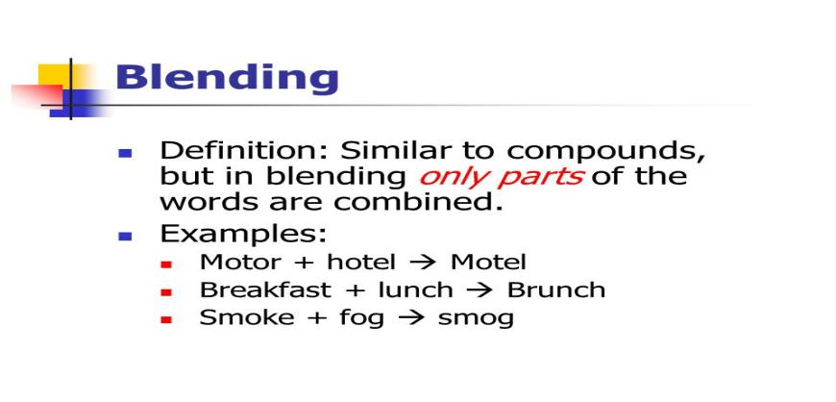
Blending:

Towards the end of the late modern period = brunch (breakfast and lunch), such blends are sometimes called ‘portmanteau words’, a term taken from Lewis Carroll.
- Slithy (lithe and slimy)
- Mimsy (miserable and flimsy)
- Overall there was a huge increase in the fund of words during this period.
Topic – 152: Standardization of Spelling & Changes in Pronunciation

There are a few differences between Addison’s punctuation and what would be considered correct today. For example, the use of capital letters, and the apostrophe in the plural Opera’s. So, the so-called greengrocer’s apostrophe’ in plurals such as potato’s, tomato’s is a recent innovation - consequence of declining educational standards. Addison can be taken as an example of good style in the 18th century. His spelling is almost identical with ours. There are minor differences, like carry’d and publick, but essentially the system of orthography is the one we use now. In Middle English and Early Modern English, there had been no standard spelling. However, it is varied from writer to writer, and even within the work of one writer. Even proper names were not fixed, for example Shakespeare, in the three signatures uses two different spellings (Shakspere and Shakspeare), Other variants: Shagspere, Shackespere and Shakespeare.

A powerful force for standardization is the introduction of printing. By the middle of the 16th century, there was still no standard system, but quite a number of widely accepted conventions. By the end of the early modern period, the spelling had become standardized in printed books; though, there is variation in people’s private writings.
Pronunciation
One result of these inconsistencies is the prevalence of spelling pronunciations happened with universal education + the wide dissemination of books new words in printed form = never heard pronounced in their home environment.
Schedule began with /s-/, and was commonly spelt sedule or cedul; the spelling with sch dates from the mid-seventeenth century, and has led to the present- pronunciations, /∫-/ and /sk-/.
Late Modern Period
Perhaps the most important change has been the disappearance of /r/ before consonants and before a pause. Formerly, the /r/ was always pronounced in words like barn and person and father. Today, in England, /r/ is never pronounced in words like barn and person but, it is pronounced in words like father only if it occurs before a vowel (‘father and mother’).
Topic – 153: Slang in the 19th and 20th Centuries

Slang is a peculiar kind of vagabond language. We find it always hanging on the outskirts of legitimate speech but it is continually forcing its way into the most respectable community. It is a part of language and cannot be ignored. Nineteenth century is significant for the growth of a more objective and scientific attitude towards slang. The word slang does not occur in Johnson’s Dictionary. In its early use, it always has a derogatory force. Webster in 1828, defines it as “low, vulgar, unmeaning language.”

Definition in the Oxford Dictionary, 1911:
“Language of a highly colloquial type, below the level of standard educated speech, and consisting either of new words, or of current words employed in some special sense.” From being “unmeaning language” to “special sense,” What is slang today may have been in good use yesterday and may be accepted in the standard speech of tomorrow.
The expression what on earth = idiomatic intensive to us. But De Quincy condemned it as slang and expressed horror on hearing it used by a government official. The word row in the sense of a disturbance was slang in the eighteenth century and was described by Todd (1818) as “a very low expression,” Boom, slump, crank, and fad, were slang once. Slang results from an instinctive desire for freshness and novelty of expression.
Nerd, geek, dweeb, dork, bimbo, and scumbag undoubtedly owe their popularity to some merit that no other word conveys the meaning.
It is sometimes difficult to define the precise quality that makes an expression slang. It is often not in the word itself, but in the sense in which it is used. Put down is proper enough if we speak of soldiers who put down a rebellion, but it is slang when we speak of a remark that put someone down or refer to the remark as a put-down. The role slang plays today is greater than it has been at certain times in the past.
Topic – 154: Issues of Register and Accent
In this topic, the following points are discussed:
RP and Regional Accents
A non-regional accent based on the speech of the great public schools, has been accepted as a standard in England for well over a century. Increasingly, however, RP has lost some of its prestige. As people educated at public schools have lost their monopoly of power and education. Today, the majority of university students are not speakers of RP. And, it is from them that a large part of the English professional classes are recruited. Most school teachers, too, do not use RP, but an educated regional accent, so that the influence of the schools is towards this rather than towards RP. RP now is the accent usually taught to foreigners learning British English. Rise in the prestige of all national and regional accents in Britain has taken place. Very respected broadcasters on the BBC now have educated Welsh and Scottish accents. Still, there is considerable prejudice against ‘broad’ regional accents. But what are popularly known as ‘soft’ accents are now in many contexts more acceptable than RP.

Topic – 155: British and Irish English
Ireland is the second largest island of the British Isles, the third largest in Europe, and the twentieth largest on earth. Politically, Ireland is divided between the Republic of Ireland, which covers five-sixths of the island, and Northern Ireland, which is part of the United Kingdom in the northeast of the island.

Some History:
The earliest evidence of human presence in Ireland is dated at 10,500 BC. Gaelic Ireland had emerged by the 1st century CE. The island was Christianised from the 5th century onward. Following the Norman invasion in the 12th century, England claimed sovereignty over Ireland. English rule did not extend over the whole island until the 16th–17th century, the colonisation and British settlement. A war of independence in the early 20th century = followed by the partition of the island = creating the Irish Free State + Northern Ireland, remained a part of the UK. Irish English has its origin in 1169. Texts are first found from around 1250. But in Ireland there was competition between three languages – English, French and Irish. Loss of French appears to have enhanced the status of Irish, rather than of English, at least until the seventeenth century. Many of the present-day features of Irish English appear in the Wexford dialects. In early Modern Irish, therefore, the use of after as a perfective mark, as in the example: I’m after missing the bus (I have missed the bus.) is extensive. Irish dialects are typically more conservative than those on the mainland. As far as syntax is concerned, Irish dialects make rather more use of do-periphrasis than elsewhere: Example: They does be lonesome by night, the priest does, surely (Filppula, 1999)
Pronunciation:
Irish dialect stories make use of spellings: tay (tea), desaive (deceive), foine (fine), projuce (produce), fisht (fist), butther (butter), thrue (true), and the like. The influence of the Irish prepositional system upon Hiberno-English = the use of with instead of for meaning “for the duration of”: He’s dead now with many a year; He didn’t come back with twenty-eight years. So, Irish English has its distinct feature.

Lesson 32
19TH AND 20TH CENTURY ENGLISH: TENDENCIES
Topic – 156: English Worldwide

Today English is not the language of the British only. It has a world-wide currency. In the various parts of the former British Empire, as in the United States, the English language has developed differences that distinguish it from the language of England. In Australia, Africa, South Asia, and Canada, there are different peculiarities of pronunciation and vocabulary. There are varieties from the dialect of the mother country and from one another. Peculiarities of communities are separated by time and space. In some countries, the most striking changes are the result of imperfect learning. Differences of nature and material civilization, and generally contact with some foreign tongue, are clearly reflected in the vocabulary. Loss of French appears to have enhanced the status of Irish, rather than of English, at least until the seventeenth century.
Topic – 157: Pidgins and Creoles
There are numerous pidgins and creoles in the world today. Their number is over two hundred. They are based on many different languages, including Swahili, Arabic, Malay and Japanese.
Definition:
A pidgin is an auxiliary language used in the first place for the purposes of trade between groups that have no common language. It arises when two or more languages are in contact. It is a simplified form of the dominant one, with influence from the other(s). This restricted type can eventually be capable of fulfilling all language functions. It may even become an official language: Papua New Guinea’s pidgin, called Tok Pisin, is formally acknowledged in the country’s constitution. Some pidgins die out because the need dies out; others spread and gain wide currency. Today, many English-based pidgins are in use, especially in the coastal regions of West Africa and on the islands of the Caribbean and the Pacific.
Creole:
When a pidgin becomes the first language of a group=creole:
There are English-based creoles in the Caribbean, for example, in Barbados and Jamaica Even in the United States: the creole called Gullah is spoken by about a quarter of a million people living along the south-eastern coastal areas Pidgins and creoles co-exist with standard varieties of the donor language In Jamaica, for example, an English-based creole exists alongside Standard English. Approximately, there are more than nine million people speak pidgin and creole languages throughout the world and about thirty to forty percent are English based. The single word hum in English is expressed in Tok Pisin (literally ‘talk pidgin’) by the circumlocution, singsing long taim maus i pas (‘to sing when the mouth is closed’). English ‘grass’ in Tok Pisin is gras; Moustache’ is mausgras; Beard’ is gras bilong fes (‘grass on face’); Hair’ is gras bilong hed; Eyebrow’ is gras antap longai (‘grass on top along eye’). In the same way ‘my mother’ is mama bilong mi; ‘John’s house’ is haus bilong John. The distinction between pidgins and creoles is not a sharp one, for sometimes a variety is used by some groups as an auxiliary language and by others as a first language. This is particularly true in West Africa, where the co-existence of more than four hundred different languages means that pidgins are especially useful. A pidgin tends to preserve the absolutely minimal grammatical structures needed for effective communication, and reduces redundancy to almost nil. The great simplification of pidgin–creole structures as compared with the donor language is seen in both phonology and grammar. Number of phonemes is reduced in a creole, so in Jamaican Creole, many speakers use the same vowel in block as in black (both [blak]), the same vowel in beer as in bare (both [biεr]).
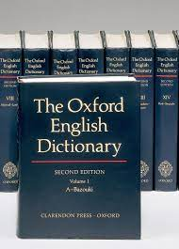
Topic – 158: The Oxford English Dictionary
In 1850, the inadequacy of existing dictionaries was felt. Those of Johnson and Richardson were incomplete and below the standards. In 1857, at a meeting of the Philological Society in London, a committee was appointed to collect words, not in the dictionaries, with a view to publishing a supplement to them. The committee consisted of Herbert Coleridge, Dean Trench, and F.J.Furnivall - three members. The most important outcome of the committee’s activity was a paper read to the Society by Dean Trench, “On Some Deficiencies in Our English Dictionaries.” A formal “Proposal for the Publication of a New English Dictionary by the Philological Society” was issued the following year.
Two principal Aims of the Project
- To record every word that could be found in English from about the year 1000
- To exhibit the history of each— its forms, spellings, uses and meanings.
- People volunteered
- The number of contributors increased.
Before the last part of the dictionary was published, six million slips with quotations had been gathered. There were various changes in people and roles. Its original name was A New English Dictionary on Historical Principles (NED). In 1895, the title The Oxford English Dictionary (OED) was added. The completed work was of ten large volumes occupying 15,487 pages. It treats 240,165 main words. Later on in 1933, a supplementary volume was published.
Topic – 159: Grammatical Tendencies- Verb-Adverb Combinations
Several factors affected these tendencies such as the printing press, popular education, improvements in travel and communication, social consciousness. Very few changes in grammatical forms and conventions are to be observed. There has been some school-mastering of the language. The substitution of you were for you was in the singular occurs about 1820, and it is I is now seldom heard. What was left of the subjunctive mood in occasional use has disappeared except in conditions contrary to fact (if I were you). There is some tendency toward loss of inflection, although we have but little to lose, is noticeable in informal speech. The nonstandard he don’t represents an attempt to eliminate the ending of the third person singular and reduce this verb in negative to a uniform do in the present tense. Likewise the widespread practice of disregarding the objective case form whom in the interrogative (Who do you want?) illustrates the same impulse
Though some people are shocked by the latter “error,” it has a long and honorable history. Shakespeare often commits it, and historically the reduction of case forms in this pronoun is as justifiable as that in the second person (you for ye.) Occasionally, a new grammatical convention may be seen springing up. The get passive (he got hurt) is largely a nineteenth-century development. ‘He is hurt’ was too static, ‘he became hurt’too formal.
Verb-adverb Combinations
One other tendency that is sufficiently important to be noticed is the extension of verb-adverb combinations. Modern vocabulary has a large number of expressions like set out, gathers up, put off, brings in, Made up of a common verb, often of one syllable, combined with an adverb. They suggest comparison with verbs having separable prefixes in German, and to a smaller extent with English verbs like withstand and overcome. Such combinations before the modern period = meaning is the fairly literal sense of the verb and the adverb in the combination (climb up, fall down).
- Mere intensification
- One of the most interesting features of such combinations in modern times, however, is the large number of figurative and idiomatic senses in which they have come to be used.

Examples:
Bring about (cause or accomplish), catch on (comprehend), give out (become exhausted), keep on (continue), put up with (tolerate), hold up (rob), lay off (cease to employ), turn over (surrender). Another is the extensive use, especially in colloquial speech, these verb-adverb combinations as nouns: blowout, cave-in, holdup and runaway. The single adverb up enters into such combinations as bring up, brace up, cough up, dig up, dish up, drum up, fly up, gum up, jack up, loosen up, pass up, perk up, scrape up, shut up, spruce up, whack up Twenty verbs back, blow, break, bring, call, come, fall, get, give, go, hold, lay, let, make, put, run, set, take, turn, and work = 155 combinations with more than 600 distinct meanings or uses.
Topic – 160: Summary of Characteristics of the 19th and 20th Century English
In this topic, the following points are discussed:
19th and 20th centuries show a more enlightened and modern attitude toward linguistic questions. Immediate Past: Role of well-meaning but misguided persons who hoped to make over the language in accordance with their individual conceived pattern. 19th and 20th centuries = tolerant of colloquial and regional forms
- More changes in vocabulary
- Influence of science
- Influence of media
- Influence of technology
- Less changes in grammar
- More stability
Overall:
- Worldwide spread
- Knowledge must be coupled with tolerance, and especially tolerance toward usage.
- That differs from our own.

Lesson 33
EXPANSION OF THE GENERAL VOCABULARY IN TODAY’S ENGLISH

Topic – 161: Reasons of Expansion of Vocabulary Today

In this topic, the following points are discussed:
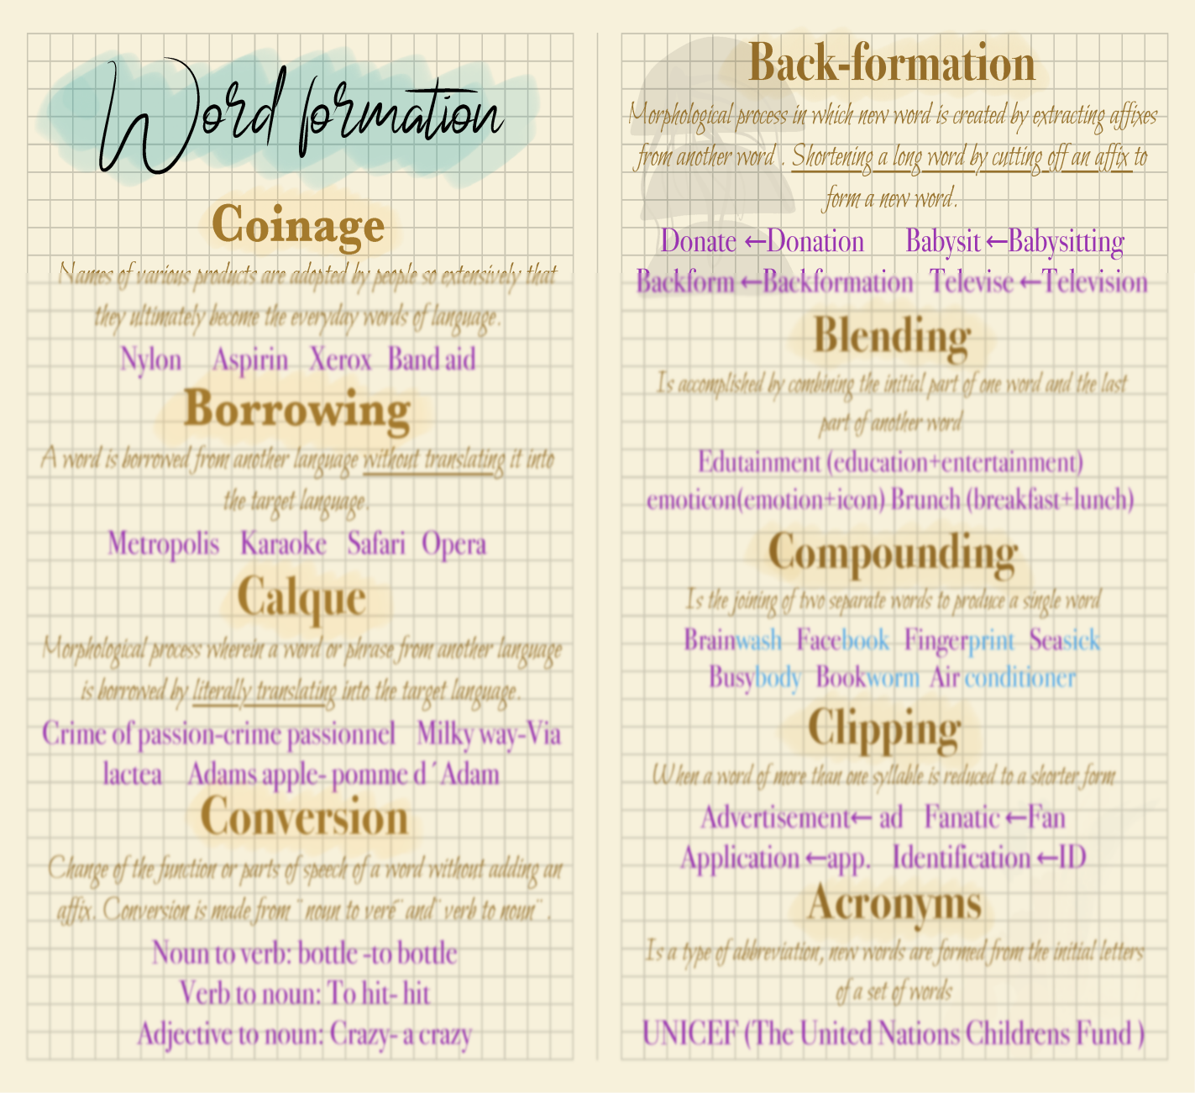
The expansion of the vocabulary seems to be going on at a great rate in our time. Many new words continue to be coined from Greek and Latin morphemes.
Some get into the general vocabulary. Especially in medicine, there is an ongoing tendency to use Latin and/or Greek elements. The question is, how does this vocabulary expand; and what are the reasons of expansion?

- Answering the how part, we need to consider the following:
  - Coined
  - Not all coined
  - Borrowed
  - Root borrowed
  - New meaning given
  - Blended
  - Chopped off
- Answering the why part we need to consider the following:
- Changing times
- Need of the times
- Inventions
- Technology
- Science
- Traveling
- Communication

- Media
Topic – 162: Expansion of Vocabulary: Loan Words

In this topic, the following points are discussed:
- The expansion of the vocabulary seems to be going on at a great rate in our time.
- Main source of expansion: Borrowing
- Mainly loan words from LATIN
- In the early modern period, a number of words were borrowed from other languages too.
The next largest source after Latin has been French. The French loans include military words (such as bayonet) and words from the life-sciences (such as anatomy, muscle). Many French words from the general vocabulary (for example, docility, entrance, invite). There were a few words from Classical Greek, though most of these came via Latin or French. They tended to be learned words, and many of them are technical terms of literary criticism, rhetoric and theology. Words which were probably borrowed directly from Greek include anathema, cosmos, larynx and pathos. Overall, loan words have always been a great source of expansion of vocabulary.
Topic – 163: Expansion of Vocabulary: Affixation
Large numbers of loanwords entered the language in the early modern period and the modern period.
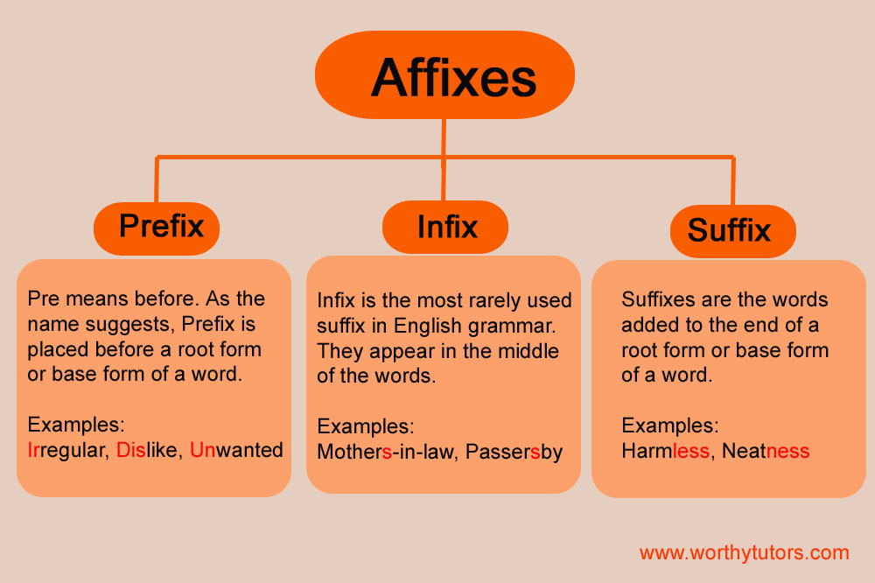
Words nevertheless continued to be coined from existing English language-material by traditional methods of word-formation, especially affixation, compounding and conversion.
- Focus: only affixations
By far, the commonest method of word-formation has been affixation, that is, the coining of new words by the use of prefixes and suffixes. Most of the words thus formed are nouns or adjectives, though there are also some adverbs and a few verbs. The ability to add affixes makes English extremely flexible.
- We can have prefixes (e.g. com-, con-, de-, ex-, inter-, pre-, pro-, re-, sub-, un-, etc)
- And suffixes (e.g. -al, -ence, -er, -ment, -ness, -ship, -tion, -ate, -ed, -ize, -able, -ful, -ous, -ive, -ly, -y, etc)
Affixation is a simple way to completely alter or subtly revise the meanings of existing words, to create other parts of speech out of words, or to create completely new words from new roots.
- Very few rules in the addition of affixes in English
- Anglo-Saxon affixes can be attached to Latin or Greek roots, or vice versa.
Example: Incomprehensibility which has the following features:
Simple root -hen- (from Indo-European root word ghend- meaning to grasp or seize).
- affixes: in- (not), com- (with), pre- (before), -ible (capable), -ity (being).
The sheer variety and number of possible affixes in English can lead to some confusion. No single standard method for something as basic as making a noun into an adjective (-able, -al, -ous and -y are just some of the possibilities). Some affix additions are surprisingly recent. For example Officialdom and boredom are products of the 20th century. And, Apolitical as the negation of political did not appear until 1952. Adding affixes remain the simplest and perhaps the commonest method of creating new words.
Topic – 164: Expansion of Vocabulary: Compounding
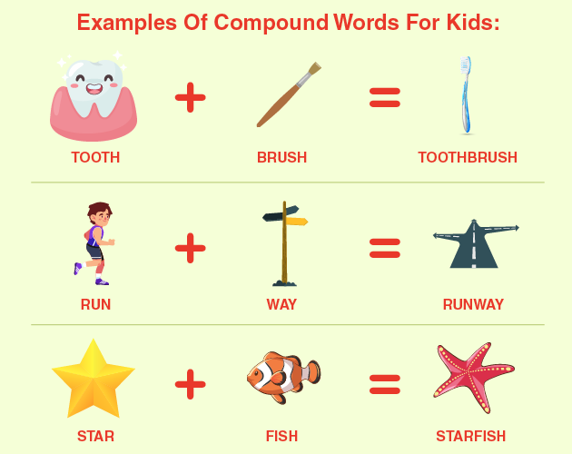
A considerable number of words are formed by compounding, that is, the combination of two or more free morphemes.
Like many languages, English allows the formation of compound words by compounding together shorter words (e.g. airport, seashore, fireplace, footwear, wristwatch, landmark, flowerpot, etc.). However, it is not taken to the extremes of German or Dutch where extremely long and unwieldy word chains are commonplace. They are nearly all nouns, and the commonest type is Noun + Noun (sheep-brand, waterdock). There are also a fair number of the type Adjective + Noun (Frenchwoman, freshman), and of the type Verb + Object (scrape-penny ‘miser’). English may even allow for different meanings depending on the order of combination. For example: Houseboat/boathouse; Basketwork/ workbasket; Casebook/bookcase.
Compounding has led to blending as well:
- Motel, which blends motor and hotel
- Smog, which blends smoke
- Chocoholic, which blends chocolate and alcoholic
Earworm
- A song or tune that, once you’ve heard it, is stuck in your head.
- Use: “That new Taylor Swift song is such an earworm!”
Staycation
- Spending your holiday in your hometown rather than travelling abroad.
- Use: “I’m having a staycation this summer, as I’m trying to save money.”
Webisode
- An episode or series created exclusively for online viewing.
- Use: “There’s a new Breaking Bad webisode online, have you seen it?”
Crowdfunding
- Funding a project or business venture by asking a large number of people (typically online) to invest a small amount of money – usually via websites such as Kickstarter and Indiegogo.
Handover
Typically, this word has a more political significance, in terms of gaining land or ownership. However, its modern usage is commonly in the workplace. The act of passing over control or responsibility relates to another person while you are off work on holiday or leaving a job.
Use: “I’ll send my notes in a handover email so you can continue the project while I’m away.”
Binge-watch
- Watching multiple episodes of a TV show, one after another, in a single sitting.
- Use: “I’m planning to binge-watch the entire series of Game of Thrones this weekend!”

Topic – 165: Expansion of Vocabulary: Conversion
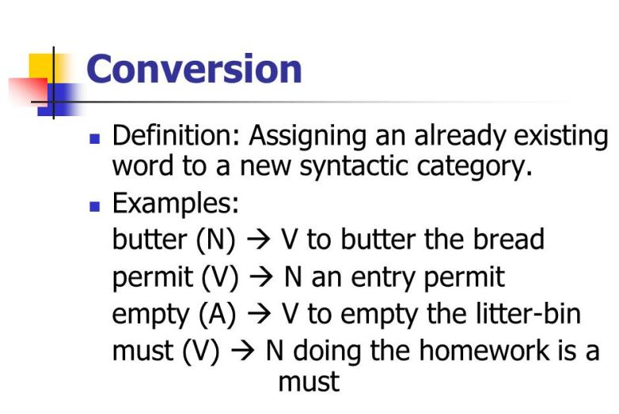
Apart from affixation and compounding, the third reasonably common type of word-formation is conversion, the process by which one word is derived from another with no change of form. This is called the act of changing from one use or function or purpose to another. A conversion may be defined as a process by which a word belonging to one word class is transferred to another word class without any concomitant change of form either in pronunciation or spelling.
- A highly prolific form
- No restriction
- A lot of freedom
So it regularly happens and some scholars call it a syntactic usage than word formation. Pyles and Algeo (1993) call it functional shift.
Major Types
- Noun to verb
- Verb to noun
- Adjective to noun
- Adjective to verb
Noun to Verb
- To bottle
- To network
- To commission
Noun to Verb
- Other examples of the formation of verbs from nouns (to bayonet, to gossip, to invoice)
Verb to Noun
- A call
- A command
- A guess
- A spy
Adjective to Verb
- To dirty
- To empty
- To wrong
Adjective to Noun (Rare)
- The poor
- The rich
- A daily
Adjective to Noun
There are other examples of the formation of nouns from adjectives (an ancient, a brisk). The words formed by affixation, compounding and conversion are often ordinary everyday words, or words to do with practical affairs. By contrast, as we have seen, Latin loanwords tend to be more formal and literary, and often the concern specialized fields of discourse like science, medicine, religion, classical culture and the liberal arts.

Lesson 34
ENGLISH AS WORLD LANGUAGE
Topic – 166: Status of English in Today’s World
Today, when English is one of the major world languages, it requires an effort of the imagination to realize that this is a relatively recent thing.

How?
Think of Shakespeare: He wrote for whom? May be, he wrote for a speech community of only a few millions. He wrote for a community whose language was not much valued elsewhere in Europe. He wrote in a language that was unknown to the rest of the world. Shakespeare’s language was pretty-well confined to England and southern Scotland. It had not yet penetrated into Ireland or even Wales, let alone into the world beyond. In the first place, the great expansion in the number of English speakers was due to the growth of population in England itself. Worldwide expansion of English means now one of the most widely spoken languages in the world. Estimates of the numbers of speakers vary. Most modest agree that there are over 400 million speakers who use it as a native language. And, many more use it as a second or foreign language. The method of its spread, however, also means that there are now many varieties of English, and that it is used for many different purposes in varying social contexts. In North America, Australia, and New Zealand, there was dense settlement by English-language speakers. They outnumbered the original inhabitants:
- Native Americans,
- Australian Aboriginals
- Maoris
They also dominated them politically and economically. The native languages, consequently, had hardly any influence on the language of the settlers. In Australia, New Zealand and South Africa, there is little regional variation in the language. South Africa is a community of those who speak English as a first language comparatively on a small scale. According to the 2001 census, English was recorded as the language most often spoken at home for 8.2% of the population. However, this does not account for the many South Africans of various ethnic backgrounds and ancestries who will speak English as a second language.

Topic – 167: Number of Speakers of English Today
In this topic, the following points are discussed:
- How do we measure the popularity and importance of a language?
Speakers of English As:
- First
- Second and
- Foreign language
First Language:
Those who have learned it as a second language are also difficult to estimate We must take into account the levels of fluency achieved. If we take a basic level of conversational ability as the criterion, with little command of specialized vocabulary, the figure is also some 400 million. So, many people now use English as a second language. The population growth in areas where English is a second language is about three times more than in areas where a first language is used.
Number of Speakers of English Today
Second-language speakers of English will soon hugely exceed first-language speakers – a situation without precedent for an international language.
Topic – 168: English as a Mother Tongue
A language does not achieve a genuine global status until it develops a special role that is recognized in every country. This role is most obvious in countries where it is spoken as a first language.
English as First Language
USA, Canada, Britain, Ireland, Australia, New Zealand, South Africa, several Caribbean countries and a scattering of other territories. Today, English is the second or third most popular mother tongue in the world, with an estimated 350-400 million native speakers. But, best recent estimates of first languages suggest that Mandarin Chinese has around 800-850 million native speakers, while English and Spanish both have about 330-350 million each. Hindi speakers number 180-200 million, Bengali 170-180 million, Arabic 150-220 million, Portuguese 150-180 million, Russian 140-160 million and Japanese roughly 120 million. However, no language has ever been spoken by more than a dozen or so countries as a mother tongue. So, mother-tongue use by itself cannot give a language global status.
Then How?
- Has to be taken up by other countries around the world.
Three-pronged Development:
- Of first-language,
- Second-language
- Foreign-language
Thus, it is inevitable that a language eventually comes to be used by more people than any other language. English has now reached this stage. Its first language, speakers are above 400 million though estimates vary greatly, because few countries keep statistics about numbers of speakers. Those who have learned it as a second language are also difficult to estimate; though approximately there are around 400 million such speakers. When the number of people who speak English as a foreign language is taken into account, again estimates are uncertain. No-one knows how many people are learning English in China. But the British Council has estimated that roughly a billion people are learning English around the world at any one time. Excluding complete beginners, it would seem reasonable to take two-thirds of these as a guess with whom it would be possible to hold a reasonable conversation in English – say 600 million. The grand total was about 1,400 million. In round terms = a quarter of the world’s population (just over 6,000 million in 2000). No other language is used so extensively – either numerically, or with such geographical reach. So, the current status of English is determined by its role other than as mother tongue.
Topic – 169: English as a Lingua Franca
Lingua Franca is a language that is adopted as a common language between speakers whose native languages are different. In the past = Arabic=Islamic world= from AD 733-AD 1792= spread from the boarders of China and Northern India through Central Asia, Persia, Asia Minor, middle East to North Africa. The term lingua franca = first coined = beginning of the 17th century by the Italians. Conglomeration of mostly Italian, with a smattering of French, Portuguese, Spanish, Turkish, Greek, and Arabic was used primarily as the language of commerce. The term literally means “Frankish language”, as “Frank” was a common designation for all western Europeans since approximately the 12th century. Today an obvious factor= the need for a common language, or lingua franca an old concept.
But for whole world = emerged strongly only in the twentieth century, and since the 1950s in particular. The chief international forum for political communication – the United Nations – dates only from 1945, and then it had only fifty-one member states. By 1960, this had risen to over eighty members. The increase continued steadily into the 1990s. In 2003 there were 191 members in the UN – nearly four times as many as there were fifty years ago. The need for lingua francas is obvious, and pressure to find a single lingua franca is a consequence.
The alternative = multi-way translation facilities= expensive= impracticable
Where is it used?
Serving as a useful heuristic in Europe, where a Spaniard, a Frenchman, and a German might all carry on a conversation in English. English as a lingua franca (ELF) plays an important role in former Anglophone colonies such as India, Pakistan, Nigeria, Uganda, and Zimbabwe, among many others.
How is it used?
- ELF differs from Standard English in a number of ways.
- Several documented overarching similarities and variances
How is it used?
- Variances in article usage (or no article usage at all),
- Variances in preposition usage,
- Novel use of morphemes (such as importancy and smoothfully)
Criticisms:
While ELF is a widespread and useful mode of communication for many, some scholars and linguists have criticized its proliferation as a form of linguistic imperialism. Speakers of ELF may eventually speak both their native language and English imperfectly, leading to issues with effective communication. In spite of these criticisms, ELF continues to flourish in many countries, oftentimes enriching the language with colorful aphorisms and unique phrases.
Topic – 170: Divergent Development in Modern English
The development of so many varieties of English has produced problems and controversies about the language. Controversies= especially in former British colonies which became independent in the second half of the twentieth century. With independence= disputes= whether English should be retained as an official language or not. If yes= whether to teach Standard British English or local variety of English as a standard. Various factors have played a part in these arguments = nationalist feeling attachment to traditional culture.
- But desire for advances in science and technology
- And the conflicting needs for local and for international communication.
- In fact, there are many cross-currents. During British colonial rule, Standard British English was the language of administration, and local departures from it were stigmatized as errors.
In India, after independence= Hindi-speaking north in favour of making Hindi official language= was opposed by the south who spoke Dravidian languages= obvious economic and political advantages to northerners. In some former colonies, a mastery of English= privilege of a dominant elite who supported its retention. More radical and democratic forces= replacement by one or more local languages. Many of the controversies, inevitably, have been fought out in the field of educational policy. They still go on, but there seems, at the moment, to be a trend in many countries towards continuing to accept English as an official or semi-official language. Given the numerous varieties of English in the world today, it is obviously impossible to do more than give a few examples of the differences between them under Phonology, Grammar and Vocabulary.
Phonology
Different varieties of English can differ phonologically in three main ways. First, their phonological systems can differ: for example, the inventory of phonemes may be different.
Phonology
Secondly, the realizations of the same phoneme can be different, that is, be pronounced differently.
Phonology
Thirdly, the distribution of phonemes can differ; different phonemes may be selected for the pronunciation of a given word. Also, there can be differences of stress and intonation.
Phonology: outer-circle varieties of English
Outer-circle varieties of English often differ considerably from phonological system from RP and General American. The number of phonemes is often much reduced. In many varieties of English in the outer circle, there is no difference between long and short vowels.
Example:
In one common form of Nigerian English, for example, there is only one phoneme corresponding to RP /ɪ/ and /iː/, so that bid and bead are both /bid/; only one corresponding to /a/ and /ɑː/, so that hat and heart are both /hat/; only one corresponding to /ɒ/, /λ/ and /ɔː/, so that stock, stuck and stork are all /stɔk/; and only one corresponding to RP /ʊ/ and /uː/, so that look and Luke are both /luk/.

Grammar
There are only minor grammatical differences between the main standard forms of English.
Example:
American English differs from British English, but the differences are minor. Among past tenses of verbs, some American English has the forms dove, fit and snuck (British dived, fitted, sneaked), and in a number of forms uses /-d/ where British English has /-t/ (for example, burned, learned, spelled, spilled), though the forms with /-d/ are increasingly found in British English.
In some verbs of this latter type, British English changes the stem vowel from /iː/ to/e/ in the past tense, whereas in American English it remains /i/ (such as dreamed, kneeled, leaped). An American often uses do have where a Briton is more likely to use have got (‘Do you have the time?’, ‘Have you got the time?’).
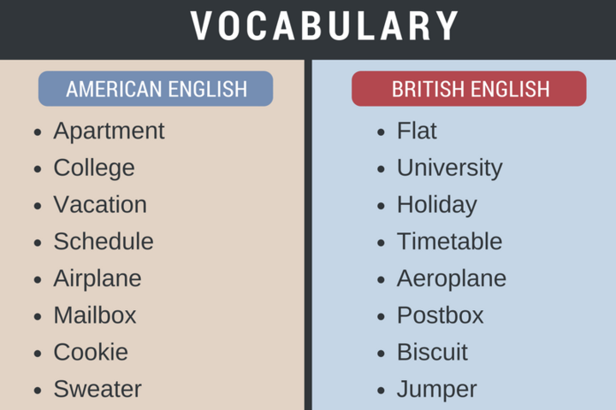
Vocabulary
It is perhaps in vocabulary that we see the greatest divergences between the different varieties of English as a first language. However, it is expanding across the vast North American continent, with new flora and fauna and different natural features from those of Europe, building up a new society , building up new vocabulary.

Lesson 35
INTRODUCTION TO AMERICAN ENGLISH
Topic – 171: English in America & its Features
Objective:
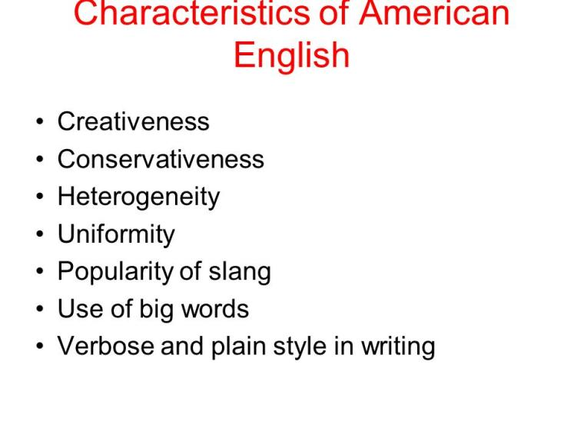
After completing this topic, students will have an introduction to American English. In this topic, the following points are discussed:
American English, sometimes called United States English or U.S. English, or AME, AE, AmEng, USEng, en-US is the set of varieties of the English language native to the United States. English is the most widely spoken language in the United States.
- The common language used by the federal government.
- Considered the de facto language of the country.
It has been given official status by 32 of the 50 state governments. The use of English in the United States is a result of British colonization of the Americas. The first wave of English-speaking settlers arrived in North America during the 17th century, followed by further migrations in the 18th and 19th centuries. Since then, American English has developed into new dialects, in some cases under the influence of West African and Native American languages, German, Dutch, Irish, Spanish and other languages of immigrants. Any American or even Canadian English accent perceived as free of noticeably local, ethnic, or cultural markers is popularly called “General American English”. Sociolinguist William Labov describes it as "a fairly uniform broadcast standard in the mass media". Otherwise, however, historical and present linguistic evidence does not support the notion of there being a mainstream Standard English of the United States.
According to Labov, with the major exception of Southern American English, regional accents throughout the country are not yielding to this broadcast standard. On the contrary, the sound of American English continues to evolve, with some local accents disappearing, but several larger regional accents emerging. Compared with English as spoken in England, North American English is more homogeneous. Also, it has remained relatively more conservative.
North America has given the English lexicon many thousands of words, meanings, and phrases. Several thousand are now used in English as spoken internationally.
The process of coining new lexical items started as soon as the colonists began borrowing names for unfamiliar flora, fauna, and topography from the Native American languages.
19th century onwards
Industrial and material innovations in the 19th and 20th centuries were the source of a massive stock of distinctive new words, phrases and idioms in AM English.
Examples:
The vocabulary of railroading ranging from names of roads (from dirt roads and back roads to freeways and parkways) to road infrastructure (parking lot, overpass, rest area).
Topic – 172: American Dialects: Linguistic Variety and Uniformity in America
In this topic, the following points are discussed:
The Size of America
A federal republic composed of 50 states, a federal district, five major self-governing territories and various possessions.
Unity in Diversity: Diversity in Unity
- A standard language
- A variety of dialects
Cultural & Ethnic American Eng. Varieties
- African American Vernacular (Ebonics)
- Cajun Vernacular
- Hawain Pidgin
- Latino Vernacular Englishes
Cultural & Ethnic American Eng. Varieties
- Chicano English
- Miami English
- Pennsylvania Dutch English
- Yeshiva English
Regional and Local
- Eastern New England
- Boston
- Rhode island
- Southeast Super region
- Mid Atlantic
- Baltimore
- Philadelphia
- Midland
- Hoi Toider
- New Orleans
- Southern
- New York City Northern
- Inland Northern
- Western Pennsylvania
Topic – 173: American English Pronunciation
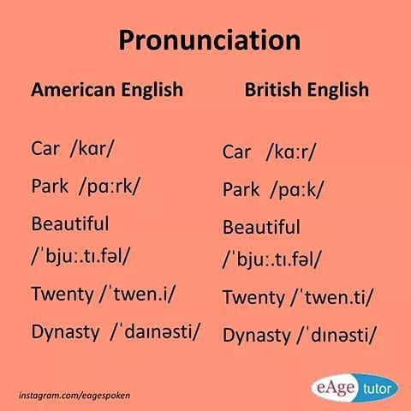
In this topic, the following points are discussed:
General American English or Standard American English accent is typically found in the middle states and in the west. Studies on historical usage of English in both, the United States and the United Kingdom suggest that spoken American English did not simply deviate away from British English, but retained certain now-archaic features contemporary British English has since lost. General American English or Standard American English accent is typically found in the middle states and in the west.
Rhoticity (or r-fulness):
General American accents are firmly rhotic, pronouncing the r sound in all environments, including after vowels, such as in pearl, car, and court.
/r/ in GA and RP:
In GA, the letter r is pronounced in all positions, but in RP it is only pronounced before vowels (e.g. very, paragraph).
Wine- Whine Merger:
The consonants spelled w and wh are usually pronounced the same; a separate phoneme /ʍ/ (wh) is present only in certain dialects. In RP, the vowels in pairs like cot/caught are distinct: [o]
And [o:] respectively. However, in GA these vowels have merged in various ways. For example, in a south-western American speech [a] is used in both cot and caught. Overall, there are considerable distinct features of GA pronunciation.
Topic – 174: American English Grammar
In this topic, the following points are discussed:
Grammar:
AE vs. BrE
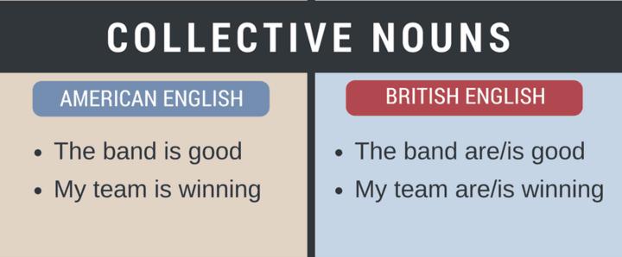
There are a few grammatical differences between the two varieties of English. The number is less compared to vocabulary and pronunciation
Collective Nouns
- Refer to a group of individuals.
- In AE collective nouns are singular. Example: Staff =a group of employee, Band = a group of musicians, Team= a group of athletes.
Examples- AE/ BrE:
Americans would say, “The band is good.” In British English: “The team are playing tonight” or “The team is playing tonight.”
Auxiliary Verbs
Verbs that help form a grammatical function. They “help” the main verb by adding information about time, modality and voice.
Auxiliary Verbs
Auxiliary verb shall= British sometimes use shall to express the future.
- Example, “I shall go home now.”
- Americans find shall formal so they use “I will go home now.”
Auxiliary Verbs
In question form, a British might say, “Shall we go now?” while an American would say, “Should we go now?”
Auxiliary Verbs
Americans express lack of obligation, by saying: “You do not need to come to work today.” British drop the helping verb and contract not. “You needn’t come to work today.”
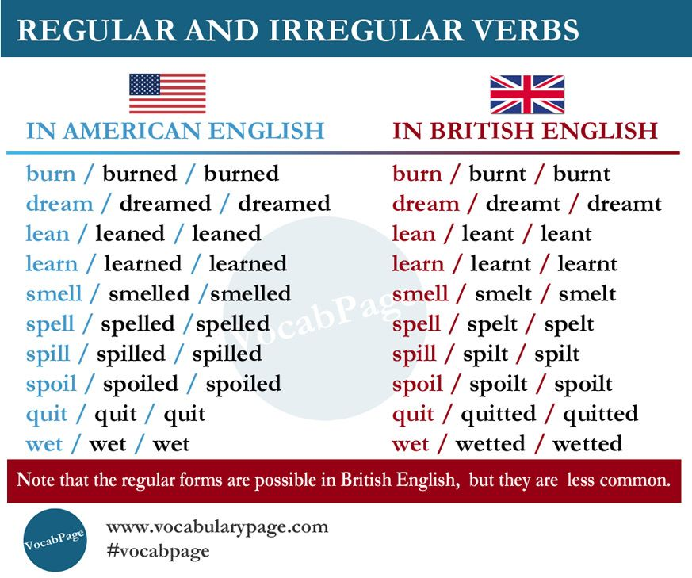
Past Tense Verbs
More examples:
- Dream, dreamed and dreamt,
- Burn, burned and burnt,
- Lean, leaned and leant.
- Americans tend to use the –ed ending; British use -t ending.
Past Participle
The most striking morphological difference between GA and British English is the use of the past participle form gotten in GA. This was the usual form in British English two centuries ago.
Past Tense Verbs
In the past participle form, Americans tend to use the –en ending for some irregular verbs.
- Example: Americans say, “I have never gotten caught”
- British say, “I have never got caught.”
Overall
There are considerable distinct features of GA grammar.

Topic – 175: American English Vocabulary
In this topic, the following points are discussed:
There never have been any major linguistic differences between British and American English as such. Moreover, the last hundred years or so have seen an increasing similarity between British and American English.
Reasons:
- Partly due to ever-improving communication systems.
- Partly due to the impact of American culture, notably through television and film.
However, most of the differences between the English of the UK and the AmE are vocabulary differences.
American Lexicon:
North America has given the English lexicon thousands of words and phrases. Several thousand are now used in English as spoken internationally.
Creation of an American lexicon
The process of coining new lexical items started as soon as the colonists began borrowing names for unfamiliar flora, fauna, and topography from the Native American languages.
Examples:
- Names such as opossum, raccoon, squash, moose
- Other Native American loanwords, such as moccasin
Examples:
The languages of the other colonizing nations also added to the American vocabulary. For instance: Cookie, stoop, pit from Dutch
- Kindergarten from German
- Barbeque from Spanish

19th Century Onwards
- Bartender, Patrolman,
- Busboy
- White-collar, Boss,
- Employee
Department store, Supermarket, Thrift store, Gift shop, Drugstore, Gas station. A number of words and meanings that originated in Middle English or Early Modern English and that have been in everyday use in the United States dropped out in most varieties of British English. Terms such as fall ("autumn"), diaper ("nappy"), candy ("sweets"), are often regarded as Americanisms. Fall, for example, came to denote the season in 16th century England, a contraction of Middle English expressions like "fall of the leaf" and "fall of the year.
Example
In GA, the season following summer is referred to as the fall, as used to be the case in British English where the term autumn is now used. While the term fall gradually became obsolete in Britain, it became the more common term in North America.
Example
- British= the front of a car = bonnet
- Americans= hood
- British= holidays
- Americans= vacation
- Londoners= flats
- New Yorkers= apartments
- Gotten (past participle of get) is often considered to be an Americanism.
- But it came from BrE and still continues to be used in some area.

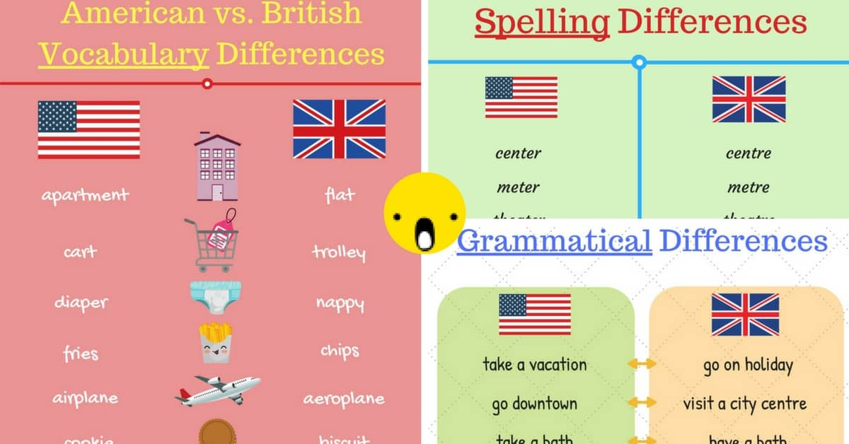

Lesson 36
AMERICAN VS BRITISH ENGLISH: A COMPARISON
Topic – 176: Difference between Attitude of Speakers
In this topic, the following points are discussed:
- Firstly, we need to take history into account.
- The process of colonization played a role.
- Geography is another aspect.
- Media, commerce and trade have also played their role.
- The difference in the nature of people must also be considered.
Topic – 177: AmE & BrE: Phonological Differences
In this topic, the following points are discussed:
Fletcher (1990: 67): The American English pronunciations are those appropriate to the variety of accent known as General American. It is what is spoken by the majority of Americans- with no noticeable eastern or southern accent. It is the appropriate pronunciation for EFL learners who take American English as their model.
/r/ Sound:
In RP, this sound disappeared except before vowels. It is not pronounced when it occurs before a consonant or at the end of a word unless the next word begins with a vowel, /r/ Sound:
In American English, especially in the middle and western states, the "r" is pronounced in all positions. Pyles (1971: 261) remarks that some of the prevalent American pronunciations of the words do not occur in standard English e.g. Figure /figjər/, leisure /li:3ər/, vase /veiz/, tomato /təmeiətu/. On the other hand, the prevalent British pronunciation of them are currently in American English e.g., /figə/, /le3ə/, /va:z/, /təma:təu/. Lyons (1981: 26) states that there are many differences between the speech of the average of well -educated American and that of the well-educated British. Swan (2005: 43-44) clarifies the most important general difference between American and British. To him some words which are pronounced with /u:/ in most of American English have /ju:/ in British English. These are words in which the, d, t, or n (and sometimes s or l) are followed by u or ew in writing. British English has one more vowel than American English. This is the round short (/ɒ/ used in word like cot, dog, got, off, stop, lost. In American English, these words are pronounced either with /a:/ like the first vowel in father or /ɒ:/, like the vowel in caught. Some words written with a+ consonant (e.g. fast) have different pronunciation: with /a:/, in standard southern British English, and with /æ / in American and some other varieties of English.
In many varieties of American English, t and d both have a very light voiced pronunciation (/d/) between vowel – so writer and rider, for example can sound the same. In British English they are quite different: /raɪtə(r)/ and raɪdə(r)/. Words ending in unstressed - ile (e.g., fertile, reptile, missile, senile) are pronounced with /aɪ/ in British English, some are pronounced with /ɪ/ in American English.
- Fertile AmE /fɜːtal/ (rhyming with turtle)
- BrE /fɜːtəl/ (rhyming with her tile)
Topic – 178: AmE (American English) & BrE (British English): Morphological Differences
In this topic, the following points are discussed:
This divergence between American English and British English has provided opportunities for humorous comment, e.g. George Bernard Shaw has a character, says that the United States and United Kingdom are "two countries divided by a common language" Morphology is the study of words, how they are formed, and their relationship to other words in the same language. It analyzes the structure of words and parts of words, such as stems, root words, prefixes, suffixes. Difference in AmE and BrE at Morphological level exist.
Word Derivation
- Directional suffix -ward(s):
- British forwards, towards, rightwards, etc.
- American forward, toward, rightward.
In both dialects distribution varies somewhat: In America afterwards, towards, and backwards are not unusual. In Britain forward is common, and standard in phrasal verbs such as look forward to. The forms with -s may be used as adverbs (or preposition towards) but rarely as adjectives in Britain as in America, one says "an upward motion". The Oxford Dictionary in 1897 suggested a semantic distinction for adverbs, with -wards having a more definite directional sense than -ward; ds are not unusual in America; while in Britain forward is common.
AmE freely adds the suffix -s to day, night, evening, weekend, Monday, etc. to form adverbs denoting repeated or customary action: I used to stay out evenings, The library is closed Saturdays. This usage has its roots in Old English, but many of these constructions are now regarded as an American. In BrE, the agentive -er suffix is commonly attached to football, cricket or netball, occasionally basketball and volleyball). AmE usually uses football player. AmE English writers make new compound words from common phrases; for example, health care is now being replaced by healthcare on both sides of the Atlantic. AmE has made certain words in this fashion that are still treated as phrases in BrE.
In compound nouns of the form verb><noun>, sometimes AmE prefers the bare infinitive where BrE favours the gerund. Generally AmE has a tendency to drop inflectional suffixes, thus preferring clipped forms: compare cookbook v. cookery book; Smith, age 40 v. Smith, aged 40; skim milk v. skimmed milk; dollhouse v. dolls' house; barber shop v. barber's shop. In British English, the past tense and past participle of the verbs: learn, spoil, spell, burn, dream, smell, spill, leap and others, can be either irregular (learnt spoilt ....etc) or regular (learned, spoiled ...etc). But in AmE no irregular forms.
Topic – 179: AmE & BrE: Lexical and Semantic Differences
In this topic, the following points are discussed:
A lexicon is not made up of different words, but different "units of meaning" (lexical units or lexical items, e.g., "fly ball" in baseball), including idioms and figures of speech.
Words and Phrases: Origins in AmE
- Easy to understand
- Sidewalk (pavement)
- Gas (gasoline/petrol)
- Counterclockwise (anticlockwise)
- Elevator (lift)
Words and Phrases: Origins in AmE
Certain terms that are heard less frequently, especially those likely to be absent or rare in American popular culture, e.g., "copacetic (satisfactory)", are unlikely to be understood by most BrE speakers.
With Different Meanings
Words such as bill and biscuit are used regularly in both AmE and BrE, but mean different things. In AmE a bill is paper money (dollar bill) though it can mean the same as in BrE, an invoice (Electricity bill). In AmE, a biscuit (from the French twice baked as in biscotto) is what in BrE is called a scone and a biscuit in BrE is in AmE a cookie (from the Dutch 'little cake.')

In the UK, the word whilst is historically acceptable as a conjunction (as an alternative to while, especially prevalent in some dialects). In AmE, only while is used in both contexts. In the UK, the term period for a full stop is not used. In AmE, the term full stop is rarely used for the punctuation mark. For example: He said, "Terrorism is wrong, full stop", whereas in AmE, "Terrorism is wrong, period”.
Americans say "Happy holidays"= especially when the subject's religious observances are not known. In the UK, "holiday season" and "holiday period" = summer = time off, AmE uses vacation for it. The American English has lost a lot of vocabulary items which have survived in British English. For example, 'waistcous' is a name of a garment that American English calls a ‘vest‘. Overall there are a lot of differences in BrE and AmE at lexical and semantic levels.
Topic – 180: AmE & BrE (Syntactic Differences)
In this topic, the following points are discussed:
BrE & AmE
(Syntactic Differences)
BrE | AmE
Yes, I have/ Yes, I have done | Yes, I have
She became tired | She got tired
Do you have any | Have you gotten any
please write to me soon | please write me soon

AmE and BrE share most, but not all, syntactic patterns. In AmE, collective nouns such as family, staff and committee, and names referring to sports teams, companies, organisations and institutions generally require singular verbs.
Examples
These headlines:
- Shadow Government Is at Work in Secret.
- Ballard Team has High Hopes for Deep-Water Robot.
- Ordinarily, sentences in which a plural verb agrees with a collective noun would be ungrammatical, such as these from Corpus (BNC):
- Once ITV realize the BBC are going ahead . . . ; the Government was driven to the desperation of calling upon alchemy.
- A few collective nouns such as police require a plural verb in AmE and BrE.
- NAE commonly uses singular forms in compounds like drug enforcement unit and new fair market rent policy.
- When the first element of a compound is itself a compound containing a plural form (hate crimes), the larger compound incorporates that plural (hate crimes policy).
- American style is more tolerant of lengthy noun string modifiers.

Example:
- Department spokeswoman Darla Jordan;
- Death penalty opponent Helen Prejean;
- Celebrity capital punishment opponent Susan Sarandon
In restrictive relative clauses, both that and which occur, but in news writing AmE shows a somewhat stronger preference for that than BrE , and in conversation a preference twice as strong.
- Question: Have you finished the assignment?
- AmE and BrE permit Yes, I have,
- Only BrE permits Yes, I have done.
- Asked whether flying time from London to Chicago varies, British flight attendants may respond: It can do, while their American counterparts are more likely to say: It can.
- In AmE, got serves as a simple past tense meaning ‘became’
- She got tired. Or ‘arrived’, When she got home.
In AmE both got and gotten serve as past participles but gotten is preferred.
BrE example: No amount of NATO pressure would have got it even on to paper.
Have you got one? is a frequent AmE equivalent to BrE Do you have one?
Example:
- An advertising campaign asks, Got milk?
- Gotten means ‘received, acquired’, as in Have you gotten any? and have got means ‘have’ (We’ve got ID cards now.)
- AmE displays characteristic adverb use, as with the amplifier real, as in real good and real fast.
- US speakers prefer the amplifier pretty (pretty easy, pretty good) over quite as an amplifier (quite big, quite easy).
- Quite occurs less frequently in AmE as compared to BrE.

Prepositions:
A lot of differences in the choice of prepositions: The Englishman lives in a village. The American lives on it. The Englishman gets into or out of a car. The American gets on or off a car. In British English at the weekend is used, while in American English on the weekend. The British says "please write to me soon". The American says "please write me soon".

Lesson 37
AUSTRALIAN ENGLISH
Topic – 181: Australian English: Speakers and Demographics
In this topic, the following points are discussed:
By 1783, the thirteen colonies in America were lost for Britain but the English language was not thrown out. Now, as the British Empire expanded, English spread to other continents: Australasia, Africa and Asia. Australia’s original inhabitants, the Australian Aborigines, have the longest continuous cultural history in the world, having begun to inhabit this vast island some 40,000–70,000 years ago. The first known Europeans to reach the continent we now call Australia were the Portuguese and Dutch sailors in the sixteenth century. Initially, it was known as Nova Hollandia ‘New Holland’; the name Australia is derived from Latin terra australis incognita ‘unknown southern land’. Then it seemed to Europeans that, logically, there must be a great Southland to balance the weight of the northern landmass of Europe and Asia. Expeditions were dispatched, among them the three voyages of James Cook, in quest of this Southland. British settlement in Australia began slightly later, after the American War of Independence.
The expansion of British influence and power continued at an even greater rate during the nineteenth century. In 1768, Lieutenant Cook was sent on a scientific expedition to the Pacific to convey members of the Royal Society to Tahiti to observe the transit of the planet Venus across the sun. Mission accomplished, Cook was to find the unknown southern continent, a task that took him to Australia aboard a 98-foot refitted former coal-hauling bark named the Endeavour. He navigated the coast of New Holland, which he claimed for Great Britain under the name of New South Wales. It was Cook and his men, including the famous botanist Joseph Banks, who later made white settlement in Australia possible.
Australia, Aussie, Oz
Australia is a young nation: the Commonwealth of Australia was formed from a combination of states only in 1901, and the Australian Capital Territory was later established for a new capital, Canberra.
Australia, Aussie, Oz
During the First World War Aussie (pronounced ‘Ozzie’) became an informal short form for both the noun Australian and the adjective (as in Aussie Rules for a code of football which originated in Australia). These days, there is also an informal name for Australia: OZ. For obvious reasons the joking expression Down Under, used to refer to Australasia, is interpreted by many Australians and New Zealanders as showing a snobbish ‘northern hemisphere perspective’.
Although English has been spoken in Australia for more than 200 years, Australian English began to be seriously recognized as a distinct variety of English only after the Second World War.
Topic – 182: Australia: The First Fleet
In this topic, the following points are discussed:
In 1788, after an eight-month voyage from Portsmouth, eleven British ships – the First Fleet, as it is always called – with convicts, marines and civilians aboard – anchored in Botany Bay on the eastern coast of Australia. The bay had been given this name after Joseph Banks and his fellow botanist Daniel Solander had observed many new plants there. But Arthur Phillip, captain of the First Fleet and the first appointed Governor of New South Wales, found the bay an unsuitable site. He decided to land at Port Jackson (now known as Sydney Harbour), which he found as ‘the finest harbour in the world’. The First Fleet anchored in Sydney Harbour on 26 January 1788, a date which was to become Australia Day. Considering its consequence, the First Fleet does not seem impressive in size. The eleven ships carried just over 1,000 men and women.
Most of them were convicts being transported to the penal colony of New South Wales to serve a seven-year term of hard labour – effectively a life sentence in view of the meager opportunities to return. Over the next 80 years 160,000 convicts were sent to Australia. In New South Wales transportation had ceased by 1840, but it continued to Tasmania until 1852 and to the West until 1868. Meanwhile, the immigrant population was augmented by free colonists. The language brought to Australia was essentially late eighteenth-century English. The precise origins of the Australian accent are unknown. The older view that it was essentially Cockney no longer holds up. Most scholars agree that, from the earliest settlement, there was a range of the British accents present, but that London English was a strong component. The early Australians were largely working-class townsfolk, many of them Londoners.
The discovery of gold in 1851 accelerated immigration, so that ten years later the Australian settler population had reached almost 1.2 million – a threefold increase in ten years. The gold rush also brought to an end the transportation of convicts, since the gold seemed to provide an opportunity for reward, rather than punishment. From this time the pattern of immigration gradually changed in that Australia became increasingly populated by people of different nationalities. But the first large-scale non-British/Irish immigration did not occur until after the Second World War.
Since 1967, Australia has reoriented itself from being a British bastion in the Southern hemisphere, with a white population made up of descendants of English, Scots, Welsh and Irish. This was the beginning of becoming a multicultural immigration country, attracting South and East Europeans, and in recent years many Asians. Although English has been spoken in Australia for more than 200 years, Australian English began to be seriously recognized as a distinct variety of English only after the Second World War.
Topic – 183: What becomes Australian English?
In this topic, the following points are discussed:
Kangaroo, koala, kookaburra become English
Australia is a young nation, but its aboriginal population has been living here for thousands of years. ‘If the history of language in Australia, currently thought in the more conservative estimates to span about 40,000 years, is reduced in imagination to a period of 24 hours, the share of English, on the same scale, is about seven minutes’.
Archaeological evidence suggests that the first Aborigines migrated from Southeast Asia to Australia. Among them, the indigenous people do not have a uniform name but accept the term borigines, derived from Latin aborigine meaning ‘from the beginning’.
The first Aboriginal loanword in English was appropriately kangaroo, today’s national symbol of Australia. It was recorded by the naturalist Joseph Banks in 1770.
Captain Cook, in his diary, has mentioned a strange hopping animal which, according to him was called by natives Kangooroo or Kanguru. In the language that the first expedition encountered, ganjurru was the name for one particular species of kangaroo, not a generic name.
Most Aboriginal loanwords refer to the Australian fauna and flora, such as the small yellow-green parrot budgerigar, the wild dog dingo, the arboreal marsupial.
If you are travelling in Australia, it is fascinating to read road signs that are a mixture of Anglo-Saxon names like Liverpool and Newcastle and Aboriginal names like Wagga Wagga and Indooroopilly. The white settlement in Australia was disastrous for both the indigenous population and their languages. Today, the Aborigines number less than 400,000, many of them speaking English only. Among the surviving Australian Aboriginal languages, about 50 are in active first-language use, mostly in places remote from major population centers.
It is feared that it will not be long before most of these languages die out. In Australia, New Zealand and South Africa, there is little regional variation in the language. BUT social and ethnic variations exist. Some speakers use a ‘broader’ accent, that is, one that is remoter from RP, and use more local Australian words in their vocabulary, but similar variations are found all over the country.

Topic – 184: Australian English Today
In this topic, the following points are discussed:
Considering its geographical spread Australian English is remarkably uniform. To understand it, we need to compare it to the situation in North America. ‘From Perth to Sydney’, says the phonetician John Wells, ‘is over 3000 kilometers, yet their accents are virtually indistinguishable’. Australia is, after all, the sixth largest country in the world, and the English language has had little more than 200 years to spread into all regions of the country.
Generally speaking, variations of accent are socially or ethnically determined; it is interesting that they are not geographically determined. Some vowel sounds resemble those found in Cockney or ‘London vernacular’. These derive ultimately from the language brought to Australia by the early immigrants, since many of them came from the southeast of England.
The characteristic sound of Australian speech is found especially in its vowels. Here are a few differences between ‘broader’ Australian English and standardized British pronunciation RP: In words such as say and Australia the diphthong is a wider sound pronounced close to /a/ where RP has /e/. In words such as now, where RP has /aυ/, the diphthong approximates to /æυ/ or even /εə/. RP-vowels /i:/ and /u:/ are often pronounced as diphthongs, so that see and do resemble /sə/ and /dəυ/.
Some vowels are pronounced with the tongue higher than in RP, so that ham sounds rather like /hεm/, and pen sounds rather like /pan/. In words like happy, the final -y is pronounced /i/ in RP, but has a more salient pronunciation in Australian English – more like a long vowel: /hεpi:/. The most common vowel in English, the unstressed schwa vowel /ə/, is more generally used than in RP. For example, chatted in RP is pronounced as /ætd/, whereas in Australian English, it is pronounced with a schwa: Overall, Australian English has uniformity in features.
Topic – 185: Features of Australian English
In this topic, the following points are discussed:
The vocabulary of Australian English tends to be colloquial and informal, much like the stereotypical ‘Aussie’. The language is full of imaginative, colourful and fun expressions, such as these:
  - Full as a goog ‘goog means ‘egg’)= dead drunk’
  - Hoon (also yobbo) ‘loutish youth’

Other Examples are:
- Ocker = the archetypal uncultivated Australian man
- Prang = minor car accident
- Sanger or sanga= sandwich
- Sheila= girl
- A beaut sheila= an attractive girl
Typical of colloquial Australian English are shortened words:
- Beaut for beautiful
- Words ending in the suffix -o or -y/-ie like arvo (for afternoon) and tinnie (for a can of beer).
The Australian settlers came upon flora and fauna so completely alien to their previous experience that the words in their language had to be given new meanings, and new words had to be coined or borrowed from native languages.
There are now over 10,000 English words and phrases with an Australian origin or meaning. Some examples of Australianisms that can be found in an Australian English dictionary, such as The Macquarie Dictionary or the Australian Oxford Dictionary, include: Barbie, also spelled bar-b-q, BBQ ‘barbecue’ bush ‘uncultivated expanse of land remote from settlement’, as in bush nurse, bush breakfast, bush house, bushman, g’day (‘good day’) an expression used as a greeting or a parting during the day. Another example is: lay-by ‘buying an article on time payment’ corresponding to US installment, UK hire-purchase. (In the UK a lay-by is an area beside a highway where vehicles can pull off the road and park, called a rest area in Australia).
Phonology:
Australian English has the same inventory of phonemes as RP, but nearly all the vowels are realized differently. For example, /a/ and /e/ are closer than in RP, so that to English ears Australian pan sounds like pen, and the /ɑː/ phoneme, in words like park and path, is realized as a front [aː] (as against the more backed [ɑː] of RP). In RP, the words taxes and taxis are both /'taksɪz/, whereas in Australian English the first is /'taksǝz/ while the second is /'taksiːz/.
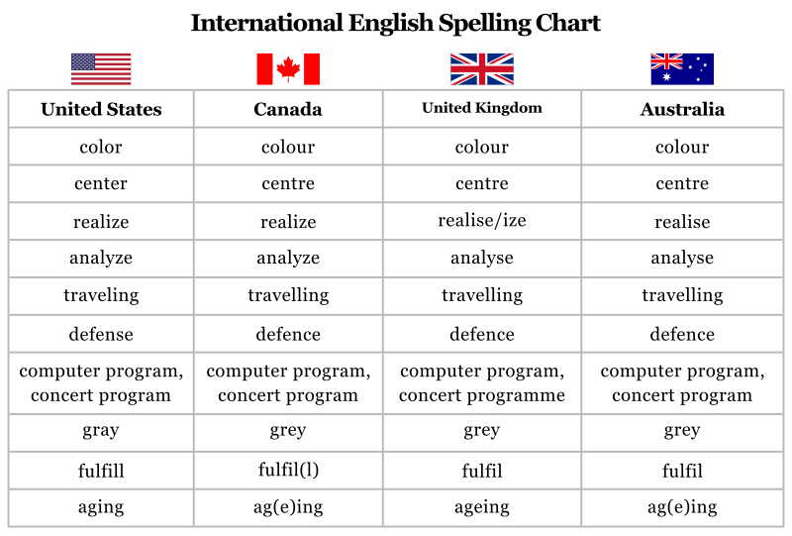

Lesson 38
SOUTH-ASIAN ENGLISH

Topic – 186: Introduction to South-Asian English
In this topic, the following points are discussed:
The worldwide spread of the English is an unprecedented phenomenon for which we do not find any example in human history. English was brought to the subcontinent in the early seventeenth century by British colonialism. Today it is spoken as a second language by 3 percent of the population of Bangladesh, Bhutan, India, the Maldives, Nepal, Pakistan and Sri Lanka. In numerical terms, we can safely say that there are approximately 33 million English speaking people.
South Asian English is sometimes called "Indian English", as British India included most of the region, but today, the varieties of English are usually divided according to the modern states. In India, there are 25 million users of English more than Australia. There are intra-national and intra-regional role of “link” language among people of diverse linguistic background. After so many years of independence, the countries of South Asia still use English to varying degrees in the domains of government administration, law, the military, higher education, commerce, the media, and the arts.
In Pakistan, English has the status of an official language alongside the national language, Urdu. In Sri Lanka, there are efforts to "peoplize" English. In Bangladesh, despite strong Bangla movement, English enjoys importance. In South Asian countries, it plays the role of the international medium for communication with the global community of nations.
Topic – 187: Features of South Asian English

In this topic, the following points are discussed:
English was introduced to South Asia in the early 17th century and was reinforced by the long rule of the British Empire. Today, it is spoken as a second language by about 33 million people, 3% of the total population. Today, the varieties of South Asian English are divided according to the modern states:
  - Bangladeshi English
  - Indian English
  - Nepali English
  - Pakistani English
  - Sri Lankan English
The following material will be helpful to get an idea about South-Asian English and its emergence as a widely spoken second language:
https://www.slideserve.com/ervin/indian-english
Although it is fairly homogeneous across the region, sharing "linguistic features and tendencies at virtually all linguistic levels", there are also differences based on various factors.
- Indian English: It has words of Indian vernaculars that have made their way into the English language.
- Examples include:
- Jungle, tank, bungalow, shampoo, verandah.
It has political, sociological, and administrative terms of modern India: dharna, hartal, eveteasing, votebank, swdeshi, tiffin, hillstation, gymkhana. We need to notice its resemblance with Pakistani English.
Vocabulary:
Our Company lays great stress on technical training and knowledge ‘upgradation’. The Prime Minister greeted the presspersons with a ‘namaskar’ and a broad smile. I read the newspaper ‘matrimonials’ on Sundays, especially the ‘English-knowing’ intelligentsia.
Spelling & pronunciation
Most Indian languages, unlike English, have a nearly phonetic spelling, so the spelling of a word is a highly reliable guide to its pronunciation. The word "of" is usually pronounced with a /f/ instead of a /v/ as in most other accents. Pronunciation of <house> as [hauz] in both the noun and the verb, instead of [haus] as noun and [hauz] as verb.
Pakistani English:
In-Charge— a casual as well as a formal title given to unit, group or division heads. Same to same— an expression to indicate something is exactly the same to some other thing.
Out of station—out of town. Got no lift—received no attention or assistance from someone.
- Miss is used to address or refer to female teachers, whatever their marital status,
- Madam is used to address and refer to females in positions of authority, usually a superior
- Cousin-brother (male first cousin) & cousin-sister (female first cousin)
- Overhead bridge (bridge meant for pedestrians)
- Flyover (overpass or an over-bridge over a section of road or train tracks)

Topic – 188: South Asian English: Imperialistic Legacy and Regional Asset
In this topic, the following points are discussed:

Languages of Imperialism in South Asia have a long history. In the second millennium, B.C.E. speakers of Old Indo-Aryan came into South Asia from the northwest-present-day Afghanistan-and spread southward and eastward, partly by peaceful settlement but largely by force of arms. In a few hundred years, the invaders had spread across the Indus Valley civilization (now Pakistan), reached modern Bihar and Bengal, and even migrated to Sri Lanka. The use of their language, in the form of Sanskrit, has persisted in South Asia to the present day.
In the form of its descendants, the modern Indo-Aryan languages, Indo-Aryan is the mother tongue of a large proportion of the population of every country in South Asia. But, Sanskrit itself as a superposed language is the clearest linguistic legacy from this early imperialism in the area. Sanskrit is related to Hinduism in special ways. Persian, similarly, has been associated with Islam. The coming of Islam to South Asia is generally dated to 711 C.E., when an Arab naval force entered what is now Pakistan from the Arabian Sea and conquered the Indus valley.
This incursion probably did not introduce the use of Persian, however, which came with the raids of Mahmud of Ghazni in the eleventh century. Although, at one point Mahmud officially reintroduced Arabic as the language of the laws and administration, it was Persian, the second great Islamic language, that was the principal language of his empire, centered on Lahore. Persian continued to be the chief court language of successive Muslim kingdoms, sultanates, and empires down to the Moghul Empire, centered on Delhi, which yielded to the power of Great Britain.
In all these polities, Persian was a major and often the dominant language. Limited uses of Persian have persisted in South Asia until the present time.
Topic – 189: Syntax of South Asian English
In this topic, the following points are discussed:
In recent years, there has been a growing recognition of institutionalized nonnative varieties of English (such as South Asian English) Existing descriptions of IVEs cover only small areas of lexical, morphological, and phonological structure, with even less attention paid to syntax.
Although these sentences are not necessarily ungrammatical in other varieties of English, they would probably be considered unidiomatic.
Examples:
- Since her birth, she has been under the hands of men. (Subservient to).
- Women in this century have come very forward.
- The present woman knows her rights.
- Above half are conservatives.
See &Look
- If we see only in the direction of art and literature.
- Now, look the difference between
House for home
- Women came out of the house for studying.
Legs for feet
- She can stand on her own legs and face the society.
Even, Also
- In our country, even women also encourage.
- Even India is also changing.
- Even in these days also.
Discourse adverbials:
- Like this, the position of women has been changing.
- Like this, she lived.
- It is noteworthy that in grammar a few characteristics are shared by all South Asian users of English. Here are a few examples:
Examples of Question Formation:
There is a tendency to form information questions without changing the position of the subject and auxiliary items:
- What you would like to eat?
- Where you would like to go?
Examples of Reduplication:
- Hot hot coffee
- Small small things
- To give crying crying
Examples of Verb aspect:
- The use of present progressive with stative verbs is quite common.
- I am having an aunt in Chicago
- I am loving it (ad for McDonalds)
- I am having a cold” (B. Kachru 1983:497, 510).

Topic – 190: The Future of English in South-Asia
In this topic, the following points are discussed:
Linguistically and culturally, South Asian English is a very interesting and a dynamic phenomenon. It is interesting because English has become one of the languages of communication for South Asians, and as such a distinctive form of South Asian English has emerged. It is dynamic also because the English language is constantly evolving and changing in South Asia, as it is constantly being used to express nuances of South Asian cultures and sensibilities. “South Asia is a linguistic area with one of the longest histories of contact, influence, use, and teaching and learning of English-in- diaspora in the world.” B. Kachru (1986:36) asserts: ‘[the] use of the term South Asian English is not to be understood as indicative of linguistic homogeneity in this variety or of a uniform linguistic competence’.
The Issue of Identities:
The term identity can be examined in more than one sense. In a regional sense, it has an identifiable speech fellowship in South Asia. The second sense is functional which relates to recognizing the South Asian contexts and domains of use as sociolinguistically and functionally appropriate. The third sense occurs in claiming in-group identity with other users. English occupies a very special position in the lives of South Asians. In South Asia, English has been nativized to such an extent that it is considered not a foreign or an alien language. Creative writing in English is at its peak today. More and more South Asian writers are emerging as great writers, winning coveted prizes such as the Pulitzer Prize (Jhumpa Lahiri) and the Booker Prize (Arundhati Roy). This indicates that English is clearly here to stay.

Lesson 39
ENGLISH LANGUAGE IN 21ST CENTURY: FEATURES OF ENGLISHES
Topic – 191: The Recency of World English & the Future of English
In this topic, the following points are discussed:
People have been predicting the emergence of English as a global language for at least two centuries. In a genuine sense of ‘global’ the phenomenon is relatively recent.
English as a first language is used in the USA, Canada, Britain, Ireland, Australia, New Zealand, South Africa and a scattering of other territories. It is the official language which means it is the primary medium of communication in such domains as government, the law courts, broadcasting, the press and the educational system. English now has some kind of special administrative status in over seventy countries, such as Ghana, Nigeria, Zimbabwe, India, Singapore and Vanuatu. English achieves a special role when it is made a priority in a country’s foreign-language teaching policy; it has no official status, but it is nonetheless the foreign language which children are most likely to encounter when they arrive at school.
Over 100 countries treat English as a foreign language (chiefly in Europe, Asia, North Africa and Latin America). The term ‘global English’ thus had a genuine application in the year 2000. However, it could not have had such an application a half-century before. The prospect that a lingua franca might be needed as a practical tool for the whole world is something which has emerged strongly only since the 1950s. A postwar demand for a mechanism was enabling nations to talk and listen to each other on a regular basis. The actual number of nations in the world participating in that mechanism was soon to increase significantly.
The United Nations had only 51 member states when it began in 1945, but this had risen to 191 members by 2002. The consequence is an increasing reliance on the concept of a ‘working language’ that is English. The only other alternative can be translation, which is not feasible because it is very expensive. Overall, we can say that today English is expanding its circle and power.
Topic – 192: How many Speakers of English?
In this topic, the following points are discussed:
Various Sources of Estimates of speakers of English are found which include:
- Linguistic surveys
- Individual authors,
- Using various criteria
Each has an in-built uncertainty, the nature of which needs to be appreciated before the totals can be used with any cogency. The first-language totals cited in the 1990s were swinging between 350 and 450 million. Reason of difference in these estimates is that the status of pidgins and creoles historically derived from English are not fixed. If these are considered ‘varieties of English’, then their speakers will be included, and we will move towards accepting the higher total
The second and foreign-language totals, often considered together are even more difficult to be sure about. The reason is that fluency is a continuum. A criterion of native-speaker-like fluency, would clearly produce a relatively small figure and including every beginner would produce a relatively large one. A British Council has referred to a billion (i.e. thousand million) people engaged in learning English (British Council, 1997). That figure needs to be interpreted cautiously, because it includes all learners, from beginners to advanced users. In India, for example, estimates of the numbers of English speakers have varied between 3% (Kachru, 1986: 54), 19% (Encyclopedia Britannica, and 33%, reporting a 1997 India Today survey)
This in real term represents a range between 30 million and over 330 million. The world population passed the 6 billion mark during late 1999. Approximately one in four of the world’s population is now capable of communicating to a useful level in English. There is evidently a major shift taking place in the centre of gravity of the language. From the 1960s, when the majority of speakers were first-language speakers, now more people are speaking it as a second language, or a foreign language. If we combine these two latter groups, the ratio of native to non-native is around 1:3. Graddol (1999: 61) suggests that the proportion of the world’s population who have English as a first language will decline from over 8 per cent in 1950 to less than 5 per cent in 2050. The situation is without precedent for an international language. Overall, we can say that the number of speakers of English as second and foreign language is increasing speedily.

Topic – 193: Cross Linguistic Influence and the Spread of English
In this topic, the following points are discussed:
The crucial factor in the development of English over the last few centuries is its role in the world. English has been brought into contact with new environments and languages, and as a result has developed in new directions, giving rise to different varieties of English.
The English language of today reflects many centuries of development. The political and social events that have in the course of English history so profoundly affected the English people in their national life had generally had a recognizable effect on their language. The Roman Christianizing of Britain in 597 brought England into contact with Latin civilization and made significant additions to our vocabulary.
The Scandinavian invasions resulted in a considerable mixture of the two peoples and their languages.
The Norman Conquest made English for two centuries, the language mainly of the lower classes while the nobles and those associated with them used French on almost all occasions.
And when English once more regained supremacy as the language of all elements of the population, it was English that greatly changed in both form and vocabulary from what it had been in 1066.
In a similar way, the Hundred Years’ War, the rise of an important middle class, the Renaissance, the development of England as a maritime power had an impact on English. The expansion of the British Empire, and the growth of commerce and industry, of science and literature, have, each in their way, contributed to the development of the language. History of English is in fact a history of quite divergent societies, which have caused the language to change and become enriched as it responds to their own special needs.
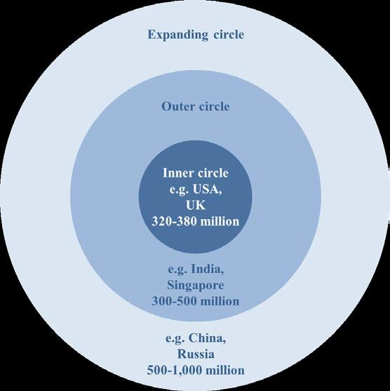
Today We Have:

- British English
- American English
- African English
- South Asian English
- Australian English
- And many more varieties.

Topic – 194: The Expanding Circle of English
In this topic, the following points are discussed:
English is Spoken in Circles:
The Indian-American scholar Braj Kachru has mentioned three concentric circles of English.
- The Inner Circle= First language.
The Inner Circle
The United States, Canada and the West Indies in the New World;
Britain and Ireland in Europe; Australia, New Zealand and South Africa in the Southern Hemisphere.
The Outer Circle
English is a second, often official or semi-official, but where most users of the language are not native speakers.
The Expanding Circle
- English is learned and used as a foreign language
The Inner Circle
In these eight regions, over 320 million people use English as a first language. They enjoy a privilege since they learn, for free to speak this global language with a native accent.
The Outer Circle
In the Outer Circle, we mostly find people who live in former British colonies, such as Kenya and Tanzania in Africa, and India, Pakistan, Malaysia and Singapore in Asia.
The Expanding Circle
It encompasses large parts of the world where English is learned as a foreign language because it is found useful, or indeed indispensable, for international contacts. This circle now seems to be ever-expanding, strengthening the claims of English as the international language of today.
In the not too distant future, it will be appropriate to rename the ‘Expanding Circle’ as the ‘Expanded Circle’.
Today we have:
- British English
- American English
- African English
- South Asian English
- Australian English
- And many more varieties.

Topic – 195: Coming Full Circle: Emergence of World English
In this topic, the following points are discussed:
English has gone global. Today, English dominates the world stage in a number of language uses. It is the main language of publishing, science, technology, commerce, diplomacy, air-traffic control and popular music. The reasons for this are to do with the political and economic power of Britain in the nineteenth century and the United States in the twentieth century. These same reasons also account for a dramatic increase in the number of users of English. In the sixteenth century, there were approximately 3 million speakers of English. Today, there are over 300 million native speakers of English. To this, one could add a further 300 million who regularly speak English as a second language.
In fact, it has been estimated that in total around a billion people use English with varying degrees of proficiency. With the international spread of English, it is perhaps more appropriate now to speak of WORLD ENGLISHES.
In this regard, American and British English are the two most important national varieties, in terms both of numbers of speakers and of the world-wide impact (Britain through its former Empire, and North America through its economic power).
Other important varieties of English include those of Australia, Canada, Ireland, New Zealand and South Africa and there are also various countries in Africa, the subcontinent of India, the Caribbean and south-east Asia.
It is sometimes claimed that English as an international language will succumb to the same fate as Latin. Around 2,000 years ago, Latin was used throughout Western Europe, North Africa and Asia Minor (i.e. including the area covered by today's Turkey).
Today, Latin is a dead language, and its descendants - such as Italian, French and Spanish - are separate languages. Do you think this prophecy is likely to be fulfilled? Will English become a group of English languages which are not mutually comprehensible?
Reasons of Emergence of English as a World English
A language becomes a world language due to extrinsic reasons and due to the power of the people who speak it. By power we mean political, technological, economic and cultural power.
Political power is seen in the form of the colonialism that brought English around the world from the sixteenth century, so that by the nineteenth century, the language was one ‘on which the sun does not set’.
Industrial Revolution of the seventeenth and eighteenth centuries was an English-language event. The nineteenth century saw the growth in the economic power of the United States. And in the twentieth century, cultural power manifested itself in virtually every walk of life through spheres of American influence.
Politics, Economics, Press, Media, Broadcasting, Music, Travel, Communication and Education- each of these played a role in this regard.

Lesson 40
FUTURE OF ENGLISH
Topic – 196: Social and Political Power Associated with English
In this topic, the following points are discussed:
The Crucial Question is:
- But why English?
- Are there any intrinsic or extrinsic factors at work?
- There is of course nothing intrinsically wonderful about the English language that it should have spread in this way.
Pronunciation& Grammar:
Its pronunciation is not simpler than that of many other languages; its grammar is no simpler.
Spelling:
Its spelling certainly is not simpler than other languages. A language becomes a world language for one reason only – the power of the people who speak it. But power means different things: it can mean political power, cultural power technological power and economic power. Each of these influenced the growth of English at different times.
Political power:
It emerged in the form of the colonialism that brought English around the world from the sixteenth century, so that by the nineteenth century, the language was one ‘on which the sun never sets’.
Cultural Power
In the twentieth century, we indeed saw the cultural power, manifesting itself in virtually every walk of life through spheres of chiefly American influence.
As a result of these different manifestations of cultural power, it is possible to recognize ten domains in which English has become pre-eminent.

Topic – 197: Power of Knowledge and English Today
English is the medium of a great deal of the world’s knowledge, especially in such areas as science and technology. And, access to knowledge is the business of education.
When we investigate why so many nations have in recent years made English an official language or chosen it as their chief foreign language in schools, one of the most important reasons is always educational. Since the 1960s, English has become the normal medium of instruction in higher education in many countries – including several where the language has no official status. Advanced courses in the Netherlands, for example, are widely taught in English.
No African country uses its indigenous language in higher education, English being used in the majority of cases. The English language teaching (ELT) business has become one of the major growth industries around the world in the past half century.
The Role of the Internet

The public acquisition of the Internet is another element contributing to the revolutionary linguistic character of the 1990s, and the one where the epithet ‘revolutionary’ is easiest to justify. Although the Internet as a technology had been around since the 1960s, for e-mails and chat, very few people began exploiting it until thirty years later. The World Wide Web itself came into existence only in 1991. But in an extraordinarily short time, people adopted and mastered the technology, and in the course of doing that encountered, adapted and expanded its highly distinctive language.
Now think of slang and jargon, breaking the conventional linguistic rules of spelling and punctuation, and other such practices. It is thought that three-quarters of the world’s mail is in English; but as no one monitors the language in which we write our letters, such statistics are highly speculative. Only on the internet, where messages and data can be left for indefinite periods of time, is it possible to develop an idea of how much of the world’s everyday communications is actually in English. In this regard, we also need to think of inventions, machines, and discoveries.
Topic – 198: Language Themes for 21st Century
Because there was so much linguistic innovation and change in the 1990s, several of our assumptions about language which we took for granted in the twentieth century need to be revised for the twenty-first. The arrival of a global language, English, has altered the balance of linguistic power in unprecedented ways, and generated a whole new set of attitudes about language and languages.
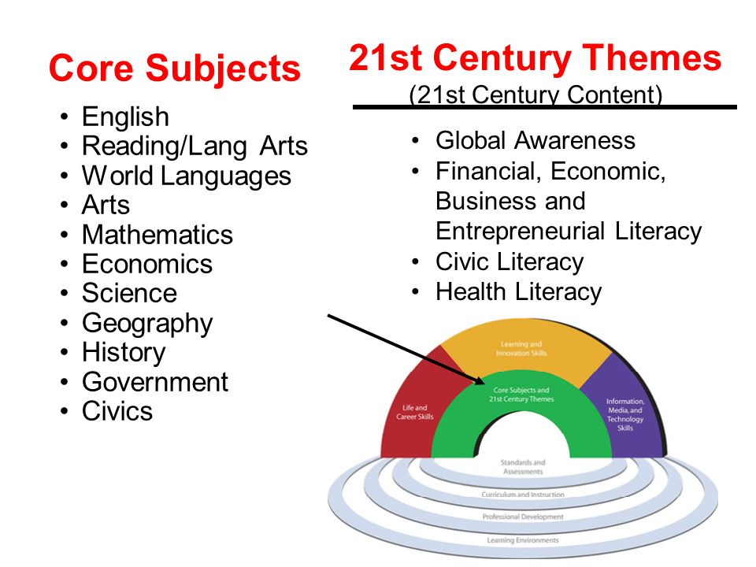
Many speech communities have begun to feel threatened by a situation which can alter the character of their language, or, in the worst case, can cause the use of their language to become so reduced that its very survival is at risk. Several are finding it necessary to introduce protective policies, or at least to find ways of managing the effects of the linguistic changes they are experiencing.
At an international level, such as in the European Union, more sophisticated strategies are to be implemented to safeguard the principle of language equivalence while recognizing the practical fact that virtually everyone speaks English. At the same time, communities want to exploit the opportunities for empowerment opened up by the availability of an international lingua franca.
They find themselves having to take fresh measures, such as devoting resources to English language teaching. Also introducing an English-language dimension at senior levels of management can be noticed. Tourist potential is maintained by incorporating an English interpreting facility into important venues.
Issue: Learners and teachers have to get to grips with a rapidly diversifying language, in which evolving regional standards and an increasing number of ‘New Englishes’ complicate a world where once only British and American English ruled.
Moreover, the process of change, has been radically affected by the arrival of the Internet. The net-speak community is unprecedented in its size today. So, here we need to consider what are the possible language themes for the 21st Century? There is a need for fresh policies and strategies. Teachers find that they must give their students exposure to new varieties and forms of English.
There are concerns regarding examination system. There is also a need for a respectful attention to regional accents and dialects, both nationally and internationally. Legal status and system of documents or the copyright position of creative work is another aspect of concern.
There is an unprecedented linguistic crisis in its scale and urgency, and in the twenty-first century, there is a huge responsibility on governments, international organizations, philanthropists, artists and activists.
Topic – 199: Future of English
English Tomorrow
It is dangerous to extrapolate or to prophesy about the linguistic scenario of tomorrow’s world. None of us can guess what the English language will be like in a hundred years’ time. The changes of recent decades suggest what forces are at work in the language today and the likely shape of things in the next few decades. But the history of the language in the coming century will depend on the history of the community.
One of the striking things at the moment is the expansion going on in the vocabulary. If this continues, the change over a century will be comparable to that of such earlier periods as 1300 to 1400 or 1550 to 1650. Another trend is dialect-mixing. Unless some global disaster disrupts world communications, this is likely to continue.
In England, other educated regional varieties of the language have achieved parity of esteem. Now it is normal for TV services in the English regions to have announcers and presenters who use the local form of the language. In pronunciation, such trends as the diphthongization of the long close vowels may well continue, and could lead to further changes in the vowel system.
In grammar, the trends of the past thousand years continue in small ways. More substantial changes could be caused by the permeation of the standard language by usages which at present are informal and/or non-standard. In grammar, for example, past-tense forms like ‘I done’ might become acceptable, as might the conflation of adjective and adverb forms.
Perhaps more controversially, the reduced forms used in electronic communications such as text messaging and e-mail, such as L8 for ‘late’ and LOL for ‘laugh out loud’, might find their way into other kinds of written usage.
What we can be sure of is that the process of change, which we have traced from the early Indo-European records up to modern times, is still going on, and will continue. It requires an effort of detachment to recognize current change for what it is. We shall recognize that our behaviour is simply that of one group at one point in time, and that in the next generation the innovations that we deplore may well have become completely respectable, and indeed uniquely right for the users.
Moreover, why not enjoy the language that you speak; why not to enjoy the richness and variety. In fact the whole of nature is in flux, and so is the whole of human life, and language.
Topic – 200: Factors that will determine the Future of English
In this topic, the following points are discussed:
- What will determine the future of English? Which factors should we consider in this regard?
- Is it the number of people?
- May be there is going to be a decline now after four centuries in the first language speakers. But, what about speakers of English as second and foreign language?
Centrifugal vs. Centripetal Forces

However, history may no longer be a guide to what is happening to English today. In fact the parallel with Latin is not perfect. One of the consequences of globalization is that through the media we have immediate access to other languages and two varieties of English other than our own, in ways that have come to be available but recently. And this is altering the manner in which people are aware of the language.
Think of a group of people in an out-of-the-way village in Pakistan- clustering around a television -hearing BBC News. With a whole range of fresh auditory models becoming routinely available, it is easy to see how the type of English spoken in different countries could move in fresh directions.
Global satellite communication has changed the whole scenario and is acting as the pull force imposed by the need for identity. Both centrifugal and centripetal forces operate in English. Alongside the need to reflect local situations and identities, which foster diversity, there is the need for mutual comprehensibility, which fosters standardization.
People need to be able to understand each other, both within a country and internationally. There has always been a need for lingua francas; but now more than ever we need a world language. And as supra-national organizations grow, the need becomes more pressing. The 191 members of the UN are there not simply to express their identities, but also because they want to talk to each other.
We know and understand that Standard English is not identical everywhere. Generally speaking, there are similarities in writing but the dissimilarities in speaking. The history of Latin is no guide to the future of English. These centripetal forces that are at work today they were lacking a thousand years ago. Once the Roman Empire had begun to fragment, there was nothing to stop the centrifugal forces tearing spoken Latin apart. In the Middle Ages, it was very easy for communities to be isolated from the rest of the world. Today, it is virtually impossible.
Both centrifugal and centripetal forces exist in the modern world; and for that matter we need both. We want to express our identity through language and we want to communicate intelligibly through language. We want to be different and we want to be the same.

