It601 current paper compiled by phistanphobia :2k25
Features of Mod Security:
- It can protect the server from various attacks.
- ▪ It uses the regular expressions and rule sets to block the attacks.
- ▪ It works as a firewall.
- It could work either embedded or as a reverse proxy.

Scenerio tha, jis m we have to tell k kon se records ki need hai. It was related to A and AAAA maybe.
A record (ipv4)
Maps a domain name to an IPv4 address
AAAA Record (IPv6)
- Maps a domain name to an IPv6 address
- They help browsers and applications resolve domain names to the correct IP address.
- Websites and applications use these records to support both IPv4 and IPv6 users.
- They ensure backward compatibility (A record for older networks, AAAA for modern networks).
Binary code given tha usko base64 mein convert krna tha, binary code k 3 sets thy each set mein 8 digits thy
Divides binary data into 24 bit blocks
• Each block is then divided into 6 bit chunks
• Each 6-bit section is interpreted as one character causes 25% overhead
aik table tha bits type btane thy for 3 examples that is: simple text, long textual script, personal photograps, jin k liye options thi 7 bits, 8 bits, base64

Simple Text (e.g., "Hello") | 7 bits | ASCII characters mostly use 7-bit encoding (e.g., A = 1000001).
Long Textual Script (e.g., Articles, Books) | 8 bits | Modern text encoding (UTF-8) usually uses 8-bit representation per character.
Personal Photographs (Images, Media Files) | Base64 | Binary image data is encoded in Base64 for text- based transmission (e.g., email, web).

types of web server:
Apache HTTP
NGINX
Microsoft IIS
Apache Tomcat

iptables kicommands likhni thi chain rules k sath, ip address given tha
▪ sudo iptables -A -i -p -s --dport –j
iptables -A INPUT -s 192.168.1.100 -j ACCEPT

Write 5 new features that are added to NFSv4:
- Stateful Protocol: Tracks client-server state, improving locking mechanisms and caching efficiency.
- 2. Security Enhancements: Uses Kerberos for authentication and data encryption.
- 3. Unified Namespace: Combines file and directory operations into a single, coherent namespace.
- 4. Performance Improvements: Reduces overhead through improved protocol handling.
- 5. Firewall Compatibility: Operates on a single port (TCP 2049), making it firewall-friendly
Steps to start a program on dynamic Web server through rpc. Explain with an example
A remote procedure call is an inter-process communication technique used for client-server-based applications.
- A stub program on client machine is called
- Stub makes a system call to send the message to the server along with the parameters.
- The message is transferred to the server by the client’s operating system.
- The message is received by server OS is passed to server stub.
- Server stub removes the parameters.
- Server stub calls server procedure.

Two scaling technologies and their working
In horizontal scaling, a web server or web service resource is replicated and the load is divided among the replicated resources.
Vertical scaling
Separates out the various kinds of subservices, rather than duplicating a whole machine
. ▪ It allows you to create an architecture with finer granularity, so that you can put more resources at the most intensively used stages of page creation.

Define System Observabilityand write its tools
➢ System Observability means the ability of a manageable system that we can see what it is doing.
Basic Tools of Visibility
▪ System Logging (All parts of the system should log events, transitions, and operations)
System Monitoring(Ability to monitor not just the system ‘s up or down, but also internal resources, timing, bandwidth, disk space usage and requests delays.)
Subnets were given and we have to tell the classes of them (it was a table
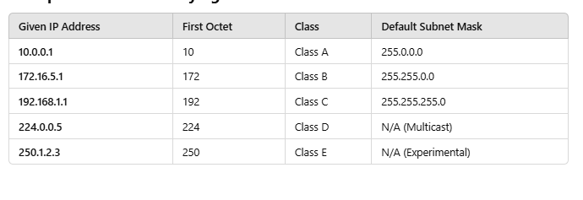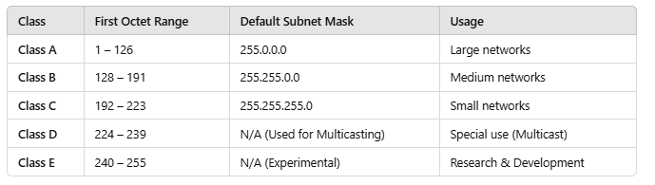

NFS ki diagram banani thi ke os stack pr kese hota ye
NFS operates at multiple layers of the OS stack, primarily in the Application, Transport, and Network layers
open architecture close architecture
Open Architecture: Systems designed for compatibility and flexibility, allowing integration with different hardware and software. Examples include Linux and other open-source environment
Closed Architecture: Proprietary systems where the software or hardware design is restricted, such as Windows Server or Apple products.

To configure DNS and list the required record to be added to DNS and server configuration ?
SOA
A and AAAA
PTR
CAA
CERT
draw a diagram where VFS lies in the operating system stack??
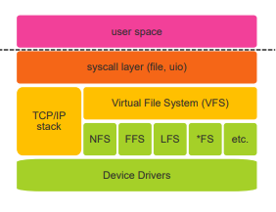
What is IP-KVM and how it helps the SA?
Keyboard, video screen, and mouse (KVM) switch is a device that allows many machines share a single.
An IPKVM switch provides the remote console access.
▪ An IP-KVM is a KVM switch that can be accessed remotely. This eliminates the need for any monitors, keyboards, or mice in the computer room. You simply run a client on your workstation that connects to the IP-KVM
A newly hide Linux system administrator wants to establish internet connectivity? what kind of the IP table he use and list the chain for that table ?
Linux firewall iptables has four default tables.
Filter
Decides what packet get in and what packets get out of network
NAT
Applies the NAT Rules, Used to alter source/destination packets

5 benefits of server appliances strategy to an organisation differentiate the scaling type used in multiple machine web server ?
Reduces resources
Time to Service
Less Expertise
Performance
Reliablity
Specialized Features

Being a part of help desk planning team what kind of processing you will choose in the planning and execution phase ?
Key Considerations OF HELP desk for planning
A Friendly Face
Reflect Corporate Culture
Enough Staff
Scope of Support
How to Get Help
Key Considerations OF HELP execution phases
Processes for Staff
Escalation Process
Defining “Emergency” Request-Tracking
Statistical Improvements

5 benefits of written requirement
Benefits
Transparency
Fewer gaps
Fewer misunderstandings
Buy-in and approval
Fixed scope Accountability
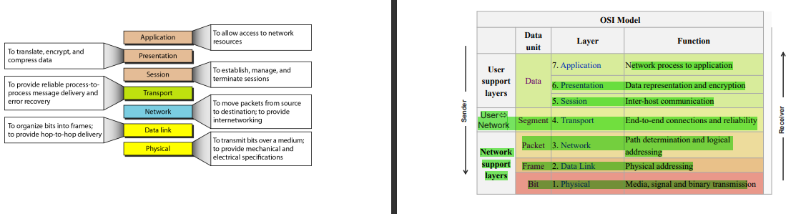

. What message communication happen at start and end termination of LDA Between clients and server
Client establishes session with server (BIND)
Client performs operations
Client ends the session (UNBIND)
Client can ABANDON the session
4phases of sstp

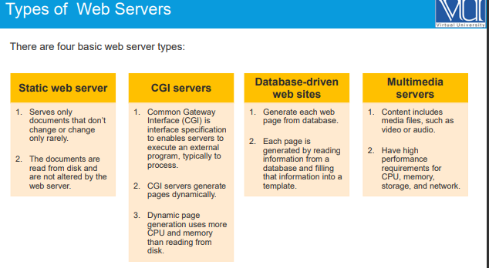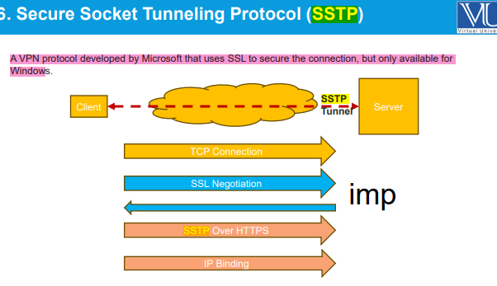
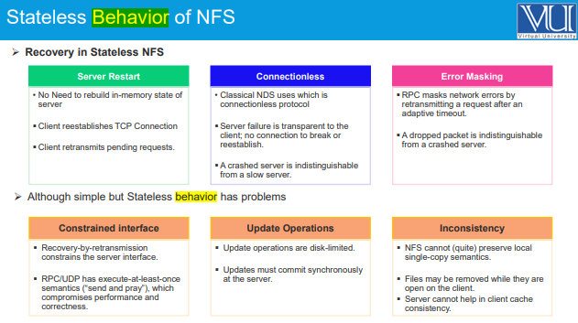
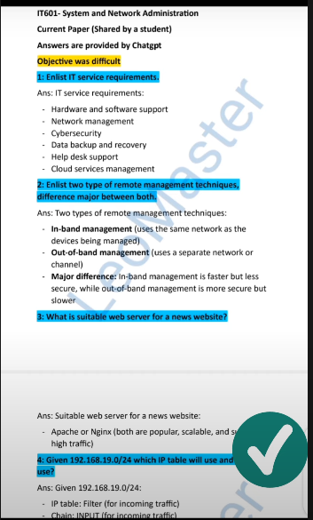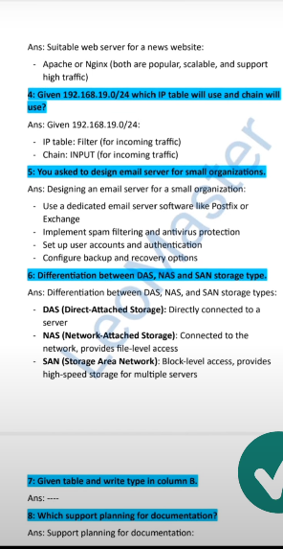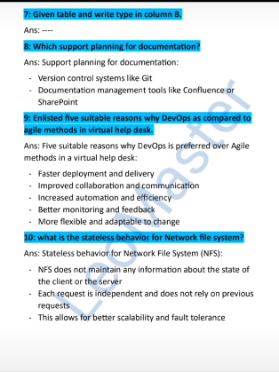

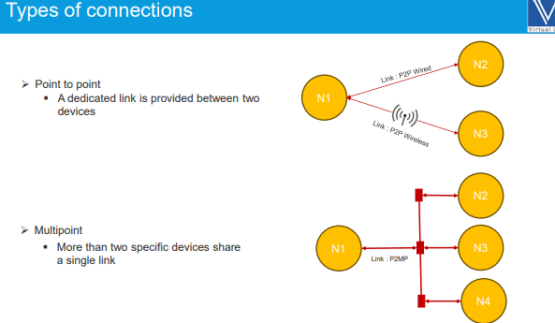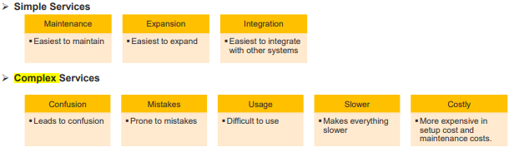
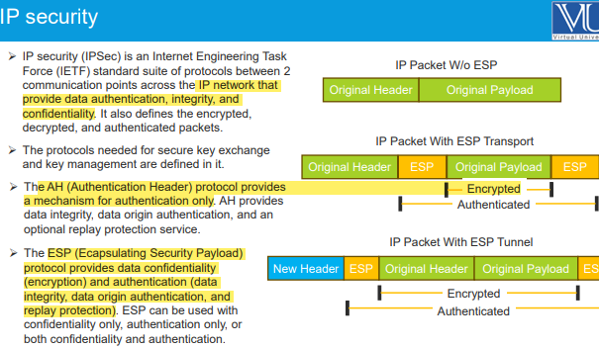

Types of connectivity
Connectivity refers to how devices, systems, or networks communicate with each other. It can be classified into different types based on technology, medium, and scope.
The management of an organization is removing remote management feautures to add new management type. Convince them over why they shouldn't remove remote management.
Remote management is essential for ensuring business continuity, cost savings, and security. It allows IT teams to monitor, troubleshoot, and update systems remotely, reducing downtime and minimizing operational costs. Removing it would increase response time, IT workload, and security risks, impacting business efficiency. Keeping remote management ensures quick issue resolution, compliance adherence, and enhanced cybersecurity.

2 types of Out of Band and a major difference between them
Integrated Out-of-Band Management is built directly into the hardware (e.g., iLO, iDRAC, IPMI) and provides a dedicated management interface for remote control. Non-Integrated Out-of-Band Management uses external devices (e.g., serial consoles, terminal servers) for remote access. The key difference is that integrated OOB is embedded within the system, while non-integrated requires additional hardware.

3 benefits of kick-off meeting
    - Introduce stakeholders and their roles
    - Resolves the issues faces in emails, IM e.t.c.
    - improves collaboration

Components of operational plan
Operational Plan is lso known as Service Support Plan. It Includes:
➢Operational level agreement (OLA)
➢Tho supports the various components of the service
The service level agreement (SLA) for the service
No raid examples
1. Single Disk Setup: A single hard drive without redundancy.
2. JBOD (Just a Bunch of Disks): Multiple drives combined without striping or mirroring.
3. USB Flash Drives: Standalone storage devices with no RAID capabilities.

Drop and reject target ka explain tha scenario base
the dropped package is not matched against any further chain does not generate an error
rejects a packet Generates an error to the connecting device

, OSI model se related tha ke wo cost kese reduce krta
The OSI model reduces costs by standardizing network communication, ensuring compatibility between different vendors and avoiding expensive proprietary solutions. Its layered approach allows for efficient troubleshooting and maintenance, minimizing downtime and IT support costs. Additionally, it enables scalability and upgradability, allowing organizations to upgrade specific layers without replacing the entire system, leading to long-term cost savings.

Layers of OSI Model and their Functions:
Physical Layer: Handles the physical transmission of data bits over the
network medium (e.g., cables, wireless).
Data Link Layer: Responsible for error detection and correction, framing
data into packets, and managing access to the physical medium.
Network Layer: Handles logical addressing (IP addresses), routing, and
packet forwarding.
Transport Layer: Provides reliable end-to-end communication, flow
control, and error recovery.
Session Layer: Establishes, manages, and terminates communication
sessions between applications.
Presentation Layer: Handles data formatting, encryption, and compression.
Application Layer: Provides services to user applications, such as email,
file transfer, and web browsing

objective:
- The Dynamic Host Configuration Protocol (DHCP) is a network service that enables host computers to be automatically assigned settings from a server as opposed to manually configuring each network host

- Serving multiple domains on the same IP address is more complex for HTTPS (encrypted) connections due to a Catch-22 in how HTTPS works.

- CGI programs can be memory-intensive or CPU-intensive processes and can produce large amounts of output

- The privacy and authenticity of the transmission can be protected by using HTTP over Secure Sockets Layer (SSL) to encrypt the web traffic. SSL 4.0 is also known as Transport Layer Security (TLS) 1.0.

- A cryptographic certificate is created by the web system administrator using software that comes with the encryption package

- Scale-up
- means getting a bigger system. To process more requests, more users, or more disk space, the main system is replaced with one that is bigger and faster.

- PAT and UAT environments are run at production standard, but upgraded ahead of the main production environment.

- Operational Plan is lso known as Service Support Plan. It Includes:
- ➢ Operational level agreement (OLA)
- ➢ The service level agreement (SLA) for the service

- Option 55—This option allows the DHCP client to request certain options from the DHCP server.

- Static web server
- Serves only documents that don’t change or change only rarely.
- The documents are read from disk and are not altered by the web server.

- In horizontal scaling, a web server or web service resource is replicated and the load is divided among the replicated resources.

- NFS is a network protocol layered above TCP/IP.

- In NAS, one or more dedicated file server or storage devices are made
- available in a LAN.

- In TCP/IP , a 16-bit port address represented as one single number

- FLSM is a better choice for private IP addresses, while VLSM is more suitable for public IP addresses

❖ Anycast : Transmission from source to single address of host where host has multiple ipv6 addresses

Current (2024) Final term Mcqs
[IT601]

1) saas stand for
• ... software as service
2) which of the given is the function of presentation layer
• ... Compression
3) Function of network layer
• ...Logical addressing
4) 4)5th layer of OSI model
• ... session layer
5) In ... network topology the number of links increases quadratically with increase in the number.
Options
a) Star
b) Mesh
c) Bus
d) Ring
Correct (Mesh)
6) The software applications needed by customers to accomplish their routine task in an
organization are referred to as...
a) Packages
b) Services
c) Utilities
d) Tools
Correct (services)
7) Which of the given is not a benefit of kick- off meeting while requirements gathering.
• ...(Avoid miss understanding of feature design)
8) Which of the given integrated approach for IT companies for coding,help desk,and developers?
a) DevOps
b) ITOps
c) ITEL
d) Agile
Correct (DevOps)
9) Support planning aspects can be divided into followings
a) 3
b) 4
c) 2
d) 1
Correct (4)
10) NFsV3 avoids the ..... problem.
a) Synchronous write
b) Retransmission
c) File cache inconsistency
d) Idempotency
Correct(synchronous write)
11) In Linux file system the ..... method increasments reference count on an active vnode .
a) Vget(vp)
b) Vrele(vp)
c) Vref(vp)
d) Vgone(vp)
Correct (vref(vp))
12) when a popular website links to a smaller website, causing a massive increase in traffic.
a)The traffic overload
b)Slashdot effect
C) bandwidth brust
D)The king surge
Correct(slash dot effect)
13) SOA stands for...
• ...(Start of Authority (SOA))
14) In LDap a... uniquely identify an entry in the directory.
a) DN
b) DC
c) CN
d) DIT
Correct (Distinguished Name (DN))
15) “Toaster is used to toast bread "
a) Modular
b) Blade
c) Grid
d) Appliance
Correct (Appliance)
16) A local engineering is also known as ....
• .... (Low Level Design description)
17) Types of web servers.
• ..... Four
Local Engineering Plan is also known as Low Level Design description
Nginx is often used to listen for incoming HTTP and HTTPS connections, determine which domain they are intended for, and forward the request as appropriate
Domain Name Service (DNS) is an Internet service that maps IP addresses and fully qualified domain names (FQDN) to one another
4## - Command was rejected, but error
the Elastic Stack now includes a rich collection of lightweight shipping agents known as Beats for sending data to
Logstash works by executing event processing pipelines,

