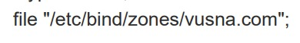s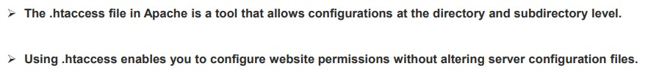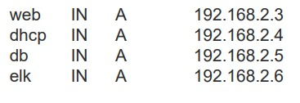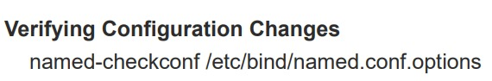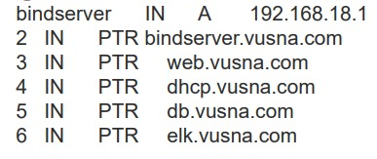

MCQs

Select the correct configuration in /etc/pan.d/common-password two enable LDAP authentication
sudo vi /etc/pam.d/common.password
password [success=1 user_unknown=ignore default=die] pam_ldap.so try_first_pass

Which of the given software package can be used to provide male sending service
these are all email server package
• Postfix • Courier-imap • Dovecot • E.t.c L
sudo apt-get install mailutils
postfix is answer

If the configuration type of SMTP is internet side then which is true
SMTP is the principal email protocol that is responsible for the transfer of emails between email clients and email servers.
keep remember definition then choose the option accordinaly

In ELK stack –-------is a used to send log to server
Logstash

Elastic search is a ______ and fall under the ______ category
"a search engine," "an analytics database," "a big data solution," "it's quick and scalable," or "it's like Google."
In the Linux system everything is located under ______directory
root (/) directory
Which command can be used to make your home directory your working directory
cd ~ # Go to home directory
pwd # Check the current working directory
Which command display the number of lines of the output file
wc -l myfile.txt (wc stands for word count. –l is for line )

Which is correct Syntax as a root Linux system
sudo
su -

______ is more powerful than _____
root is more powerful than regular user
Logstash is more powerful than Filebeat
according to present option you can select

Select the correct statement about MUA and MTA
these are the following are correct for better understanding
MUA communicates with MTA to send emails using SMTP (Simple Mail Transfer Protocol)
MUA retrieves emails using POP3 or IMAP protocols.
MUA (Mail User Agent) is used to compose and read emails, while MTA (Mail Transfer Agent) is used to send and receive emails.

Which is a GNU's implementation of open PGP
gnupg

Which command is used to start a new container
docker run --name it601p_m1

Web server contact are placed in the directory ____
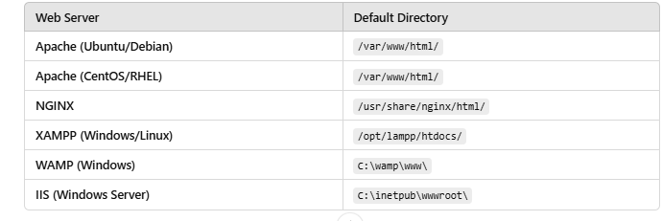
DNS record zone files have the template______
- The SOA (Start of Authority) record defines the zone.
- The NS (Name Server) record specifies the authoritative name server.
- The A (Address) record maps a domain to an IP.
Which utility create an update the files Aside content protection can be enable into _______ file
touch
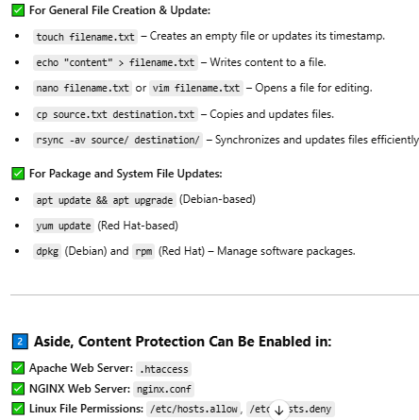

The latest kerberos package available in debian respiratory are_______
Kerberos 5 (krb5)

Select the correct statement about the shadow group in Ubuntu OS
The /etc/shadow file contains hashed passwords and is only readable by root and users in the shadow group.

what doesn mv do?
mv is the move/rename command in Linux.
shadow se related tha aik. k
Admin ko bhi shadow main hona chaiye
srf admin ko shadow m hona chaiye
users ko shadow main hona chahiye ya
admin and users dono ko shadow main hona chahiye
use ss (Socket Statistics) utility to check status of SMTP port 25
set other parameters like attachment size, protocols in /etc/postfixmain.cf
inet_protocols = all
inet_protocols = ipv4
mailbox_size_limit = 0

Copy server certificates in /etc/postfix/certs
Restart postfix service
sudo systemctl restart postfix
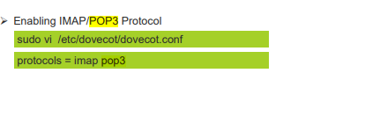
Subjective
Write a Linux command to print the first three characters from each file names scores
ls scores/ | cut -c 1-3
• ls scores → Lists the files in the scores directory.
• cut -c1-3 → Extracts the first three characters from each filename

What will be the output of the command Ubuntu terminal pseudo installed-m0755-d / etc / ATP / keyrings
sudo install-m 0755 -Id/etc/apt/keyrings
- sudo → Runs the command as a superuser (required for system-level changes).
- install → A command used for copying files or creating directories with specific permissions.
- -m 0755 → Sets the permissions for the directory being created:
  - 0 → No special mode (like SUID, SGID, Sticky bit).
  - 7 → Full permissions (rwx) for the owner.
  - 5 → Read & execute (r-x) for the group.
  - 5 → Read & execute (r-x) for others.
- -d → Creates a directory (instead of copying files).
- /etc/apt/keyrings → The target directory where APT (Advanced Package Tool) stores keyring files (for verifying package signatures).

Write the visual host configuration where web content are located
<VirtualHost *:80>
ServerAdmin admin@example.com
DocumentRoot /var/www/html/example
ServerName example.com
ErrorLog ${APACHE_LOG_DIR}/error.log
CustomLog ${APACHE_LOG_DIR}/access.log combined
</VirtualHost>
Wich file contain and configure on ubtan server . Enlist parameters.
the primary configuration file for an Ubuntu server is the /etc/network/interfaces file for network settings, managed by Netplan in newer versions. Here are some common parameters you might configure in this file:
- Interface Name: iface eth0 inet dhcp (for DHCP) or iface eth0 inet static (for static IP).
- IP Address: address 192.168.1.100
- Netmask: netmask 255.255.255.0
- Gateway: gateway 192.168.1.1
- DNS Servers: dns-nameservers 8.8.8.8 8.8.4.4
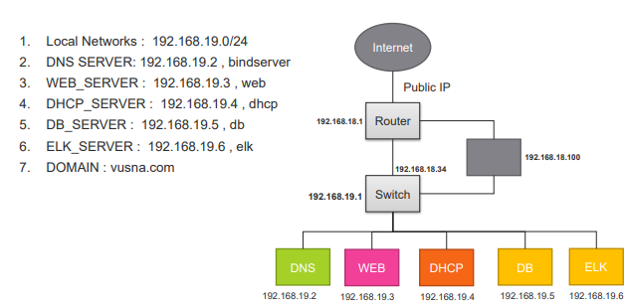

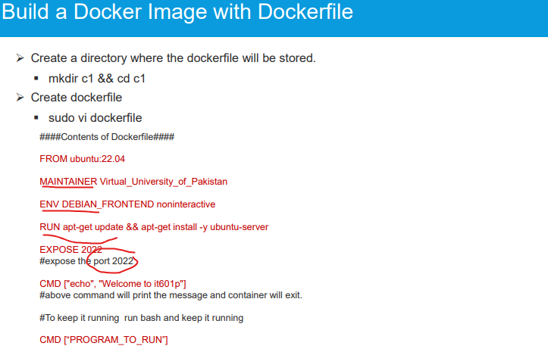

1 ) write the command in Linux replace and append thi output.txt in ls-s
ls -s >> output.txt
DHCP server each lines in fixed ip address (192.168.19.2) and having physical server (55:22:33:AB:2.)
sudo nano /etc/dhcp/dhcpd.conf

# Add the following lines:
host fixed-ip {
hardware ethernet 55:22:33:AB:2;
fixed-address 192.168.19.2;
}
- Restart the DHCP service for changes to take effect:
systemctl restart isc-dhcp-server

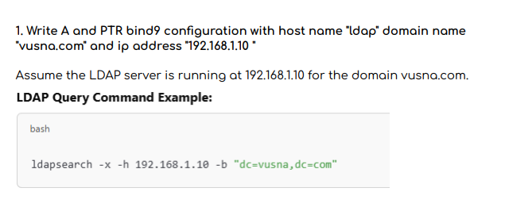
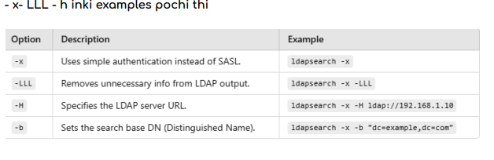
Sna@vusna on kld server . Enlist all steps

install Kerberos Server Packages
Run the following command to install the necessary packages:
sudo apt update
sudo apt install krb5-kdc krb5-admin-server krb5-user

2️⃣ Configure Kerberos Realm (/etc/krb5.conf)
Edit the Kerberos configuration file:
sudo nano /etc/krb5.conf
Ensure it contains:
csharp
CopyEdit
[libdefaults]
default_realm = VUSNA.COM
dns_lookup_realm = false
dns_lookup_kdc = false

[realms]
VUSNA.COM = {
kdc = kdc.vusna.com
admin_server = kdc.vusna.com
}

[domain_realm]
.vusna.com = VUSNA.COM
vusna.com = VUSNA.COM
Save and exit the file.

3️⃣ Configure the KDC Server
Initialize the Kerberos database:
sudo krb5_newrealm

4️⃣ Create a Principal (sna@vusna.com)
Run the following command to create a new Kerberos principal for the user:
sudo kadmin.local -q "addprinc sna@VUSNA.COM"
- Set a password when prompted.

5️⃣ Start and Enable the Kerberos Services
bash
CopyEdit
sudo systemctl enable krb5-kdc
sudo systemctl start krb5-kdc
sudo systemctl enable krb5-admin-server
sudo systemctl start krb5-admin-server

6️⃣Verify the KDC Setup
To check if the KDC is working, run:
kinit sna@VUSNA.COM
Enter the password set earlier. If successful, check the Kerberos ticket:
klist

5:secure shell sy tha aik configuration wla
1 – view Ip address information
$ Ifconfig -a |more
$ Ip a
2 – Update APT repositories and install openssh-server
$ sudo apt update
$ sudo apt install openssh-server
3 – Check status of the ssh server
$ sudo systemctl status ssh
4 – Check status current sshd configuration and default port to 2022
$ sudo Vi /etc/ssh/sshd_conf
5 – connect remote server with ssh on custom port and using remote user password
$ ssh -p 2022 <remoteUsername>@<remoteIpAddress>

ip address given th .os ka host find krna th.
sudo hostnamectl set-hostname ldap.vusna.com

. Aur ak question.hatcess say related tha
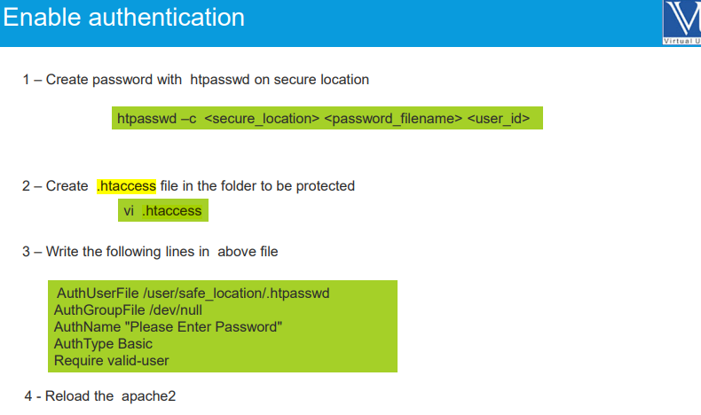

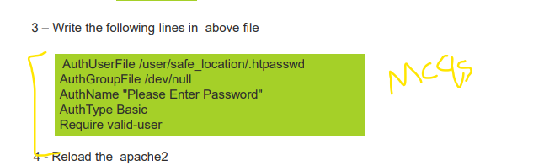

In 2 topics se related tha mcqs. Definition check kar lena inki.
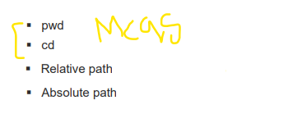

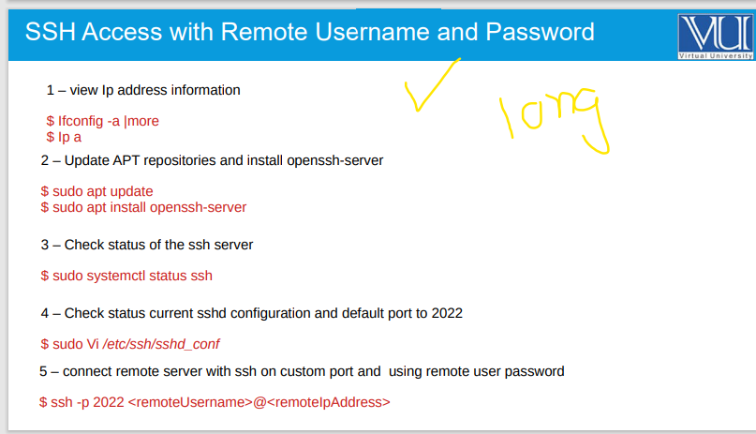

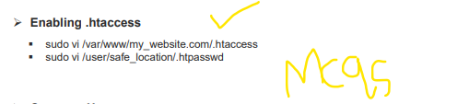

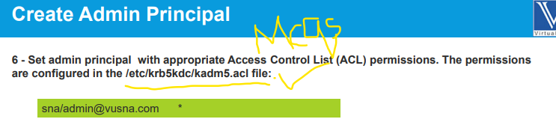

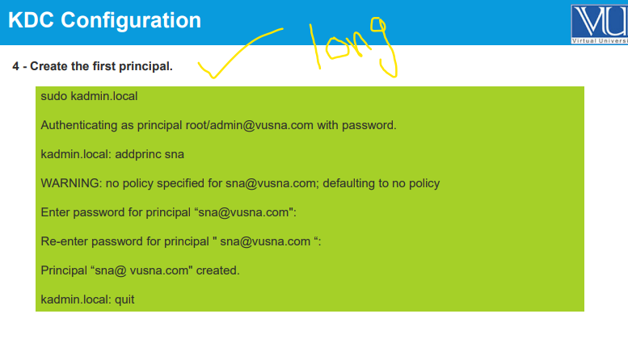
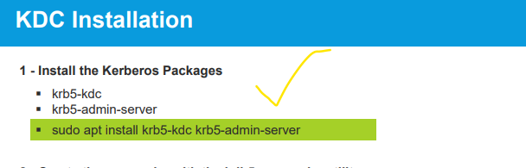

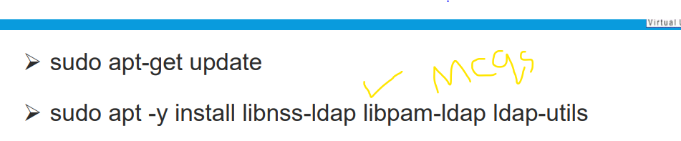

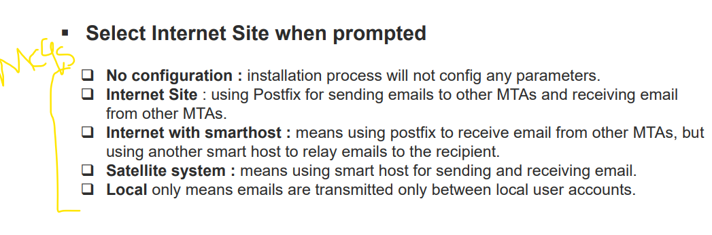

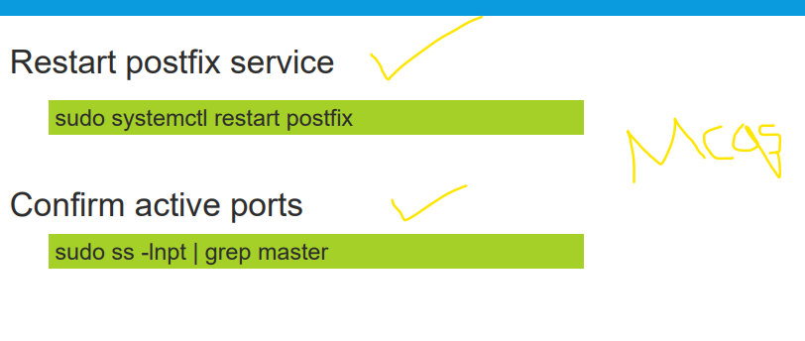

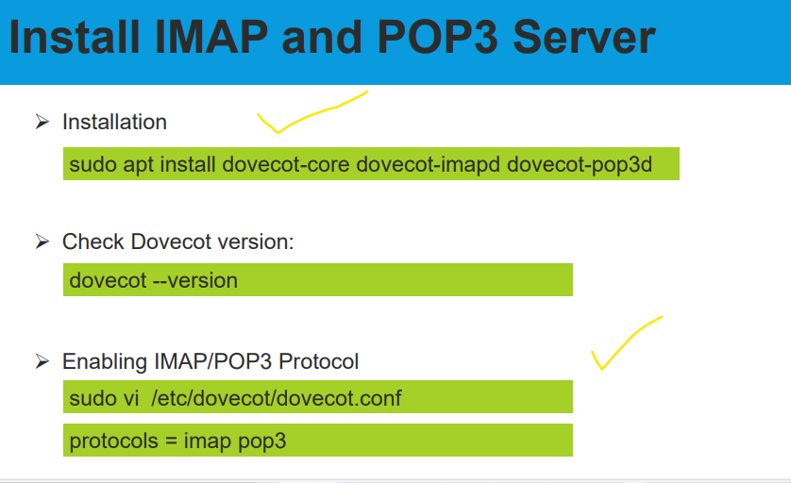

sudo apt install slapd ldap-utils
➢sudo dpkg-reconfigure slapd
➢configure the OpenLDAP libraries with certain defaults in
/etc/ldap/ldap.conf
BASE dc=vusna,dc=com
URI ldap://ldap.vusna.com
View the slapd-config DIT looks like via the LDAP protocol
Configure the LDAP Client
sudo apt -y install libnss-ldap libpam-ldap ldap-util
After the installation, edit /etc/nsswitch.conf and add
LDAP authentication to passwd and group lines.
passwd: compat systemd ldap
group: compat systemd ldap
shadow: compat ldap
integration of LDAP with Kerberos
with common password and session
Restart the nscd service

